

**ROMANIAN ACADEMY**

***CENTER FOR STUDIES AND RESEARCH***

***IN AGROFORESTRY BIODIVERSITY "Acad. David Davidescu"***

HABILITATION THESIS

**Professional scientific and academic performances obtained in gynecology, andrology and obstetric from veterinary medicine, necessary for eco-innovative application on reproduction biotechnology in livestock biodiversity, through  integrated eco-bio-economics solutions in one medicine, based on ecosanogenesis**

**Prof. BOGDAN T. Alexandru, DVM, PhD., D. h.c. (m)**

**Senior research**

**Member of Romanian Academy**

**Member of Academy of Agricultural and Forestry Science**

**Member of Romanian Academy of Scientists**

**PREFACE**

Now at the end of this synthesis of "Habilitation Thesis" are profound grateful to all my teachers who guided me to the highest professional competence and moral probity on nicest roads, but difficult of knowing through scientific research performant, during my professional youth and maturity for 55 years (September 1959 when I became a student at the Department of Animal Science of the Faculty of Agriculture from Agronomic Institute "Nicolae Bălcescu" in Bucharest, where in 1964 I graduated in Faculty of Veterinary Medicine and that until September 2014 when I finalized this text).

At the same time and equally thank them collegial and cordial to all my collaborators working groups for scientific research for over 30 years from Agronomic Institute "Dr. Petru Groza "Cluj-Napoca (which after the Revolution of December 1989 has changed in USAMV Cluj), ie the period January 1, 1955 January - 1 1995, when I was transferred to Bucharest at the Laboratory of Biotechnology breeding and in 2006 change the name in "Center for AgroBiodiversity Acad. David Davidescu".

It is evident that about half of a century is a relatively long way and I hope that in part have been different joys and perhaps even some notable results; are also very sure that there were many difficulties, failures and even mistakes, that everything is specific to real life.

 At the end of this afterword I express a deep sense of gratitude the memory of my parents, grandparents, great-grandparents and my uncles who make a dedication arch over time with the hope that I not disappointed a lot. In the same sense I address and my family all thanks to full support moral, social and professional that I have given generously and I think a good part of my eventual scientific successes are due to the intellectual climate of the extended family.

 I am optimist for the future and I want to continue to finish some of my projects and the Strategic national consensus for a modern and prosperity in Romania, in a changing multipolar world.

I thank to the Great and Almighty God with all reverence and humbleness for all  has given me so far and ask him to give me a few more years of intellectual biopower us spiritual fulfillment.

Postscript

I am very honored that my last rows and thoughts to express now for leadership, colleagues, collaborators and friends that I had in the Academic Cluj, a veritable another time Heidelberg, and have the highest respect and gratitude because  have been hospitable hosts in youth and my first professional maturity, that I was honored with the highest title of Doctor Honorius Causa, and now agreeing to present at the Faculty of Veterinary Medicine Cluj-Napoca this Habilitation Thesis, as a the unique and peak moment in my life.

**FIRST PART – Abstract**

I sustained doctoral thesis in the field of veterinary medicine, in 1971 from the former Timisoara Agronomic Institute under the leadership of Prof. Nicolae Gluhovschi DVD, PhD, Dr. habil., member of the The New York Academy of Sciences and of The Royal Society (the National Academy of Science in the UK). Thus, at the age of 30 years, I was in Romania one of the youngest and first doctor in veterinary medicine from the Faculty of Veterinary Medicine Timisoara. In over 43 years since of my confirmation my PhD by former PhD Degrees Commission from the Ministry of Higher Education, I conducted a permanent scientific, professional and academic activity, who, with great modesty and respect for my teachers and mentors, for my family and my friends, try to do it in the limits of abilities thesis format.

In Section I, named „Thematic directions in the breeding of farm animals and animal breeding ", on 21 pages, 8 tables and 12 figures are presented in a total 10 thematic directions, 5 disciplinary and 5 interdisciplinary (according to their titles specified in Section I). Original research presented in the first 5 disciplinary thematic directions were and are confirmed that the current scientific work supported at international level by me and published, based on rigorous scientific professional selection, made by international personalities at World Congresses of Reproduction and Artificial Insemination, from Paris (1968) and from Munich (1972) and the International Conference of Biotechnology of Reproduction in Munich (1970), Cadarache near Marseille (1974) and Cambridge (1991), including the World Congress of Veterinary Medicine in Moscow (1979) etc. They also, were and are confirmed as scientific priorities at international level, with over 10 patents, which are first author (eg. uterine biopsy instruments for cows and sows; artificial vagin for biotech semen colection from breeding stallions and boars; insulated glass to dilute semen from breeding rams, boars and cocks; device for zygotes biotechnological transfer in cows; methods and recipes for frozen semen from breeding boars and cocks etc.). For the other five interdisciplinary thematic directions, the personal original results were and are especially presented and published in several international congresses, symposia and conferences organized in the Romanian Academy, in the Academy of Agricultural and Forestry Sciences and in the Academy of Medical Sciences and abroad to Athena (2010), Cambridge (2011), Palma de Mallorca (2011), Venice (2012) by WSEAS and known international event named Green Week in Berlin from 2011 to 2013 etc. All these prestigious international scientific events, both I and my collaborators from my working group presented original scientific results obtained in two's international POSTDRU projects, ID 63258 and ID 77082 obtained in the competitive system, with funded by the European post-accession. These two projects were conducted with experts from Center for Studies and Research in Agroforestry Biodiversity "Acad. David Davidescu", from National Institute for Economic Research of the Romanian Academy. This center was organized by me in 2001 through activity of Senior research as a laboratory for „Biotechnology of reproduction” and I leads it like director since 2006. Thus, we created new concepts integrated "agrifood green power", "rural eco-bioeconomy" "smart eco-bio-geo-economy" „eco-geoeconomics integrated bioplatforms” „eco-bio-diplomacy” „integrated enviromental health” etc. which have been accepted for publication in several journals indexed ISI.

In the Second Section, I present my plans for the future, them I forecasted on their triple size in professional, scientific and academic, so the main directions of scientific research are continuing on biosciences veterinary medical and compared, through strategies for eco-bio-geo-cosmo-economics glocalizate solutions needed to prevent and combating poverty, hunger, social exclusion and food insecurity, through paradigms and paradoxes of the new concept of "one medicine" approach using smarter technologies advanced studies and research in biodiversity genomics and traceability, in the natural bioresources food, multifunctional, transgenic and biostimulation, in a changing multipolar world of the twenty-first century. Progress plans and development of my career in the university area/space for over half a century, is based on the directions of teaching at the excellence level for the Doctoral and Postdoctoral School for Bioeconomics Veterinary Medicine of Romanian Academy. I wish that all these academic courses to be doubled in the directions of practical applications, the technology transfer in animals farm and food bioindustry based on successful partnerships and consortiums with innovative SMEs.

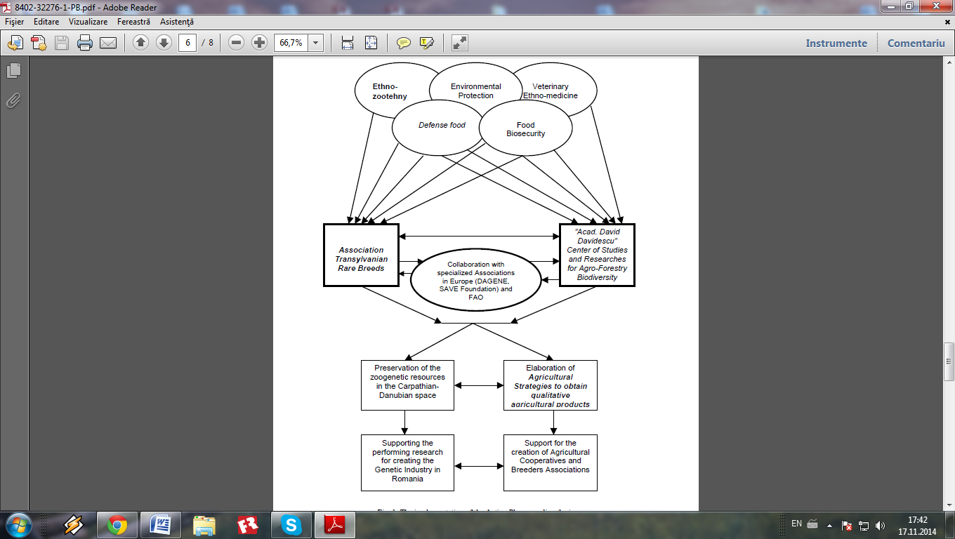

Fig. 1. The implementation of the European Action Plan regarding the increase

in economic competitivity and the decrease of the rural poverty

(orig. Alexandru T. Bogdan, Marcel Matiuti, Dorina Bogdan, Carmen Matiuti

and Amalia Străteanu - 2012)

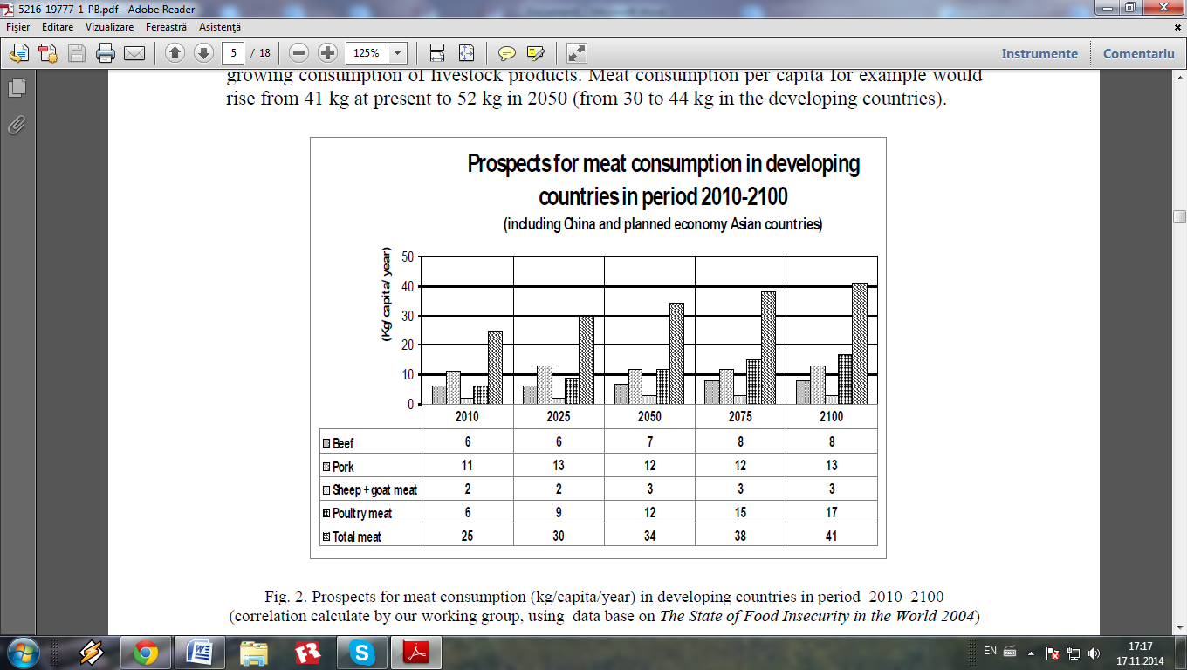

Fig. 2. Prospects for meat consumption (kg/capita/year) in developing countries in period 2010 – 2100 ( correlation calculate by Alexandru T. Bogdan, Radu Burlacu, Ion Surdu and our working group, using bata base on The State o Food Insecurity in the World 2004)

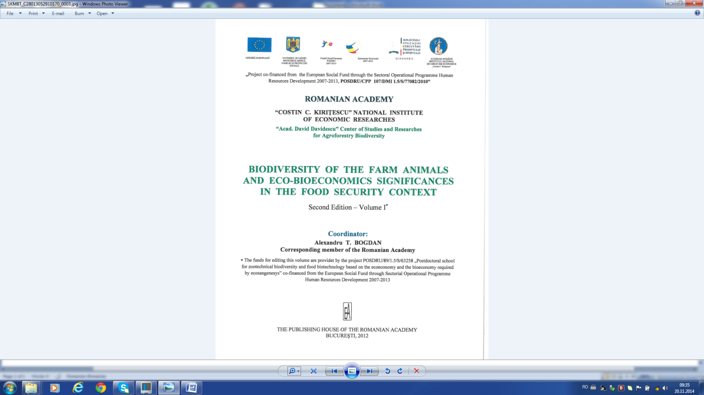 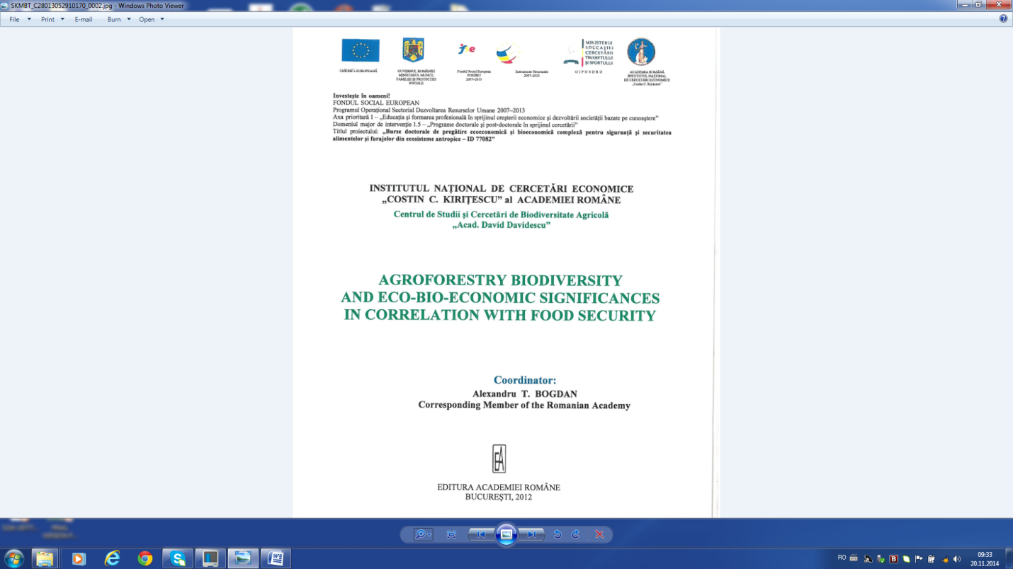

**SECOND PART**

**SCIENTIFIC AND PROFESSIONAL ACHIEVEMENTS,  EVOLUTION AND CAREER DEVELOPMENT PLANS**

**SECTION I**

**“ THEMATIC DIRECTIONS** **FOR PROFESSIONAL, SCIENTIFIC**

**AND ACADEMIC PERFORMANCES OBTAINED**

**IN THE FIELDS OF REPRODUCTION IN FARM ANIMALS**

AND IN **VETERINARY REPRODUCTION ”**

In Section I, named „Thematic directions for professional, scientific and academic performances obtained in the fields of reproduction in farm animals and in veterinary reproduction”, on 30 pages, 7 tables and 25 figures are presented in a total 10 thematic directions, 5 disciplinary and 5 interdisciplinary : 1). Veterinary Gynecology; 2). Veterinary Andrology; 3). Veterinary Obstetrics; 4). Veterinary Infant animal care; 5). Nuclear medicine veterinary and those 5 more interdisciplinary thematic directions: 6). Bio-economy, biodiversity and bioresourcs breeding farm animals; 7). Eco-economy, ecology and ecopathology breeding of farm animals; 8). Eco-bioeconomy, eco-biomanagement and eco-biomarketing of farm animals; 9). Eco-bio-geoeconomy, eco-bio-geostrategies and eco-bio-geo-solutions in indices dynamic for breeding farm animals; 10). Rethinking smarter for eco-bio-geo-political work necessary to food safety and security, which include their original results obtained by biochemical methods (eg. hormonal profile and metabolic profile in animals breeding; biochemistry spermiograms; ovocitograme and biochemical zigotograme); biophysical methods (eg. electron microscopy in gametes cryopreservation and thyroid scintigraphy in the lactation physiology of cattle breeding); citohistologice methods (eg. anteropituitary citohistotopochemistry of farm animals). Original research presented in the first 5 disciplinary thematic directions were and are confirmed that the current scientific work supported at international level by me and published, based on rigorous scientific professional selection, made by international personalities at World Congresses of Reproduction and Artificial Insemination, from Paris (1968) and from Munich (1972) and the International Conference of Biotechnology of Reproduction in Munich (1970), Cadarache near Marseille (1974) and Cambridge (1991), including the World Congress of Veterinary Medicine in Moscow (1979) etc. They also, were and are confirmed as scientific priorities at international level, with over 10 patents, which are first author (eg. uterine biopsy instruments for cows and sows; artificial vagin for biotech semen colection from breeding stallions and boars; insulated glass to dilute semen from breeding rams, boars and cocks; device for zygotes biotechnological transfer in cows; methods and recipes for frozen semen from breeding boars and cocks etc.). For the other five interdisciplinary thematic directions, the personal original results were and are especially presented and published in several international congresses, symposia and conferences organized in the Romanian Academy, in the Academy of Agricultural and Forestry Sciences and in the Academy of Medical Sciences and abroad to Athena (2010), Cambridge (2011), Palma de Mallorca (2011), Venice (2012) by WSEAS and known international event named Green Week in Berlin from 2011 to 2013 etc.

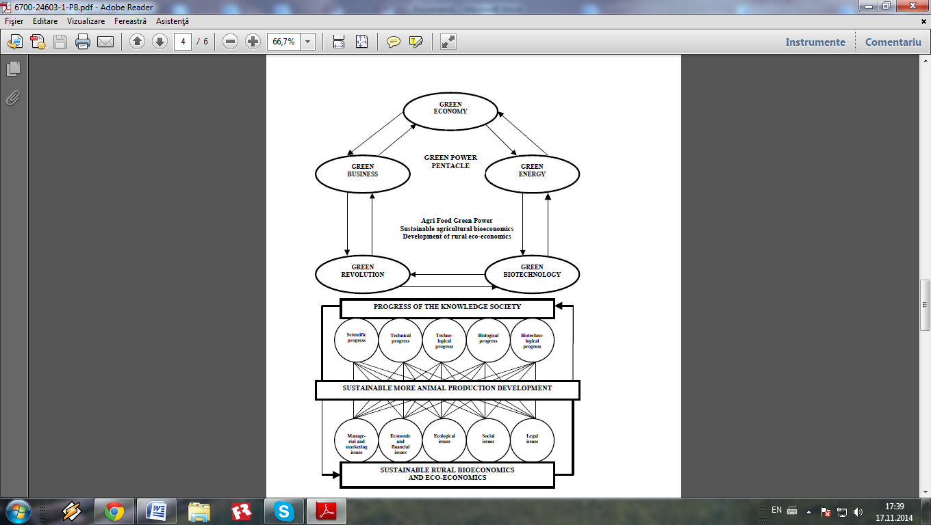

Fig. 3. The components of the Green Power pentacle, correlated with sustainable more animal production development based on sustainable rural bioeconomics and eco-economics

(orig. Alexandru T. Bogdan, Dorina Bogdan and Amalia Străteanu - 2007)

All these prestigious international scientific events, both I and my collaborators from my working group presented original scientific results obtained in two's international POSDRU projects, ID 63258 "Postdoctoral school for zootechnical biodiversity and food biotehnology based on the eco-economy and the bio-economy required by eco-sanogenesys” and ID 77082 "Doctoral Scholarships for eco-economy and bioeconomic complex training to ensure the food and feed safety and security of anthropogenic ecosystems” obtained in the competitive system, with funded by the European post-accession. These two projects were conducted with experts from Center for Studies and Research in Agroforestry Biodiversity "Acad. David Davidescu", from National Institute for Economic Research of the Romanian Academy. This center was organized by me in 2001 through activity of Senior research as a laboratory for „Biotechnology of reproduction” and I leads it like director since 2006. Thus, we created new concepts integrated "agrifood green power", "rural eco-bioeconomy" "smart eco-bio-geo-economy" „eco-geoeconomics integrated bioplatforms” „eco-bio-diplomacy” „integrated enviromental health” etc. which have been accepted for publication in several journals indexed ISI.

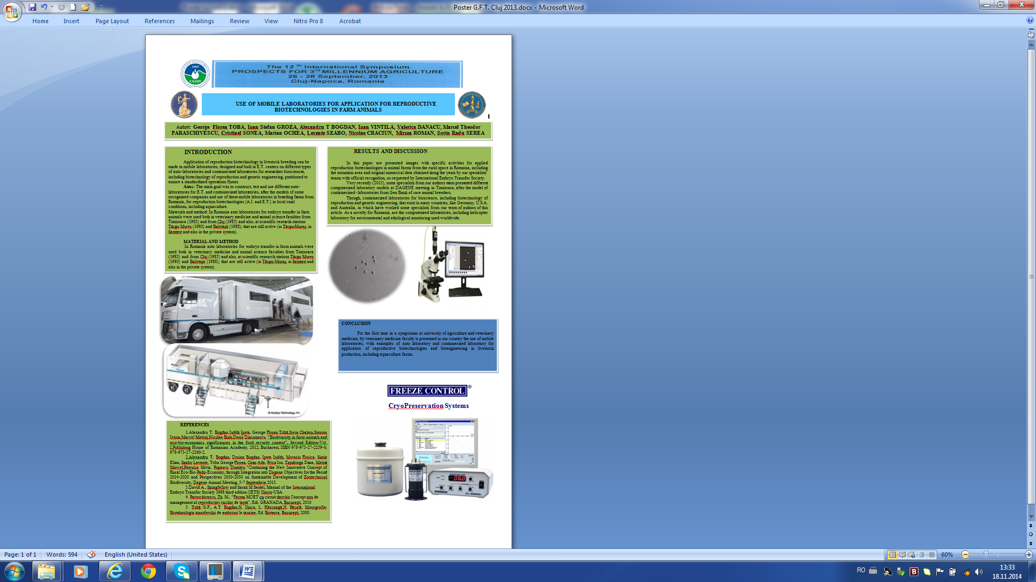

Habilitation thesis constitutes a mirror of career paths, scientific achievements represented by articles and books, which are found in the list of publications of the researcher, working in the Romanian Academy, in the Center for Studies and Research in Agroforestry Biodiversity "Acad. David Davidescu"

By structure, Habilitation thesis reflects the research and teaching across the candidate presenting objectives and outcomes after obtaining PhD in Veterinary Medical Sciences.

The targets of the Biodiversity Center is the durable exploitation of animal genetic resources, the conservation of animal genetic biodiversity, the realization of a biotechnological bank of Animal Genetic Resources (AGR) of preserving the genetic background of farm animals by applying modern reproductive biotechnologies. We will pursue the realization of two objectives: analysis objectives, description of animal genetic resources, which group the rules for investigation and surveillance, a genetic evaluation of rare characters and experimental objectives, of conservation of the animal genetic resources by applying reproduction biotechnologies and using the methodology specific to obtaining, handling and freezing the sperm; obtaining, cultivating and freezing eggs and embryos. We consider it is obvious that any kind of forecasting or prospective study regarding the dynamic of agro-food production on a period of several decades (in our study the interval is 2010-2050-2100) must begin with the presentation of the population dynamic at global and regional levels.

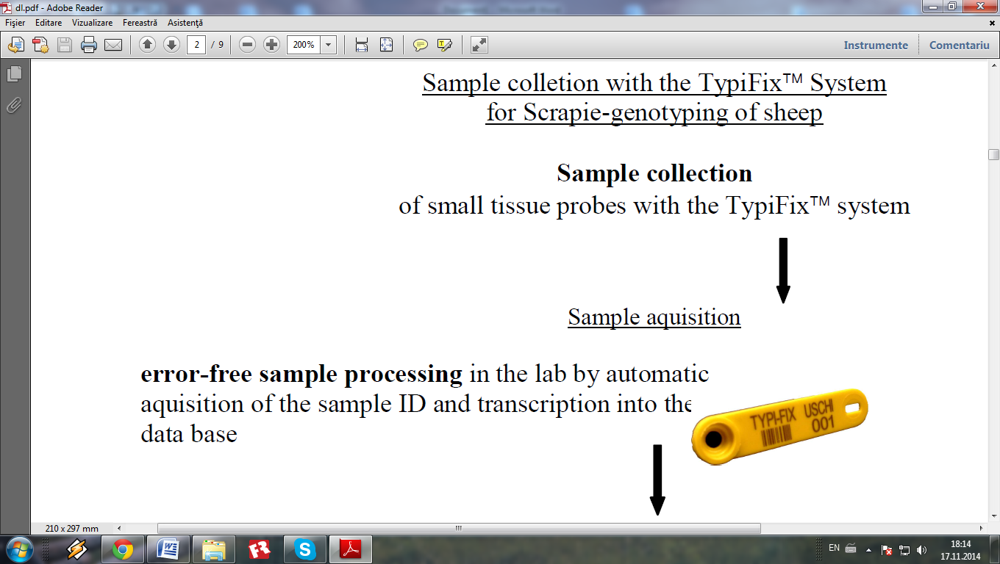

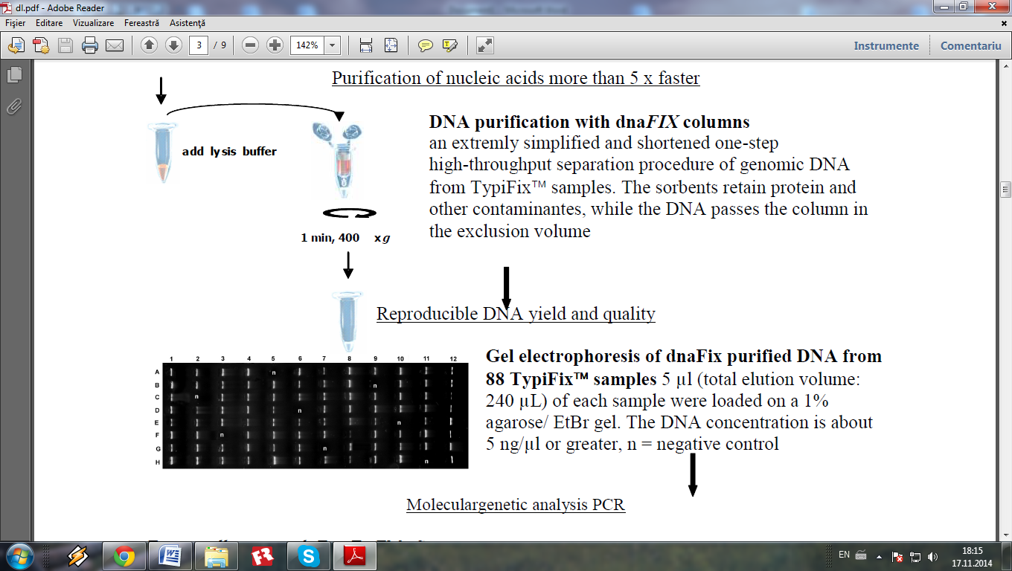

Tab. 1

DNA profile of pig samples obtained by analysis of 5 microsatellite markers

(S0386, SW24, SW240, SW857, SW951) and results of identity control

(after Alexandru T. Bogdan, Ipate Iudith and al., 2009 )

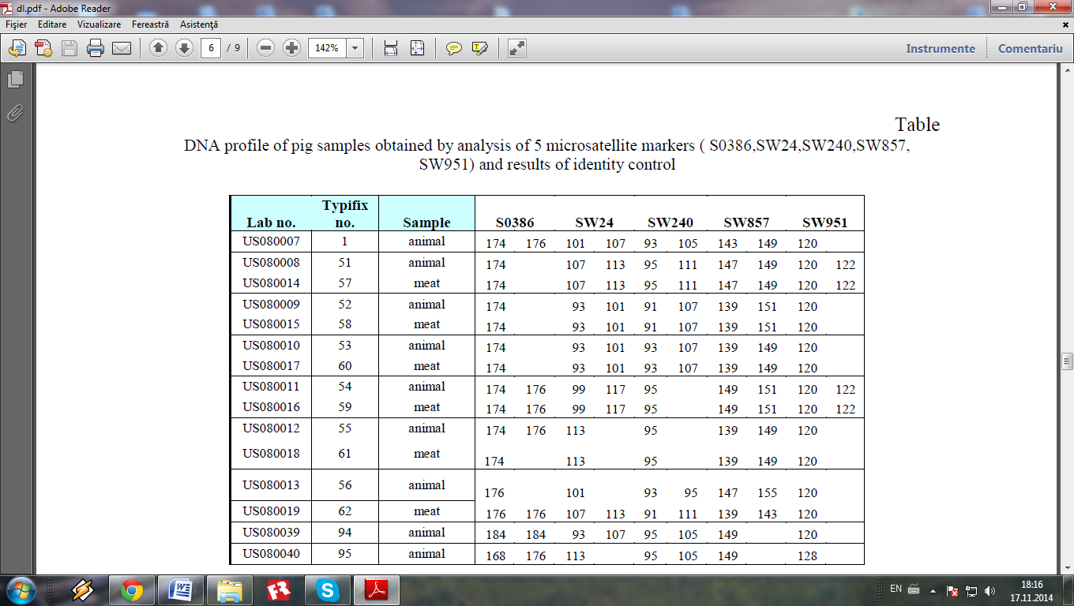

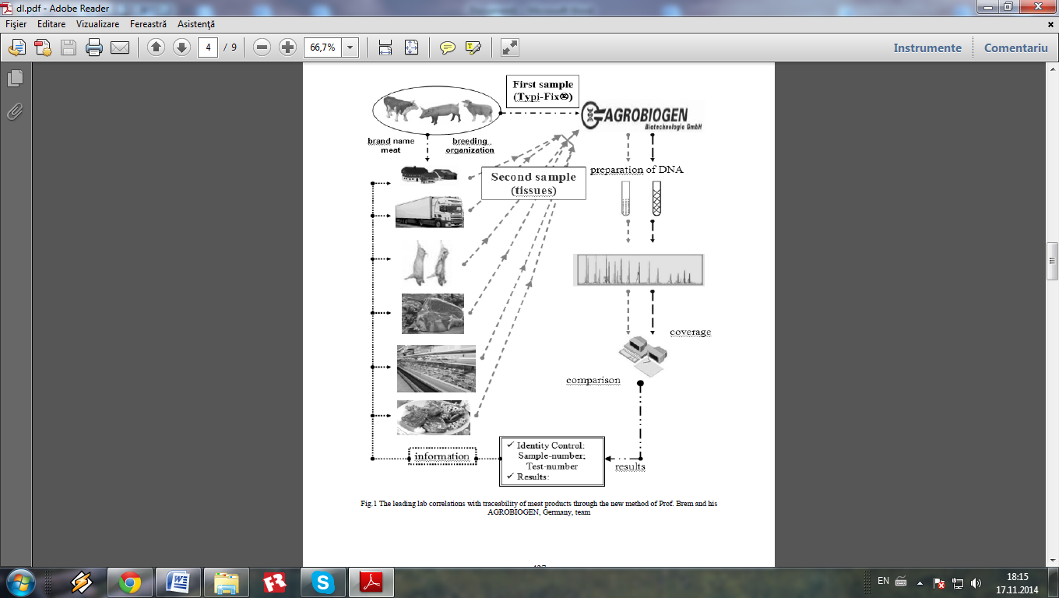

Fig. 4. The leading lab correlations with traceability of meat products through the new method of Prof. G. Brem and his team from AGROBIOGEN, Germany

(image obtaine in 2008 by Prof. A.T. Bogdan)

We consider it is obvious that any kind of forecasting or prospective study regarding the dynamic of agro-food production on a period of several decades (in our study the interval is 2010-2050-2100) must begin with the presentation of the population dynamic at global and regional levels. It is a known fact that population statistics is well establish on scientific basis and as such we will present graphics and tables with the dynamic of global population levels, on the basis of the highest bibliographical sources authorized by known scientific documentation (for example the UN Department for Population).

World livestock production has been analyzed in parallel with the official statistical data regarding the consumption of agro food products and nutrients respectively, as forecast up to 2050–2100 and correlated with population growth, production and consumption demands for vegetal and animal food products, level of poverty and risks on other vulnerabilities: economic, social, environmental, reduction of natural resources, pollution, atmospheric emissions, all correlated with farm production, etc. The analyses made are characterized by: comprehensiveness, reproducibility, certitude and consistency. Average annual rates of population change show that Africa has experienced considerably faster growth than any other major area, for most of the 1950-2000 periods. Growth rates reached a higher peak in Africa (2.86%) than anywhere else—in the early 1980s, at least 15 years after growth had begun to decline in every other major area.

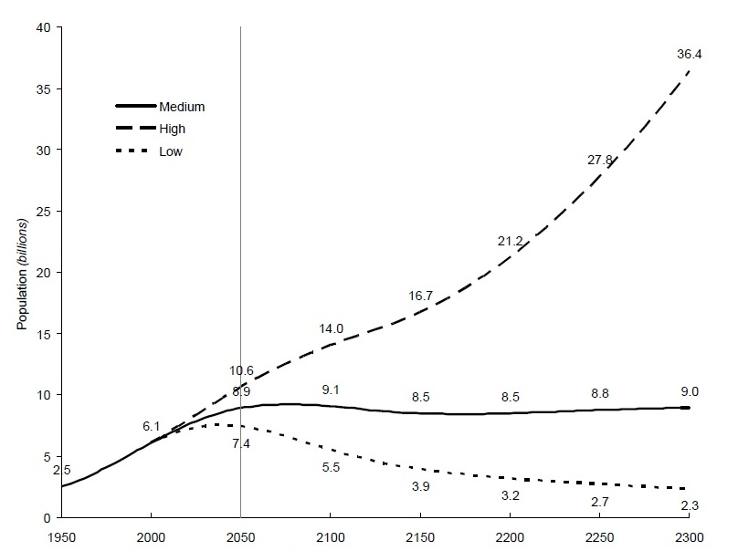

Fig. 5. Forecasting the change in world population over 50 year periods, estimates and three scenarios: 1950-2300 by United Nations, New York, 2004, Department of Economic and Social Affairs, Population Division. Note: This is the first signaling of this important study, in relation with bio-eco-economy and justifies the scientifical researches for ensuring the food of humankind on long and very long-term, ***representing stability in developing of agrifood and seafood production for globalised biopower.***

It is evident that an increasing of 1/3 of actual world population put a lot of different ethics (bio-ethics), economics (bio-economics), medical (bio-medical), ecological, juridical, and philosophical. All these aspects have a strong social impact with germinate a severe and long crisis, including agro-food crisis and unfortunately moral crisis. The projection for Africa, consequently, shows growth declining belatedly, though nevertheless following a downward path similar to that in other major areas. Europe is at the other end of the spectrum, with growth rates having just turned negative and continuing to fall up to 2050. Africa again stands out, not only because of the much lower level of life expectancy but also because it is the only major area where projections show any decline in life expectancy for any period.

For me is very important the massege of Terri Raney et al.(FAO – The State of Food and Agriculture 2009 – Food and Agriculture Organization of the United Nations– Rome, 2009). One of the key messages published in the report made by the group of experts in Rome in June 2009 is essential: “*The livestock sector is one of the most dynamic parts of the agricultural economy. The sector has expanded rapidly in recent decades and demand for livestock products is expected to continue growing strongly through the middle of this century, driven by population growth, rising affluence and urbanization”.* The global livestock sector is characterized by a dichotomy between developing agriculture, developing rural zones and developing countries.

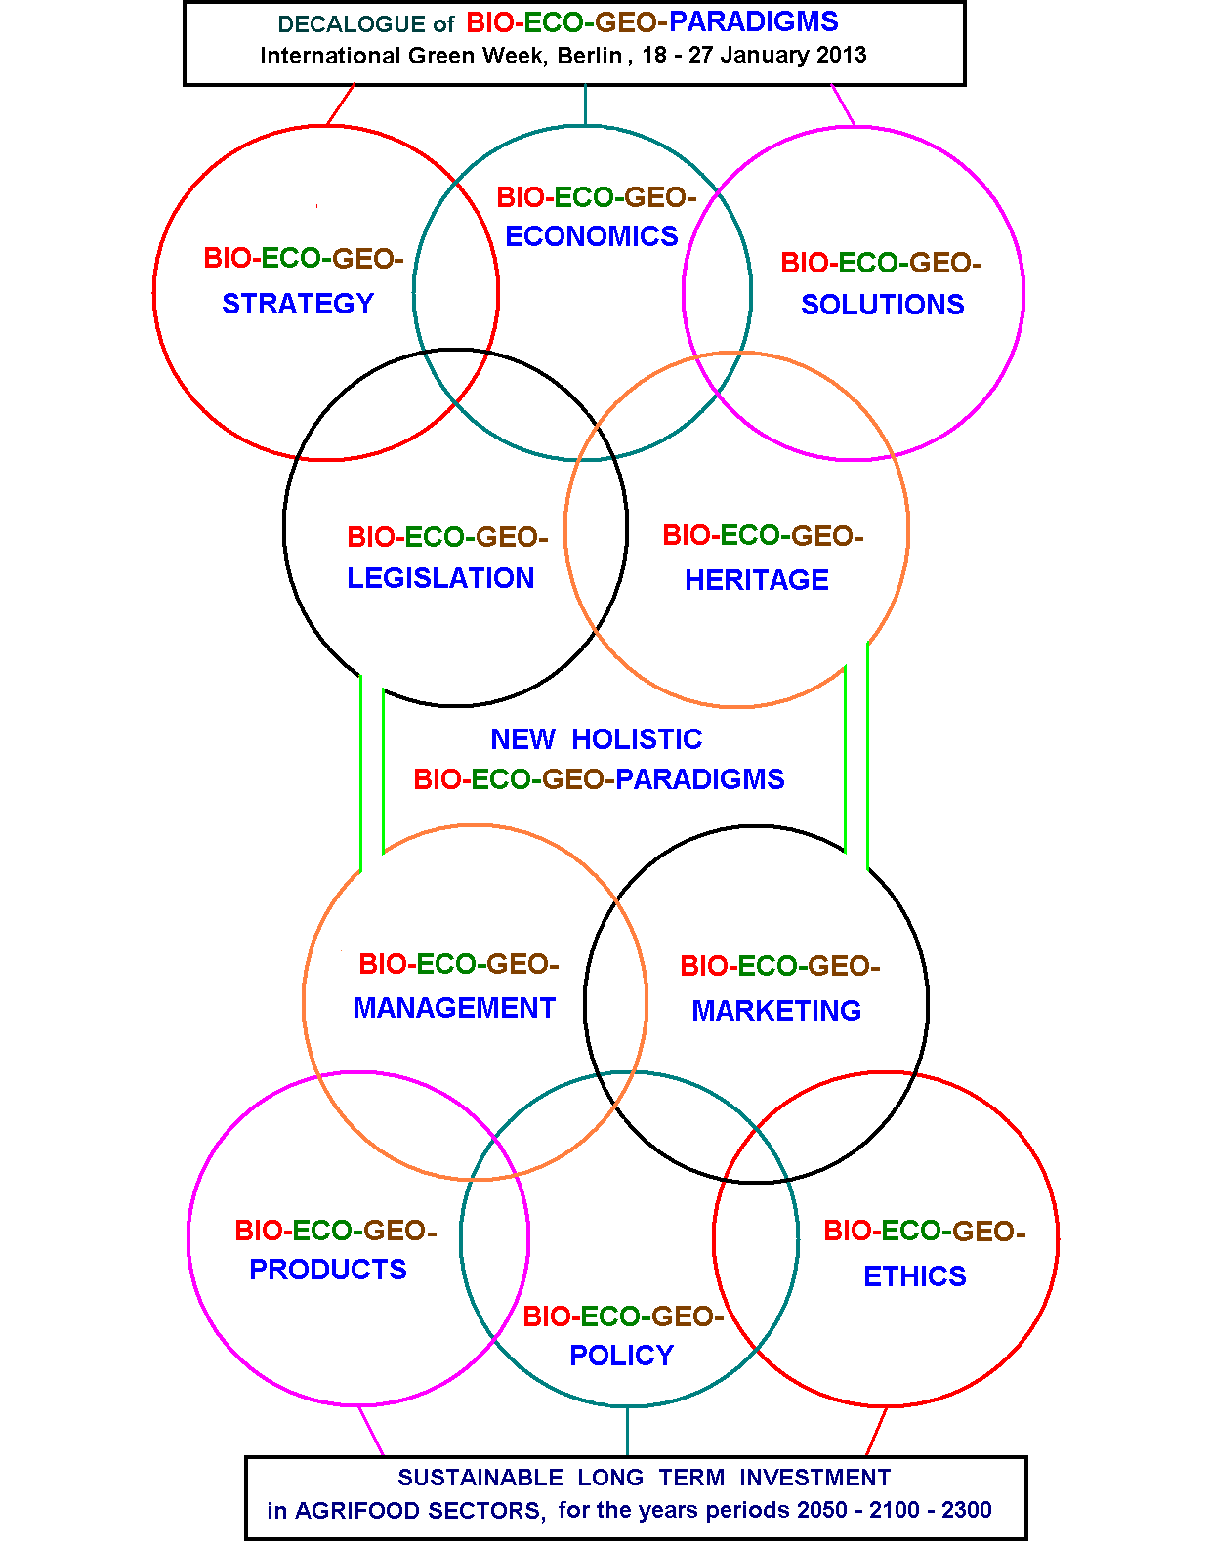

Fig. 6. New holistic Bio-Eco-Geo-Paradigms, sustainable long term investment in agrifood sectors, for the periods 2050 – 2100 – 2300

(orig. Alexandru T. Bogdan, Dorina Bogdan and Amalia Străteanu - 2013)

Decisive action is required if the sector is to satisfy this growth in ways that support society’s goals for poverty reduction and food security, environmental sustainability and improved human health. Livestock products contribute 17% to kilocalorie consumption and 33% to protein consumption globally, but there are large differences between rich and poor countries (Rosegrant *et al.,* 2009).

At the same time, the expansion of agricultural production needs to take place in a way that allows the less well-off to benefit from increased demand and that moderates its impact on the environment. Livestock systems have both positive and negative effects on the natural resource base, public health, social equity and economic growth (World Bank, 2009). Alexandru T. Bogdan`s working group, from the POSDRU project ID 63258 with title "Postdoctoral school for zootechnical biodiversity and food biotehnology based on the eco-economy and the bio-economy required by eco-sanogenesys”, composed of experts with professional background, elaborated the *priority strategic national project and integrated through recently objectives of Lisabona 2020 Strategy*, with *main objective*: sustainable development by turning into profit the elements that generate material, economic and human value. These elements are specific for the competitive poles that exist in the current rural environment of Romania. Their characteristics: vegetal and animal production, derivatives developed in good geo-climate conditions, all of these made with support from the local community (at socio-cultural level, traditions, the school profile). The result of effective solutions that reconsider and resize notions of rural society and economy, provides the economic and technical space to develop jobs both in the innovative Agro-Forestry and Zootechny-Veterinary Bio-Parks (in the business centers for rural development, produces vegetal and/or animal derivatives, bio-fuels from plant waste, makes possible the use and exploitation of alternative energy sources).

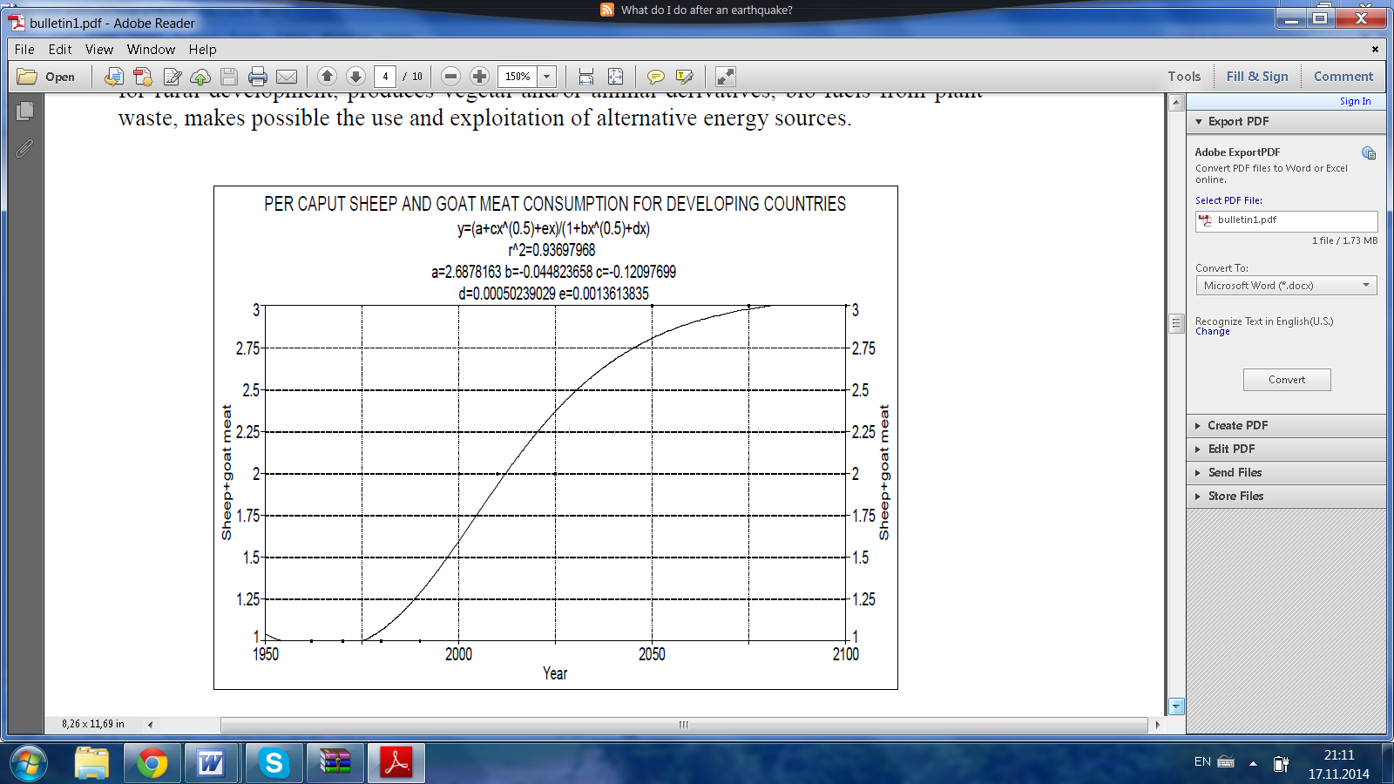

Fig. 7. Regression curve to describe the dynamic of sheep and goat meat consumption for developing countries (correlation calculate by Alexandru T. Bogdan, Radu Burlacu, Ion Surdu and our working group, using data base on *The State of Food Insecurity in the World, 2004*)

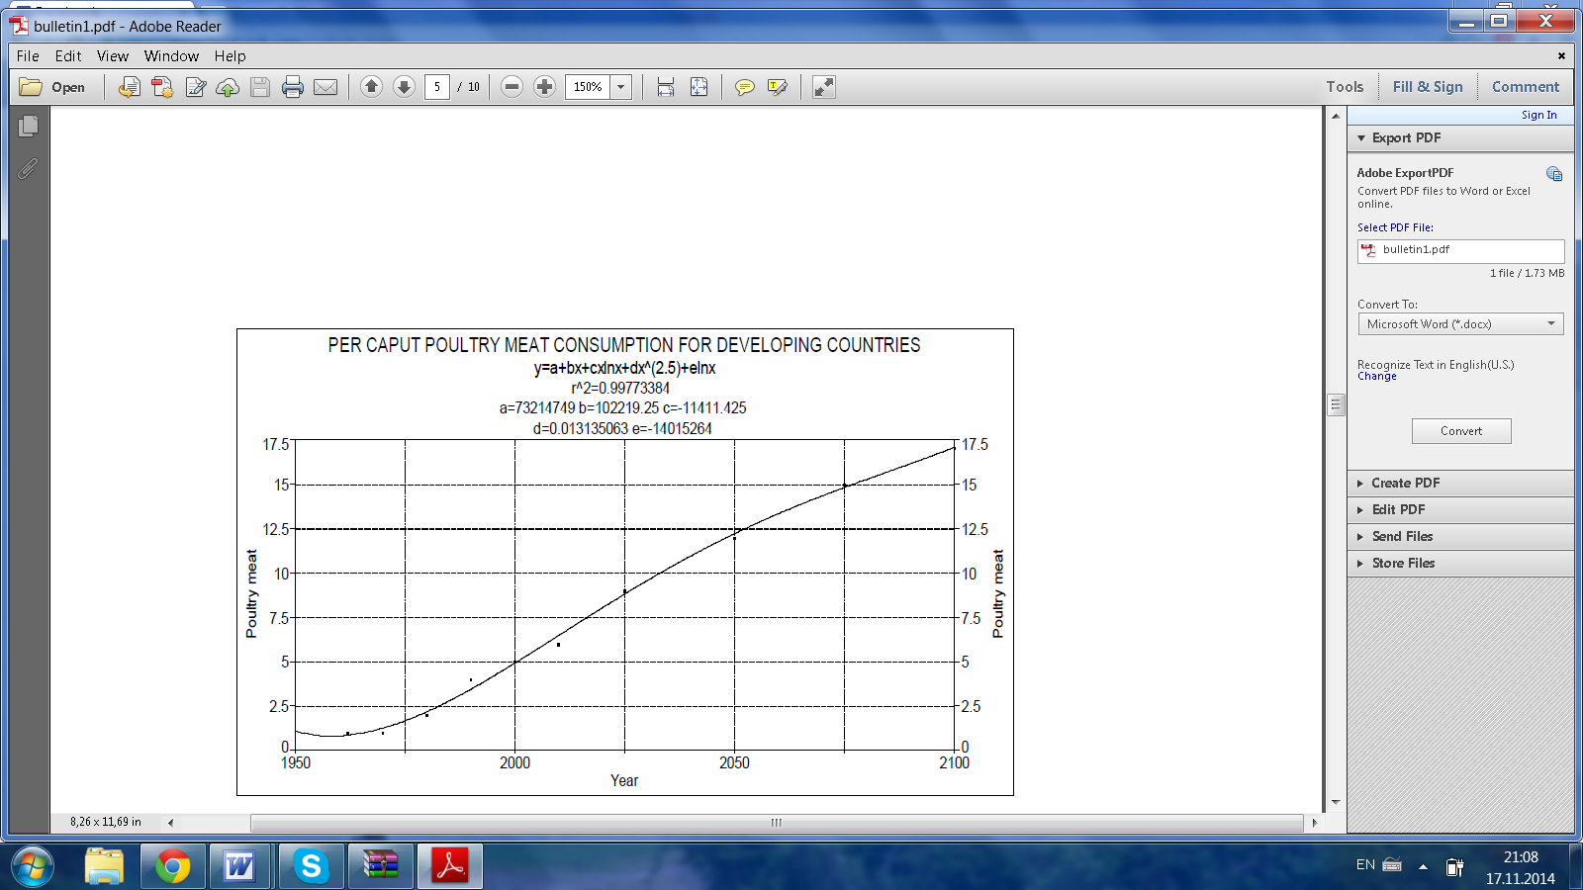

Fig. 8. Regression curve to describe the dynamic of poultry meat consumption for developing countries (correlation calculate by Alexandru T. Bogdan, Radu Burlacu, Ion Surdu and our working group, using data base on

*The State of Food Insecurity in the World, 2004*)

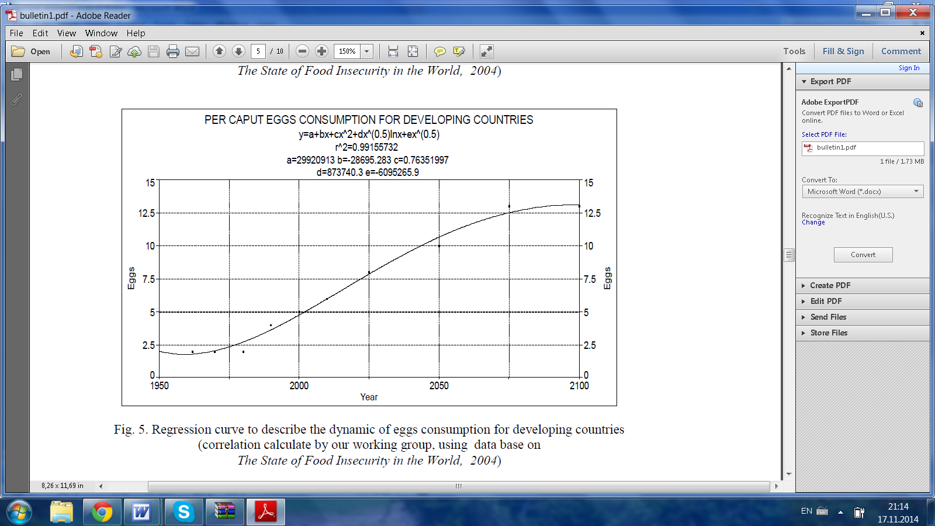

Fig. 9. Regression curve to describe the dynamic of eggs consumption for developing countries (correlation calculate by Alexandru T. Bogdan, Radu Burlacu, Ion Surdu and our working group, using data base on The State of Food Insecurity in the World, 2004)

The assessments presented have a calculation model as a basis as used by Rosegrant *et al.* on the basis of certain indicators obtained by processing statistical date from 2001, 2002, 2005, as published by FAO in the Reports and periodicals from 2007 to 2009.

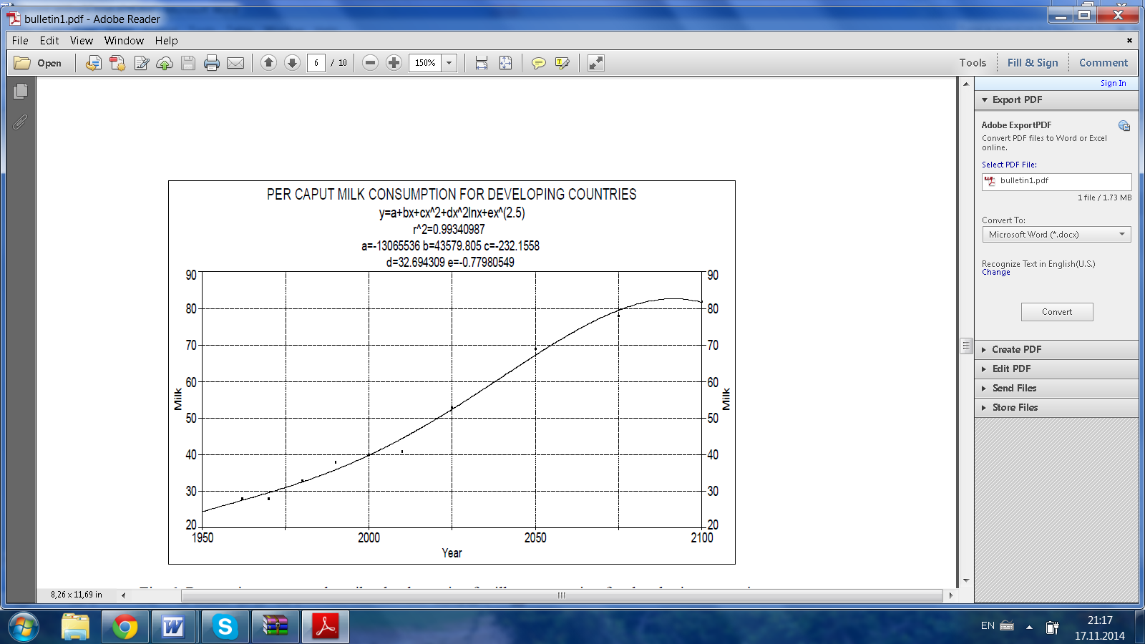

Fig. 10. Regression curve to describe the dynamic of milk consumption for developing countries (correlation calculate by Alexandru T. Bogdan, Radu Burlacu, Ion Surdu and our working group, using data base on *The State of Food Insecurity in the World, 2004*)

Tab. 2

The resulted “more animal production” potential of Romanian agriculture expressed by livestock and meat production of the 2025 year (orig. from AGRAL Project about Livestock Production in Romania for the periode 2005-2025, coodonating by Alexandru T. Bogdan, Dorina Bogdan and Amalia Străteanu – 2003)

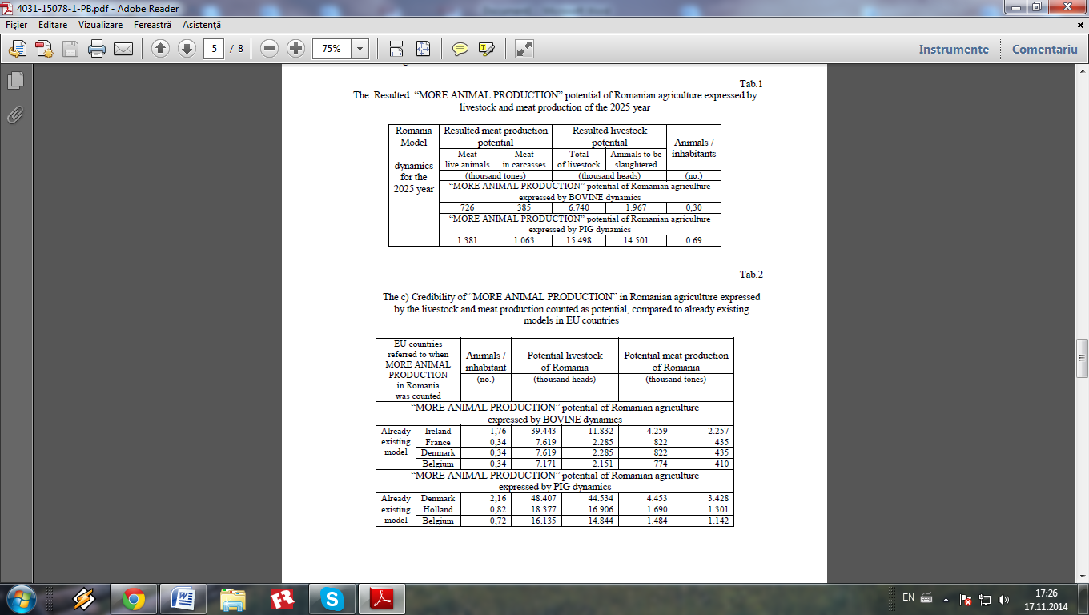

Tab.3

The credibility of “more animal production” in Romanian agriculture expressed

by the livestock and meat production counted as potential, compared to already existing models in UE countries (orig. from AGRAL Project about Livestock Production in Romania for the periode 2005-2025, coodonating by Alexandru T. Bogdan, Dorina Bogdan and Amalia Străteanu, 2003)



Tab. 4

The credibility of “more animal production” in Romanian agriculture expressed

by the livestock and milk production counted as potential, comparing to already existing models in UE countries (orig. from AGRAL Project about Livestock Production in Romania for the periode 2005-2025, coodonating by Alexandru T. Bogdan, Dorina Bogdan and Amalia Străteanu – 2003)

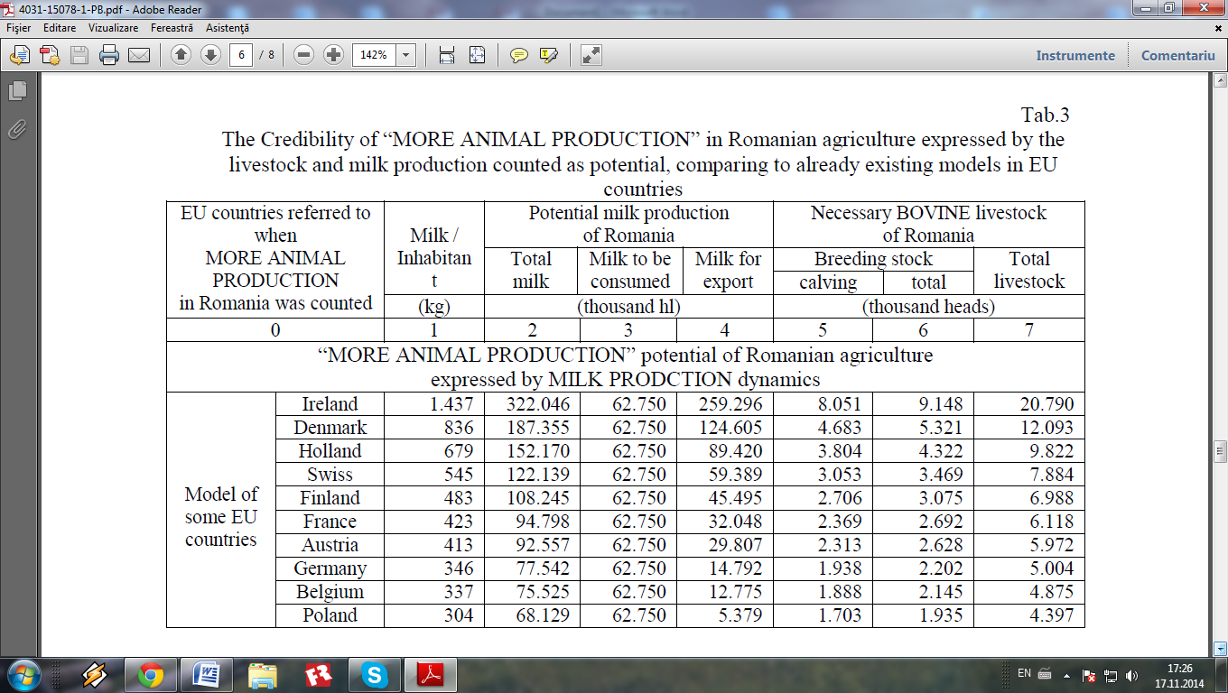

Tab.5.

Prospects and forecasting for populations and livestock products in period 2010-2100 data base from developing countries communicated by FAO, Land and Water Bulletin 6, Roma, 1997, A.F. Bouwman, and by N. Alexandratos MID FAO, 2009, World foods and agriculture to 2030/2050; selected dates and % calculation from our working group

|  |  |  |  |  |  |  |  |
| --- | --- | --- | --- | --- | --- | --- | --- |
| Region | Developing including China and CP Asian countries | | | | | | |
| Item | UM | 2010 | 2025 | 2050 | 2075 | 2100 | |
| Quantity  (UM) | % from  2010 |
| 0 | 1 | 2 | 3 | 4 | 5 | 6 | 7 |
| Population | Mil | 5619 | 6802 | 8327 | 8917 | 9569 | 170,30% |
| Beef | Kg/cap/year | 6 | 6 | 7 | 8 | 8 | 133,33% |
| Pork | Kg/cap/year | 11 | 13 | 12 | 12 | 13 | 118,18% |
| Sheep + goat meat | Kg/cap/year | 2 | 2 | 3 | 3 | 3 | 150,00% |
| Poultry meat | Kg/cap/year | 6 | 9 | 12 | 15 | 17 | 283,33% |
| Total meat | Kg/cap/year | 25 | 30 | 34 | 38 | 41 | 164,00% |
| Eggs | Kg/cap/year | 6 | 8 | 10 | 13 | 13 | 216,67% |
| Milk | Kg/cap/year | 41 | 53 | 69 | 78 | 82 | 200,00% |

Tab. 6.

Prospects and forecasting for populations and livestock products in period 2010-2100 data base from Latin America Region communicated by FAO, Land and Water Bulletin 6, Roma, 1997, A.F. Bouwman, and by N. Alexandratos MID, FAO, 2009, World foods and agriculture to 2030 **/** 2050; selected dates and % calculation from our working group

|  |  |  |  |  |  |  |  |
| --- | --- | --- | --- | --- | --- | --- | --- |
| Region | Latin America | | | | | | |
| Item | UM | 2010 | 2025 | 2050 | 2075 | 2100 | |
| Quantity  (UM) | % from  2010 |
| 0 | 1 | 2 | 3 | 4 | 5 | 6 | 7 |
| Population | mil | 596 | 701 | 829 | 856 | 883 | 148,15% |
| Beef | Kg/cap/year | 22 | 21 | 20 | 20 | 19 | 86,36% |
| Pork | Kg/cap/year | 9 | 12 | 15 | 19 | 23 | 255,56% |
| Sheep + goat  Meat | Kg/cap/year | 1 | 1 | 1 | 1 | 1 | 100,00% |
| Poultry meat | Kg/cap/year | 17 | 21 | 27 | 33 | 38 | 223,53% |
| Total meat | Kg/cap/year | 49 | 54 | 63 | 73 | 81 | 165,31% |
| Eggs | Kg/cap/year | 9 | 11 | 14 | 17 | 20 | 222,22% |
| Milk | Kg/cap/year | 96 | 103 | 114 | 126 | 136 | 141,67% |

There will be significant progress in raising food consumption levels and improving nutrition. There will be significant reductions in the relative prevalence of undernourishment (percent of population affected), but these will not be translated into commensurate declines in the numbers undernourished because of population growth. Reduction in the absolute numbers of undernourished is likely to be a slow process. The number of undernourished in the developing countries is not likely to be halved by 2015 from the 823 million of 1990/92 (the 3-year average used as the basis for defining the World Food Summit target). However, the *proportion* of the population undernourished may be halved by 2015 and decline further in the rest of the projection period. The our projected slow progress in reducing undernourishment will reflect the inadequate progress of many countries towards rapid economic development and poverty reduction. However, empirical evidence suggests that in the countries with high dependence on agriculture, assigning priority to the development of food production holds promise of overcoming the constraint to better nutrition represented by unfavorable overall economic growth prospects. This prospect underlies the projection that the countries with long histories of stagnant food consumption levels and high undernourishment could make some progress in the future. Poor agricultural resources may represent a serious obstacle to such prospects, particularly in countries with high demographic growth. Despite this slow pace of progress in reducing the prevalence of undernourishment, the projections imply a considerable overall improvement. In the developing countries the numbers of well fed (i.e. not classified as undernourished according to the criteria used here) could increase from 3.9 billion in 1999/01 (83% of their population) to 5.2 billion in 2015 (90% of the population), to 6.2 billion (93%) in 2030 and to 7.2 billion (96%) by 2050. That would be no mean achievement.

In many countries, including some of the more populous ones, the relative prevalence of undernourishment (percent of the population) will decline significantly. Fewer countries than at present will have high levels of undernourishment, none of them in the most populous class. The problem of undernourishment will tend to become smaller in terms of both absolute numbers affected and, even more, in relative terms, hence it will become more tractable through policy interventions, both national and international.

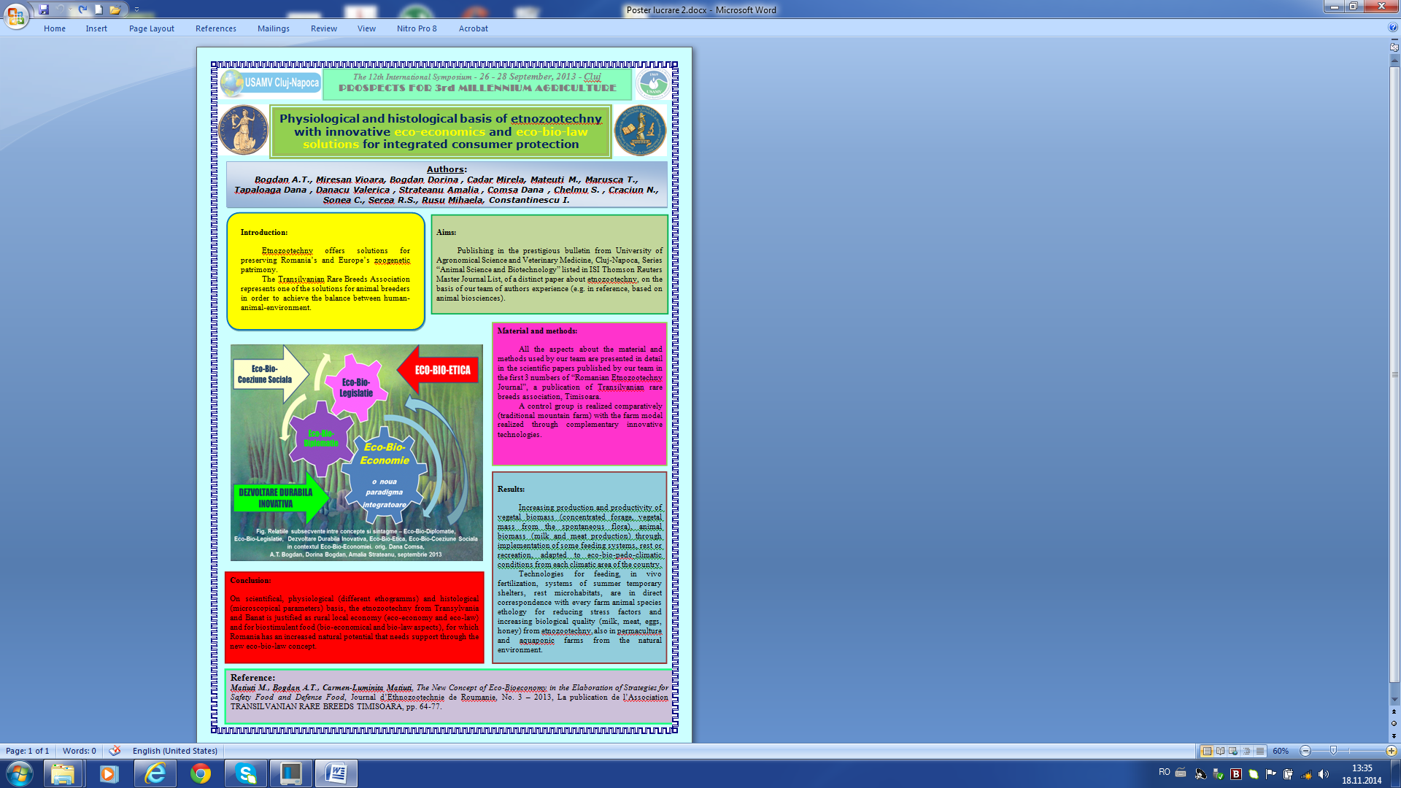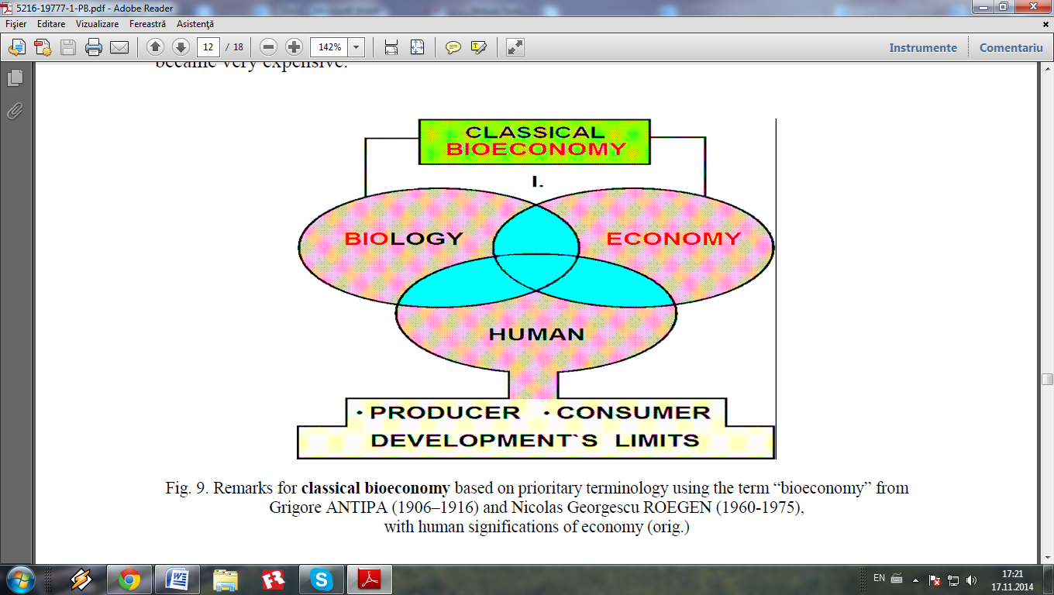

Fig. 11. Remarks for classical bioeconomy based on prioritary terminology using the term “bioeconomy” from Grigore ANTIPA (1906-1916) and Nicolas GEORGESCU ROEGEN (1960-1975), with human significantions of economy

(orig. Alexandru T. Bogdan, Dorina Bogdan and Amalia Străteanu – 2006)

The livestock sector plays a crucial role in the provision of global public goods and services. There are opportunities to alleviate many of the risks associated with the expanding sector and to develop its full potential in ensuring benefits for the poor with a gender equality perspective, and to encourage a more responsible use of increasingly scarce inputs and natural resources. This will require dynamic generation and adoption of new technologies, products and services as well as networks and institutional development within an enabling policy and regulatory environment. The vigorous growth of the livestock sector, its importance for income generation, food security, human nutrition and health, and its impact on various public goods and services require careful attention by the international community.

The new concept of Eco-bioeconomy

Bio-economy, a concept elaborated and promoted by Nicholas Georgescu-Roegen (1906-1994) resulted in a theory which represents a revolutionary way inside economic concepts. Contrary to the previous way of thinking, theory of bioeconomy placed the industrial revolution and technical progress on one side and live world evolution and ecology on the other side. Such way N. Georgescu- Roegen, the economist with Romanian origins, got a decisive clarification with clear connotations in contemporary political economy.

The Green power is amplified by biodiversity. It is obvious that a sustainable economy of the future has to become a bio-economy, adapted to the rural area and based on a large biodiversity that will create first of all an opportunity for more producers of primary organic synthesis and further on for a longer line of consumers up to the final state of dead organic matter that must be mineralized. In this context, Nicolas Georgescu-Roeger’s worldwide-known bioeconomics paradigm of improving the agricultural efficiency becomes most topical, particularly as mankind’s limited natural resources are being depleted.

Besides these new concepts presented so far, Academic Alexandru T. Bogdan comes with a new concept presented in his paper *Eco-physiological aspects of the traditional product (slow) Food and its Eco-Bioeconomics impact* at the International Symposium of Veterinary Medicine in Cluj-Napoca in 2011. In this paper which have to do with meat and milk products, it is very much highlighted the importance of obtaining animal products of a very good quality. This quality cannot be obtained unless one uses inclusive from local breeds.

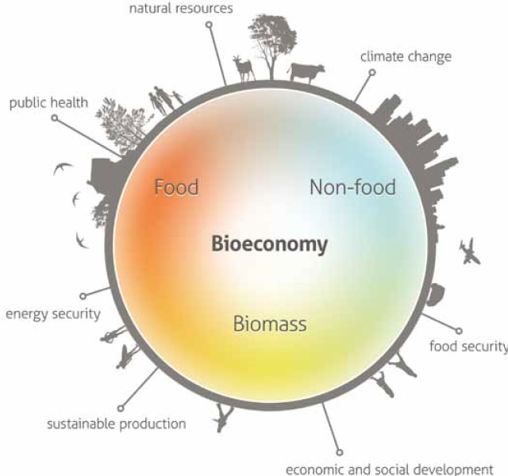

The Bioeconomy refers to the sustainable production and conversion of biomass into a range of food, health, fibre and industrial products and energy. Renewable biomass encompasses any biological material (agriculture, forestry and animal-based including fish) as a product in itself or to be used as raw material. In many congreses, symposia and round tables organised in the last years, on all continents, in all countries and well-known institutions through their researches, both fundamental and applied, the next principles and objectives have been outlined:

Fig. 12. The European Bioeconomy from The European Bioeconomy in 2030, p. 6.

New holistic approach of ecoeconomics theories. In the last 30 years, and especially over the last 12 years, in the world speciality literature, through the complexity, depth and originality of innovative approaches of relationships between ecology and economy, another american scientist imposed – Lester R. Brown, founder of the well-known Worldwatch Institute and Earth Policy Institute, being also chosen member of the Romanian Academy. Through his book, entitled “Eco-Economy: Building an Economy for the Earth”, published in 2001 and translated in over 25 languages, spoken on every meridian of the world, the Romanian Academy member Lester R. Brown is unanimously recognized as the father of the new concept/paradigm of ecoeconomy. Recently, he published the book “Full Planet, Empty Plates: The New Geopolitics of Food Scarcity”, in which considers, with scientifical, geostrategical and social-economical arguments that the humankind already entered a new era, that of chronic shortage of food, thus considering that “the agricultural land (the soils) represents the new gold and the food is the new oil”. In this context, the author senses corectly the contradiction between the limited natural resources of the Earth and using the agricultural land for production of biofuels, being very well documented on new challenges and opportunities of the agro-food globalized crises.

Bridging between green economy and blue economy. In the current conditions, of unpermitted growth of numerous and varied major pollutant factors in all anthropic ecosystems, from those local to those regional and globalized, scientists and an important part of the responsible civil society fights vigorously and with plausible arguments for a sustainable development of the humankind through green economy and performant, but clean technologies. This green economy is based on green energy, green technologies, green business and green industries, that in agriculture led to the success application of the “green revolution” principle elaborated by Norman Borlaug. Today, the green economy is expanding in the European Union and at global level through clean technologies, with green energy produced, for example, through wind turbines and biofuels.

In agriculture industry, the green economy uses different plant types and animal breeds, with high genetic performances in bioconversion of solar energy in vegetal biomass and then, through the food chain from agroecosystems, based on agrobiodiversity, agrifood green power increases through bioconversion of plant biomass in animal origin proteins biomass, including green products obtained in bioreactors.

Blue economy is a new concept released by Gunter Pauli, concept that is based on applying nature’s mechanisms and principles for humankind development. A few principles of this concept, selected by R.S. Serea, are presented below:

Nature responds to basic needs and then evolves from sufficiency to abundance, while the present economic model relies on scarcity as a basis for production and consumption; Nature only works with what is locally available, because sustainable business evolves with respect not only for local resources, but also for culture and tradition; Nature evolved from few species to a rich biodiversity, wealth meaning diversity, while industrial standardization is the contrary; Natural systems cascade nutrients, matter and energy – waste does not exist and any by-product is the source for a new product; in Nature one process generates multiple benefits, because Nature is efficient, so sustainable business maximizes use of available material and energy, which reduces the unit price for the consumer.

It’s obvious the fact that, from these principles, that are correct and real, a part of them are common with the principles of bio-economy established by Nicholas Georgescu-Roegen, and another part, with those of eco-economy, established by Lester R. Brown; also, there are marked differences between the approaching ways from the green economy and blue economy, especially under the aspect of excessive nonrenewable raw materials consumption, thus our group will carry on with this kind of comparative approaches for the benefit of human society development, in conditions of social inclusion and employment positive trend.

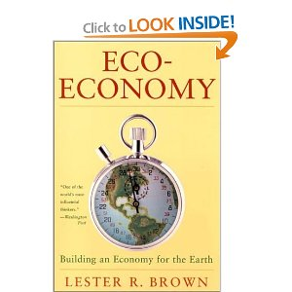 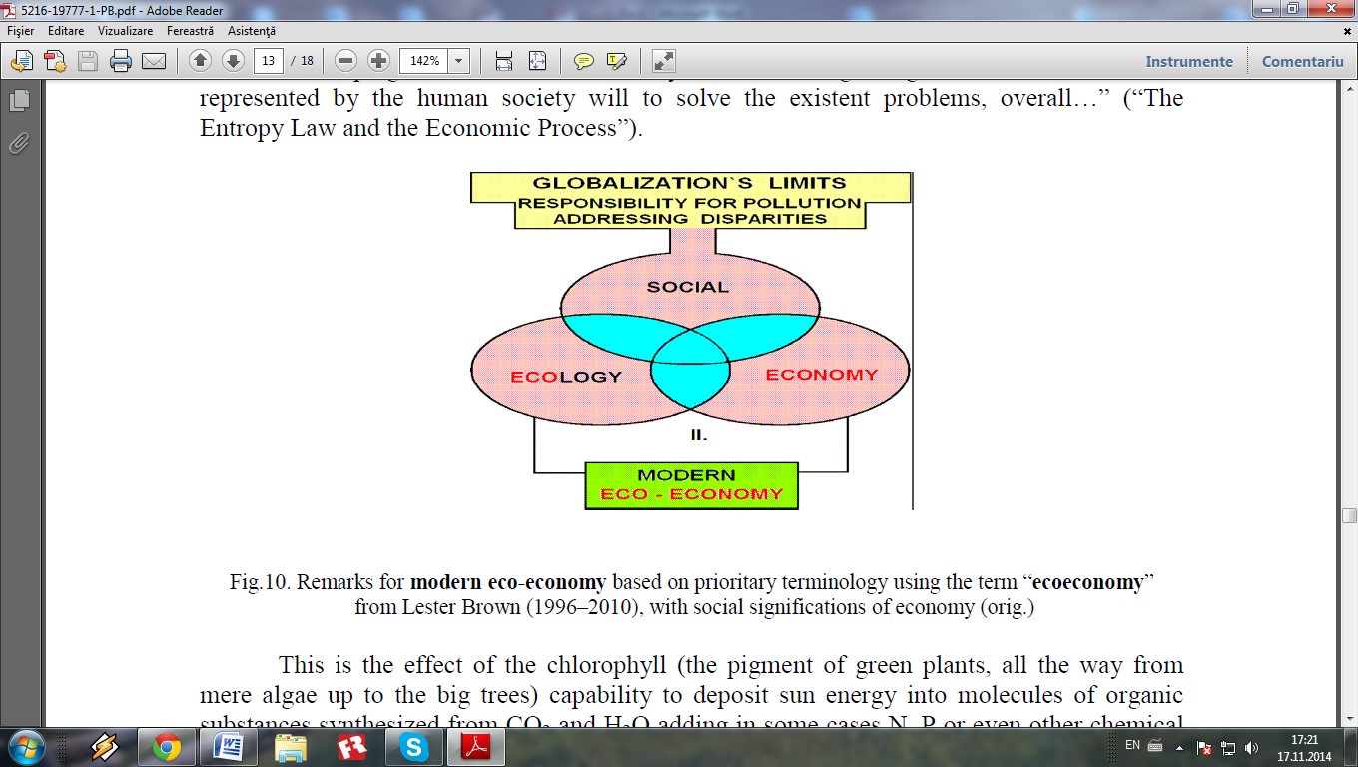

Fig. 13. Remarks for modern eco-economy based on prioritary terminology using the term “ecoeconomy” from Lester Brown, with social significantions of economy

(orig. Alexandru T. Bogdan, Dorina Bogdan and Amalia Străteanu - 2007)

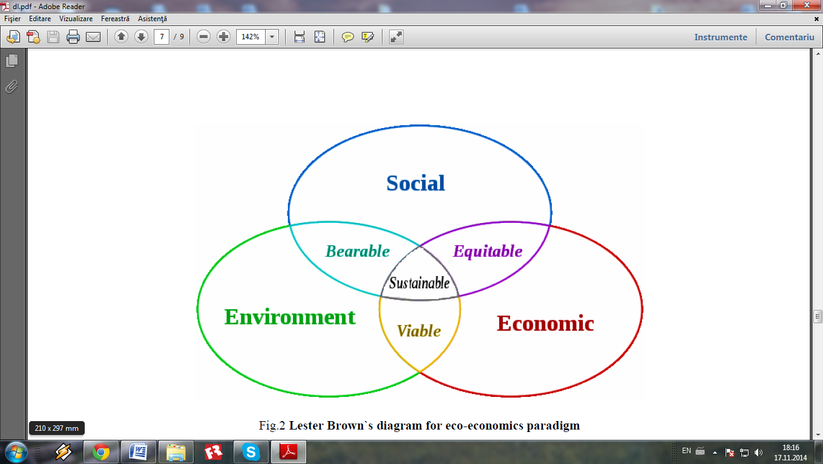

Fig. 14. Lester Brown`s diagram for eco-economy paradigm

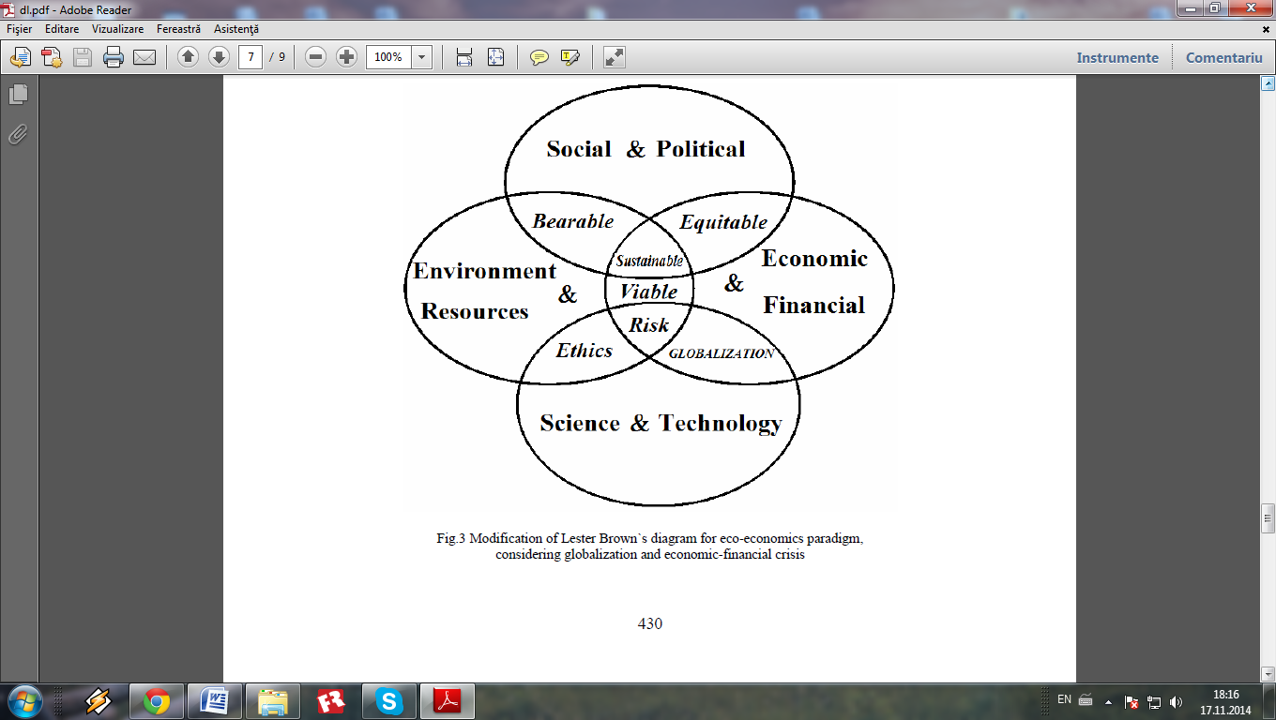

Fig. 15. Modification of Lester Brown`s diagram for eco-economics paradigm, considering globalization and economic-financial crisis

(orig. Alexandru T. Bogdan, Dorina Bogdan and Amalia Străteanu - 2007)

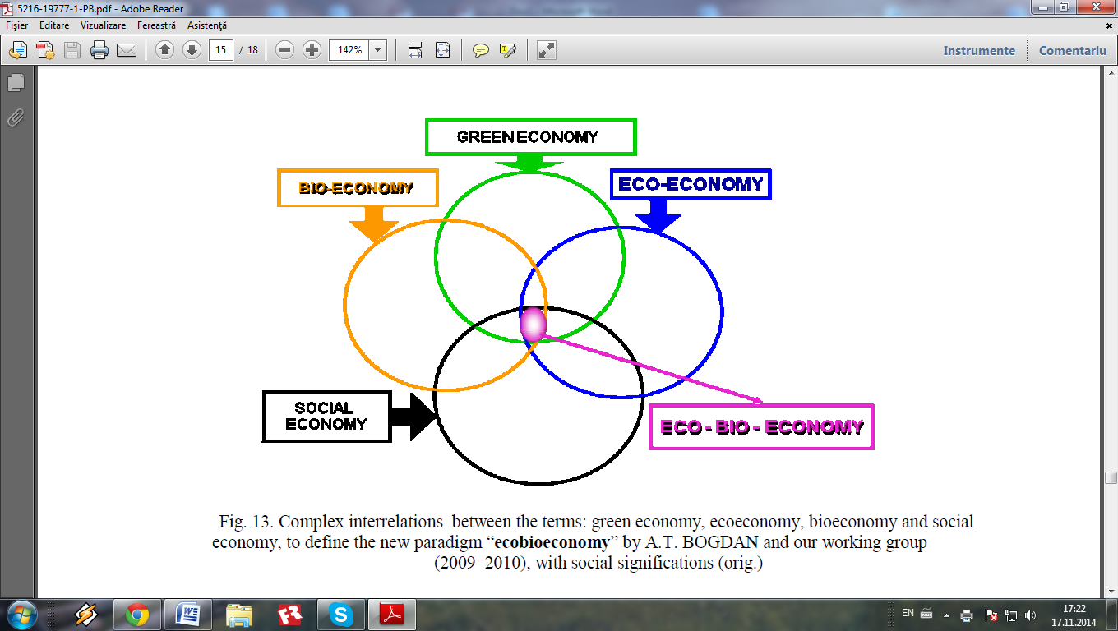

Fig. 16. Complex interrelations between the terms: green economy, ecoeconomy, bioeconomy and social economy, to define the new paradigm “eco-bio-economy” by A.T. BOGDAN and our working group (2009-2010), with social significations

(orig. Alexandru T. Bogdan, Dorina Bogdan and Amalia Străteanu - 2009)

In collaboration with colleague Dr. Marcel Matiuti and Prof. Carmen Matiuti, chemical engineer, I was co-author of several works which fall into EU bioeconomy development strategy for the period 2014-2050-2100. The scientific papers presents original concepts and strategies for development in Danube Euroregions and are relating to food safety, food defense (new term for Romania) and the possibility of ecological action of biohazardous forms. The strategies for the development of this region is very important because it values the economic, scientific, historic, environmental and multicultural capital of a population, which forms the territorial capital of the Danubian euro-region. Creating a rural web network is of major importance for rural development. This should facility farmers (including animal breeders), services and information for dissemination of best practices; all this aimed at raising the competitiveness of Danubian Euroregions. Part of the works contain results from the Euroregion of Romanian Banat  and Serbian Banat, including comparisons between them using a new science for Romania, ethnozootechny as a component of geoeconomy; were made new concepts ethno-geoeconomy and etnogastronomy. Etnozootehnia is the science which studies human-animal-environment relationship, we promoted through several works where we have introduced the new paradigm of eco-bio-geo-strategy. The ethnozootechny studies appear in the works for the application of innovative bio-economic strategy Euroregions Carpathien-Danubian-Pontic. In my work I approached the eco-physiological aspects of traditional meat products and milk in Transylvania and Banat.

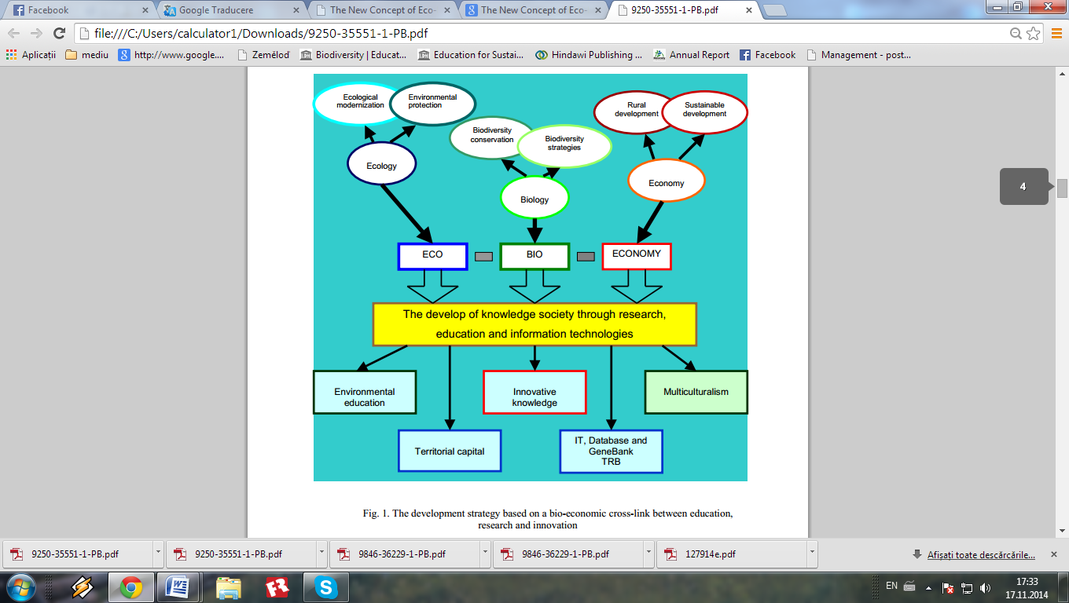

Fig. 17. The development strategy based on a bio-economic

cross-link between education, research and innovation

(orig. Marcel Matiuti, Alexandru T. Bogdan, Dorina Bogdan, Carmen Matiuti, 2012)

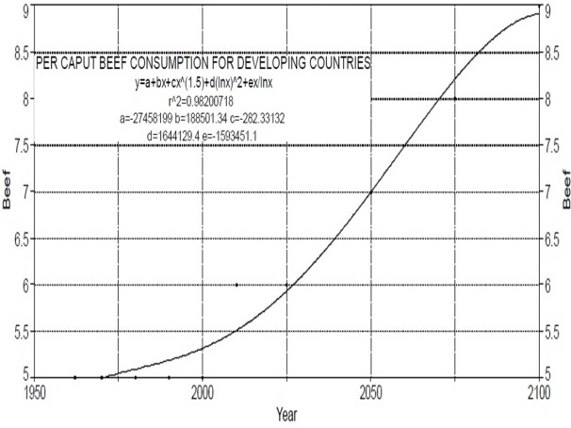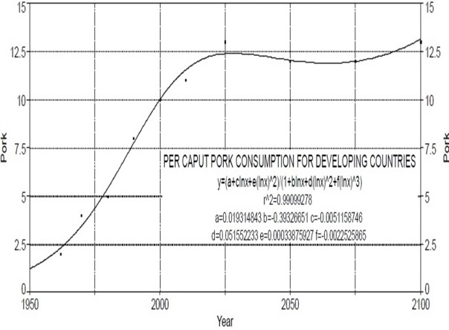

Fig. 18. Regression curve to describe the dynamic of beef and pork consumption for developing countries (correlation calculated by A.T. Bogdan, R. Burlacu, I. Surdu, using database on The State of Food Insecurity in The World, 2004).

Within National Institute of Economical Researches “Costin C. Kiritescu” there is, for many decades, a constant concern for the study and capitalization of the original scientific contributions of romanian origin american scientist Nicholas Georgescu-Roegen, demonstrated through publication, in the last 25 years of 15 volumes from the scientifical opera of the scientist, that have been edited and published under the coordination of Aurel Iancu, Romanian Academy member and professor Ion Valeriu Franc.

The objectives of Horizon 2020 programme, as core part of Europe 2020, Innovation Union & European Research Area are: responding to the economic crisis to invest in future jobs and growth; addressing people’s concerns about their livelihoods, safety and environment; strengthening the EU’s global position in research, innovation and technology.

Tab. 7.

Biotechnologies with a high probability of reaching the market by 2030

|  |  |  |
| --- | --- | --- |
| **Agriculture** | **Health** | **Industry** |
| Widespread use of marker assisted  selection (MAS) in plant, livestock, fish  and shellfish breeding. | Many new pharmaceuticals and  vaccines, based in part on  biotechnological knowledge, receiving  marketing approval each year. | Improved enzymes for a growing range  of applications in the chemical sector. |
| Genetically modified (GM) varieties of  major crops and trees with improved  starch, oil, and lignin content to improve  industrial processing and conversion  yields. | Greater use of pharmacogenetics in  clinical trials and in prescribing practice,  with a fall in the percentage of patients  eligible for treatment with a given  therapeutic. | Improved micro-organisms that can  produce an increasing number of  chemical products in one step, some of  which build on genes identified through  bioprospecting. |
| GM plants and animals for producing  pharmaceuticals and other valuable  compounds. | Improved safety and efficacy of  therapeutic treatments due to linking  pharmacogenetic data, prescribing data,  and long-term health outcomes. | Biosensors for real-time monitoring of  environmental pollutants and biometrics  for identifying people. |
| Improved varieties of major food and  feed crops with higher yield, pest  resistance and stress tolerance  developed through GM, MAS,  intragenics or cisgenesis. | Extensive screening for multiple genetic  risk factors for common diseases such  as arthritis where genetics is a  contributing cause. | High energy-density biofuels produced  from sugar cane and cellulosic sources  of biomass. |
| More diagnostics for genetic traits and  diseases of livestock, fish and shellfish. | Improved drug delivery systems from  convergence between biotechnology  and nanotechnology. | Greater market share for biomaterials  such as bioplastics, especially in niche  areas where they provide some  advantage. |
| Cloning of high-value animal breeding  stock. | New nutraceuticals, some of which will  be produced by GM micro-organisms  and others from plant or marine extracts. | Biotechnological bioindustry based on future GMO technology, produced in animal bioreactors.* |
| Major staple crops of developing  countries enhanced with vitamins or  trace nutrients, using GM technology. | Low-cost genetic testing of risk factors  for chronic diseases such as arthritis,  Type II diabetes, heart disease, and  some cancers; regenerative medicine. | Applying in antreprenorial practical bioindustry of nanotechnologies and picotechnology (10**12**) research development in academical research areas.* |

*Note: This table is presented after The BIOECONOMY to 2030; Designing a Policy Agenda from OECD.

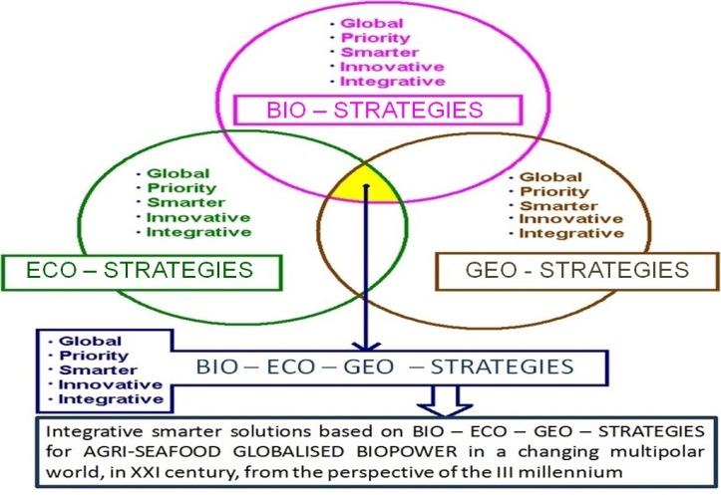

Fig. 19. Synthesis of BIO-ECO-GEO-STRATEGIES

(orig. A.T. Bogdan, Carmen Pasalau & R.S. Serea, 2013).

Main Findings and Policy Conclusions; Health column was modified at the penultimate section by adding “regenerative medicine”, that was taken from the last section, thus being simplified. In the Industry column, in the original table the last 2 sections were uncompleted and now the text introduced with “*” was realized by A.T. Bogdan and R.S. Serea. All this aspects from table no. 1 and 2 are explicated through the content of fig. 5 and 6, that are refering to BIO-ECO-GEO-STRATEGIES and BIO-ECO-GEO-ECONOMY.

In this context, Alexandru T. Bogdan, in collaboration with specialists from National Institute of Economical Reserches and Center for Studies and Research of Agroforestry Biodiversity have considered that the synoptic presentation of data forecasting for trends in R&D and jobs and skills dynamic perspective is very useful.

**Note:** Table 8 is cited from “The Bioeconomy to 2030”, OECD, Paris, 2009. Notes are based on Just *et al.,* 2006. Lower estimates exclude all costs that could be associated with proving environmental or human safety, while higher estimates include such costs. All estimates exclude “facility & management overhead costs”. 3. Figures from the German Bundessortenamt and converted from Euros to USD using the average of monthly exchange rates from June 2005 to September 2008 (1 EUR = USD 1.34). 4. Provided by the USDA Center for Veterinary Biologics. Estimates assume that the applicant already possesses an establishment license. 5. Fiscal year 2008 fees for the FDA from US Federal Register, 2007a. 6. Based on a new drug application requiring clinical data, product fees, and a rough estimate of the costs of production establishment inspections per drug, from US Federal Register 2007b. 7. Fiscal year 2008 fees, based on FDA, 2008.IVDs are classified as medical devices. Lower figure is for businesses with less than USD 100 million in sales. 8. Total costs to industry in first year, in 1995 USD, from EPA, 1997.

**Table 8.Indicative regulatory costs**

**to commercialise**

**a biotechnology product**

**(USD thousands).**

|  |  |
| --- | --- |
| **Agriculture** |  |
| Plant  GM crop2  MAS crop3  Animal  Vaccine4  Therapeutic5  Diagnostic4 | 435–13 460  5–11  242-469  176–329  9-189 |
| **Health** |  |
| Therapeutics6  *In vitro* diagnostics7 | 1 300  150–600 |
| **Industry** |  |
| GM open release8  GM in closed loop | 1 200–3 000  Unknown |

The table below is from European Bioeconomy to 2030.

The European bio-economy has an a pproximate market size of over €1.5 trillion, employing more than 22 million people.

|  |  |  |
| --- | --- | --- |
| Sector | Annual turn­over (billion €) | Employment (million) |
| Food | 800 | 4.1 |
| Agriculture | 210 | 15 |
| Paper/Pulp | 400 | 0.3 direct (4 ind.) |
| Forestry/ Wood ind. | 150 | 2.7 |
| Industrial Biotcch. | 50 (est.) |  |
| Total | 1610 | 22.1 |

*estimated to be around €100-160 million by 2010;

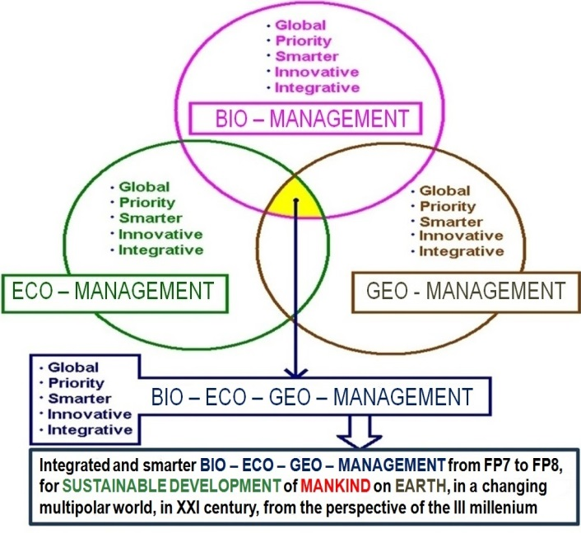

Fig. 20. New concept of Bio-Eco-Geo-Management in relation with european research programme, FP7 and FP8 (orig. A.T. Bogdan et al, 2010; actualized with R.S. Serea).

A.T. Bogdan et al that is also the corresponding author, in collaboration with the author’s group and with prestige specialists from long-term experts nominee in the 2 research POSDRU projects – postdoctoral and doctoral researches (ID no. 63258, respectively ID no. 77082), funded by European Union from Romania’s granted funds in post-adheration period (2007-2013).

We consider that today, in the context of accelerated developing of bioeconomy at European and global level, including the perspectives guaranteed by ascendant evolution, at least until 2030 (we are convinced that developing will continue until 2050 and until 2100, as we suggested in our previous papers – A.T. Bogdan et al, 2010-2013) exists numerous and varied biotechnologies that, applied correctly, with the strict following of international protection rules of consumers allow passing from “fiat panis” at “habemus panis”. So, on the basis of this scientific and technical considerations that are founding BIO-ECO-GEO-ECONOMICS, the affirmation from this article’s title, is that in the present we already have the capacity to say “HABEMUS PANIS”, in the context of GLOBALISED BIOPOWER *through more agrifood and seafood*, for all world population, with the condition to have the desire of political and governmental factors for bioeconomical applying of scientifical discoveries made through excellence researches, and technological transfer in developing countries that it’s necessary and justified.

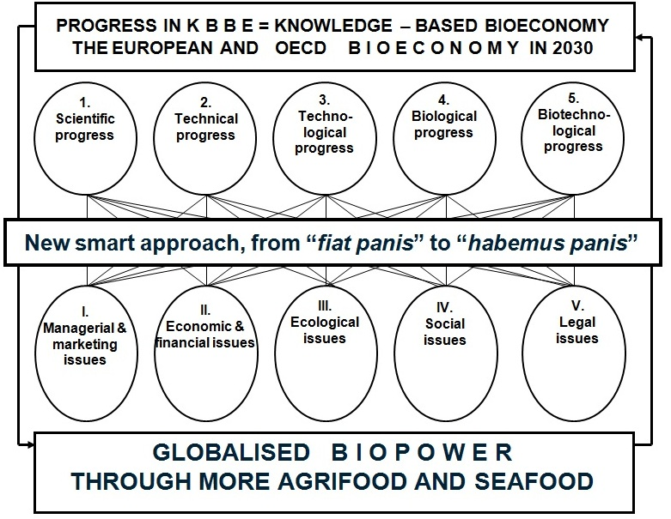

Fig. 21. Applying the principles and objectives of complexity science for resolving through KBBE (Knowledge-Based Bio-Economy) of food bioresources for humankind through innovative BIO-ECO-GEO-STRATEGIES, that will ensure passing from “*fiat panis*” to “HABEMUS PANIS”, respectively realization of globalised biopower through more agrifood and seafood (orig. A. T. Bogdan, Dorina Bogdan, Amalia Strateanu, 2011, with modifications made in collaboration with Carmen Pasalau and R.S. Serea 2014).

The KBBE will play an important role in a global economy, where knowledge is the best way to increase productivity and competitiveness and improve our quality of life, while protecting our environment and social model. It is a sector estimated to be worth more than € 1.5 trillion per year. KBBE addresses the following needs:growing demand for safer, healthier, higher quality food; sustainable use and production of renewable bio-resources; increasing risk of epizootic and zoonotic diseases and food related disorders; sustainability and security of agricultural, aquaculture and fisheries production; increasing demand for high quality food, taking into account animal welfare and rural and coastal contexts and response to specific dietary needs of consumers.

World bioeconomy, European and National bioeconomy makes real progresses under technical, scientific and socio-economic aspects, already existing at European level, from official statistics of European Comission a total market of 1.610 billion euro/annually and over 22 milions employees, from which, the agrifood sector and industrial biotechnologies goes over 1 trillion euro, this justifying our optimism that humankind has today the possibility of passing from “*fiat panis*” at “HABEMUS PANIS”.

On the basis of our own researches made within the scientific thematic approved by Romanian Academy for the National Institute of Economical Researches “Costin C. Kiritescu”, through the specialists and collaborators from the Center for Studies and Researches of Agroforestry Biodiversity, the authors of this article propose the understanding of actual and perspective situation, when we entered into a new economy that represents GLOBALISED BIOPOWER through smart and innovative agrifood and seafood, in the context of the new concept of BIO-ECO-GEO-DIPLOMACY, necessary for the protection, capitalization and development of world natural and cultural heritage of humankind.

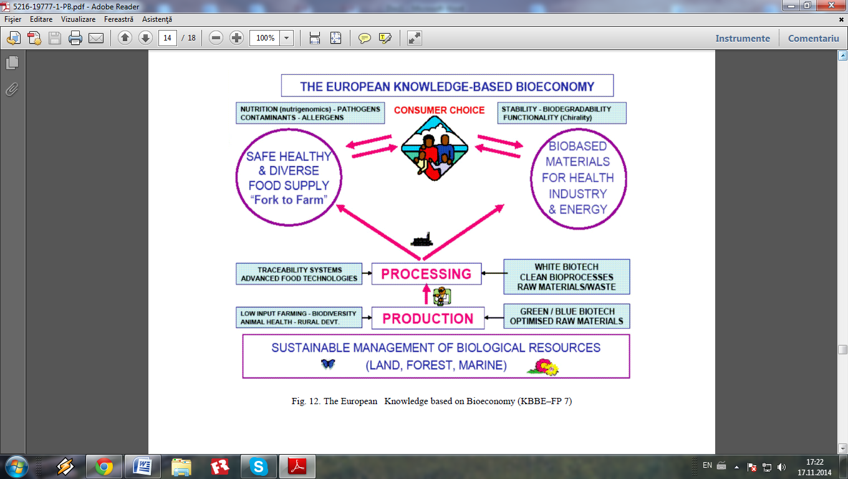

Fig. 22. In this scheme, that became a symbol for European KBBE, we consider that Complex relantionships between sustainable management of biological resources (land, forest, marine), on the basis of biodiversity and especially of agricultural, forestry, zootechnical and medical biotechnologies, with a major role in ensuring food bioresources for mankind, only in conditions of consumers protection and feed-back control on traceability of food and feed in anthropic ecosystems (actual aspects, especially after different alerts with problems in food chain; These possible frauds are today verified through molecular genetics methods, as specialists from N.I.E.R. / C.R.S.A.B. study from many years the traceability of food and feed through the method G. Brem and analysed with the support of AgriLab from Germany).

Alexandru T. Bogdan propose that this new economy to include also the capitalization, under dry state, of animal and vegetal food, because when there are periods with rich crops and the market request is low and offer very abundant, the producers from agriculture and aquaculture have a huge loss. If deposits will be made, at regional, national or international level for dry food, that can be utilised in emergency situations, including the years with very low crop production, the loss of producers will be diminished and food security will be ensured for at least a year, based on risk management and biosecurity actions.

New integrated and innovative paradigm about “bio-eco-geo-economy”. The scientific researchers collective, including those recently nominee as associated scientific researchers at the Center for Study and Research of Agroforestry Biodiversity within National Institute of Economical Research of Romanian Academy, after many years and many scientifical papers regarding the original concept/paradigm about eco-bio-economy (in essence an economy based on environmental factors and especially on limited natural resources that are needed for a durable life of actual generations and especially those in the future). In the central square of figure no. 23 posted below, we synthesize the elements of Bio-Eco-Economy, with explications also in figure no. 22.

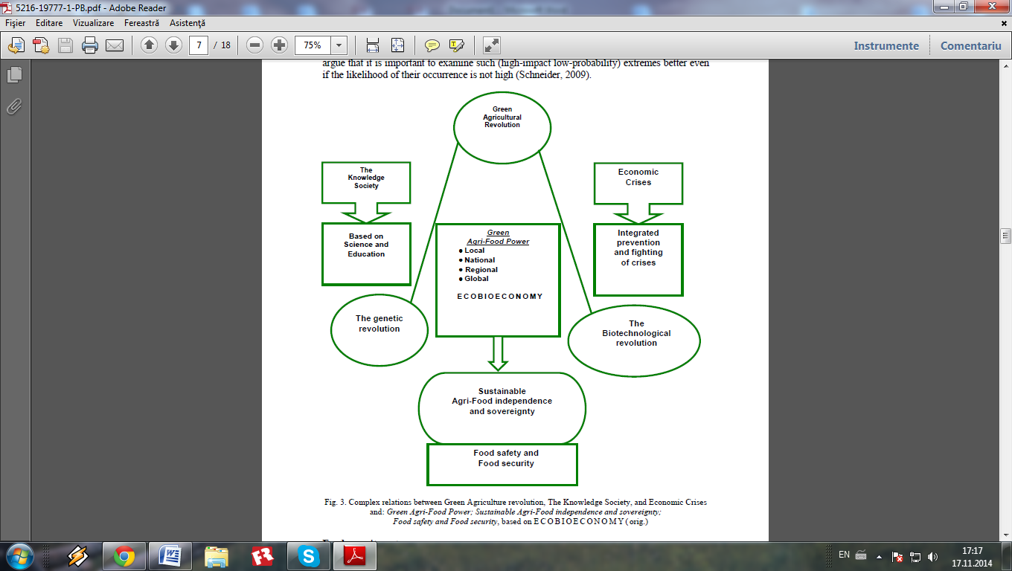

Fig. 23. Innovative use of Complexity Sciences and Innovative Applications for Globalized Interrelations between Green and Blue Agriculture and Aquaculture Revolutions, in the context of Knowledge Society and Genetic, Genomics and Proteomics Revolutions, with Integrated Prevention and fighting of Economic and Financial Crisis for Biotechnological and Bioindustrial Revolutions, based on Reshaping the Sustainable Agri-Aqua-Food Independence and Sovereignty, through smart Bio-Eco-Geo-Economics, that will achieve Food Safety, Security and Defense (orig. A.T. Bogdan, Dorina Bogdan, Denis L. Diaconescu, S. Chelmu and Amalia Strateanu, 2009; modified by A.T. Bogdan, N. Istudor, N. Bulz, I. Gaf-Deac, S. Chelmu, I. Prica, C. Sonea, R.S. Serea and Carmen Pasalau, 2013).

These new innovative approaches of our group start from the fact that the biogeochemical cycles are based on bio-eco-geo-entropy for life survival and sustenability in anthropic ecosystems (fig. 24). This image explains Georgescu-Roegen’s ideas about thermodynamic laws in generally, and especially about entalpy and entropy, respectively the scientific foundation of his bioeconomical theory. Looking at this image, with a butterfly on a flower from the globalized ecosystem’s biota, the coresponding author of this article, in collaboration with the young biologist Radu-Sorin Serea from the Ecological Society “Aquaterra” have discussed about the well-known expression refering to the fact that “something as small as the flutter of a butterfly’s wing can ultimately cause a typhoon halfway around the world” (this is today’s reality of the globally interconnected world, with unpredictible actions of *chaordic systems* principles).

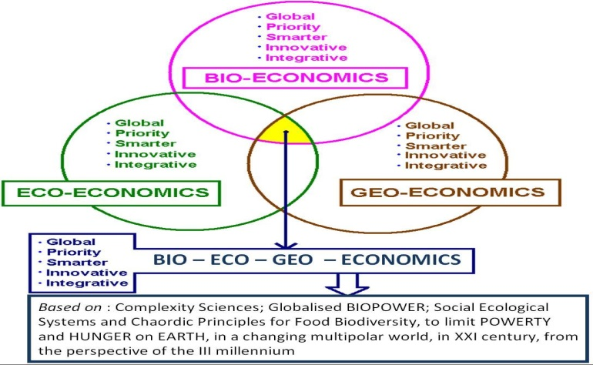

Fig. 24. Global, Prioritary, Smarter, Innovative and Integrative - principal characteristics of BIO – ECO – GEO – ECONOMICS triade, to limit POVERTY and HUNGER on EARTH in a changing multipolar world, in the XXI century from the perspective of the III Millennium, for practical bridging from the green economy to blue economy, in the context of reshaping the world’s economy (orig. A.T. Bogdan, Dorina Bogdan and Amalia Strateanu, 2013; modified by A.T. Bogdan, N. Istudor, C. Sonea, R.S. Serea and Carmen Pasalau, 2013).

Scientifical basis of bio – eco – geo – economics. In a synoptic way, in the figure 25 and 26, the complex role of science and technology in the modern, globalized society is presented, highlighting some particularities that resulted from the activity of our group of specialists and associated scientifical researchers from N.I.E.R. / C.S.R.A.B., during activities progress from our annual thematic plans 2007-2013, refering to new theoretical and practical approaches on the impact of bioeconomy and ecoeconomy in the actual context of multiple and simlultaneous crisis.

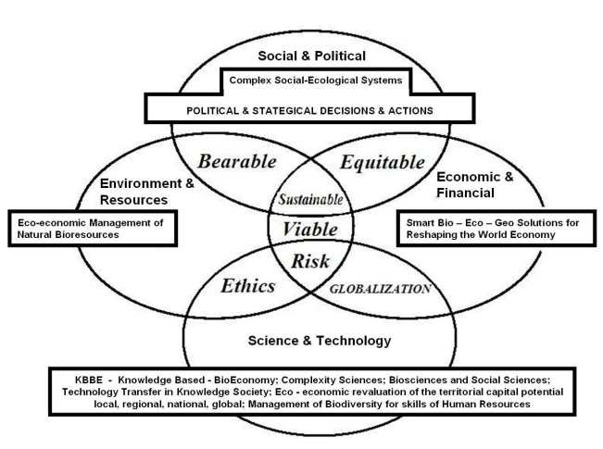

Fig. 25 Modifications and completions of the initial scheme used by Lester R. Brown, based on a triade of determining factors in the practical realisation of the benefits from eco-economy, in the actual and perspective context of holistic bio-eco-geo-economic approaches, underlining the role of life sciences and that of social - ecological system complex (after A. T. Bogdan, N. Istudor, N. Bulz, Dorina Bogdan, G. F. Toba, Denis L. Diaconescu, I. Prica, Amalia Strateanu, R. S. Serea, C. Sonea, Carmen Pasalau, 2013).

The special importance of scientific research in knowing and applying innovative strategies in bioeconomy at local, regional, national and global level is highlighted through the fact that, in the FP7 program and further, in FP8 program, an more and more important focus is on the new paradigms of ecoeconomy, bioeconomy and eco-bio-economy (fig. 26).

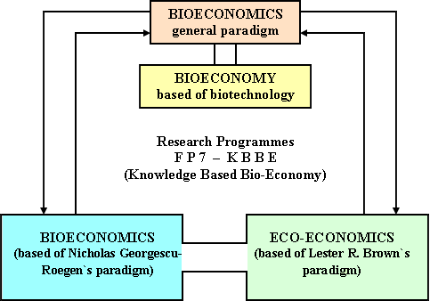

Fig.26 Schematic presentation of the links between research programme FP7, referring to KBBE = Knowledge-Based Bio-Economy, including the relationships between bioecoeconomy and biotechnology (orig. A.T. Bogdan et al., 2009).

These scientifical approaches, combined under the name KBBE continue also for the period 2014-2020, such that already exist in progress more project proposals for scientifical research, competitively funded by the European Union, proposals that our group from N.I.E.R. / C.S.R.A.B. is structuring into the next 3 national and prioritary megaprojects:

* bioeconomical capitalization of natural resources potential from the national, territorial Carpathian-Danubian and Pontic capital, in collaboration with prestige specialists from the Danube riveran countries, inclusively from the eco-area of European Carpathians and coastal areas of the Black Sea;
* implementation of pertinent proposal from the text of “National Strategic Framework for Sustainable Development of Agro-food Sector and Rural Space in the period 2014-2020-2030”, elaborated by a Presidential Committee (in which are part several members of the Romanian Academy, in collaboration with university teachers, representatives of professional associations from agriculture and performance farmers) in the context of global food crisis and constant growth of food needs of humankind;
* integrated bio-eco-geo- approach of interdependence between main ecological factors in their dynamics, modified through pollution actions and biodiversity decrease, consecutive to unfavorable anthropic actions, respectively the elaboration and implementation of some integrated projects, with concrete measures of techno-prophylaxis, especially for prevention and fighting anthropogenic pollution.

This new time horizon that already prefigured the advance with at least another decade, respectively 2030, the fierce competition at world level, under the aspect of excelence scientific researches, road openers, through the originality of approaches, data gathering and, especially, elaboration of new studies and prognosis, based on the progress of life sciences, but also on some unfavorable consequences, due to distructive actions on long and very long term, actions conducted, unfortunately, by people with a low ecological and civic education.

Practical aplications of bioeconomy in the specific biomass for agri-aqua-food. In the 2 principal papers for projection of bioeconomy development strategies in the European Union and in OECD countries until the year 2030, there are numerous and varied examples of vegetal biomass conversion (respectively the feed) into animal biomass (respectively milk, meat and eggs). In this respect, in figure 8 the global dynamic for milk production, forecasted for the year 2040 is presented and we can observe a permanent increase of this index. This is why, we also have to have in our country real prognoses regarding bioeconomic dynamic of milk production. Thus, we consider that the potential production of milk biomass is, for Romania, of at least 125.000 hectoliters, respectively a potential production of cow milk for internal consumption of at least 65.000 hectoliters and the difference of 60.000 hectoliters represents the real disponibilities for export.

This milk biomass, consecutive to bioeconomic approach of milk cow growth is obtained from cattle effectives of which potential is at least 7 millions heads; if Romania would have as indicator the degree of quantitative intensification of milk cows effectives from Switzerland, from Netherland and from Denmark then, the source effective of pregnant cows and calved cows from Romania, has to be over 3.5 million heads. Unfortunately, the dramatic decrease, both under quantitative and qualitative aspects of cattle effectives from Romania, to only a quarter from the potential number mentioned, proves indubitable the fact that bioeconomy is a real opportunity for sustainable development of agrofood sector, like the green power, respectively a biopower, especially in the perspective of a substantial increase of the demand for dairy products and their derivates.

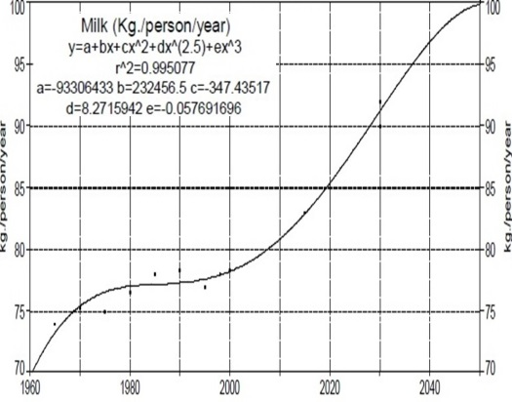

Fig. 27 Milk dynamic production in the period 1960-2040; calculations made by A.T. Bogdan, R. Burlacu and I. Surdu, on the basis of figures published by specialised organisms of ONU and FAO.

Through the versatility of speciality professional training of the author’s of this scientific article, our group from National Institute of Economical Researches **/** Center for Study and Researches of Agroforestry Biodiversity, within the topics of scientific research has statistically processed calculations regarding also other animal species from romanian zootechny, as from other agricultural production areas, vegetal and animal, as for example: from aquaculture, fish culture, aquaponics, permaculture, vegetable culture in green houses and solarium; these data are available by forwarding a request through e-mail at the e-mail address mentioned in the abstract page.

It is obvious, both from international and national speciality literature, and also from our group researches, that the agrifood bioeconomy, especially in her integrating form of agro-aqua-food (or agro-sea-food), represents today a major concern in what is named “The Reshaping of the World:Consequences for Society, Politics and Business”, the title in which the World Economic Forum will be held in Davos, Switzerland, in January 2014.

This is why, our extended group, with prestige specialists from the romanian academical environment propose further another national, strategical and prioritary megaproject, that will target the 2020 horizon, the real ensuring of agro-sea-food independence and sovereignty for Romania’s population and some disponibilities for export. These proposals are made on the basis of our participation at Global Agriculture Forum, that is organized annually, in January, at Berlin, with massive world representation, the participation at World Economic Forum, also organized annually in January, at Davos (Switzerland), as exchanges of “good practices” developed within the 2 POSDRU projects (doctoral and postdoctoral researches), competitively funded by European Union and won through National Institute of Economic Researches / Center for Researches and Study of Agroforestry Biodiversity, with scientifical research thematic in bioeconomy and ecoeconomy of food and feed safety and security. These projects have been conducted in good conditions, with the permanent professional support of National Institute of Economic Researches.

At the end of this subchapter are presented forward a synoptic sketch regarding the holistic decalogue of bio-eco-geo-paradigms proposed by A.T. Bogdan et al., for research and study in the period 2014-2016.

The cellular and metabolic homeostasis is projected in ecosystems through the state of climax specifically for complex food chains and for a richness of vegetal and animal biodiversity, thus the eternal nature, through her self regulation and perpetuation mechanisms it offers the most efficient and durable examples of energetic conversion at low entropy, namely through intelligent bio-eco-geo-economical strategies, we can still balance and re-ecologize the anthropic ecosystems, until it becomes an irreversible global process, thus integrating the principles of bio-eco-geo-economy in the dynamic of food chains, with dystrophic modifications specific for ecopatology, from cell apoptosis to economical apoptosis remaining one single step!...

We have to realise very fast and definitive, at global level, the reconciliation of humans with nature, the rational construction of a durable and fair partnership between humans and nature, thus the green economy and, especially the green agrifood biopower to develop, this thing leading at rethinking of production and distribution systems of food, uniformly at world level, in a mechanism with profound implications in managing our planet’s resources, including through intelligent use of blue economy, thus avoiding the increase of ecological debt of actual generations from the “accounts” of natural resources necessary for the sustainable survival of future generations, because “living on debt” led to the globalised economical and financial crisis from the last years and major social and ecological conflicts.

**SECTION II**

After the presentation of my PhD thesis in veterinary medicine in 1971 I won a scholarship through international competition of 12 months (with possibility of extension for another 12 months) from the known world renowned foundation Alexander von Humboldt in veterinary medicine (I was the first winner of the international scholarships in veterinary medicine in Romania in the period after 1948). Initially I started this scholarship only for three months, respectively September to November 1971 and  has been approved to continuing only after 20 years respectively after the Romanian Revolution of December 1989 ( I continued this scholarship, at special invitation of the Humboldt Foundation leadership done in 1990, because it was unique in the long history of several thousand Humboldt scholars worldwide) who were in the Annals of the Foundation, who have not completed the stage of international scientific research.

During the period 1990-1992 I have officially completed this important original scientific research, based on the latest research with computerized bioluminiscence (precision of picotechnology, namely 10-12) about the metabolism of oocytes and zygotes fertilized in vitro,  with computerized videomicrophotometry. These researches (.......................) are out of date even now after 20 years of making their. I mention that recently in 2010 at Humboldt College I had the work in collaboration with Marcel Matiuti:

In section 2, I present the evolution and development plans for my further career, after over 53 years since my first scientific paper and more than 43 years after confirmation of the first doctorate in science, because I am looking optimistically into the future (based on the average age of over 83 years now members of the Romanian Academy, part of which has already reached over 90 years and still have working professional, scientific and academic).



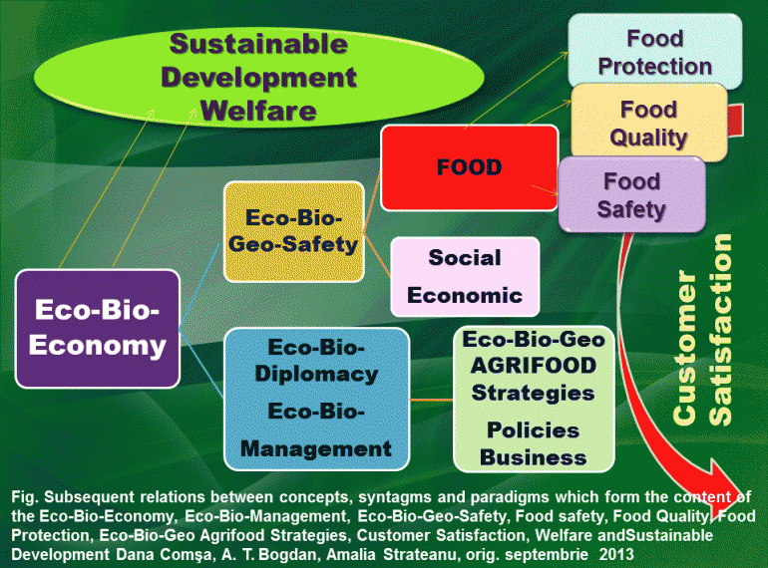

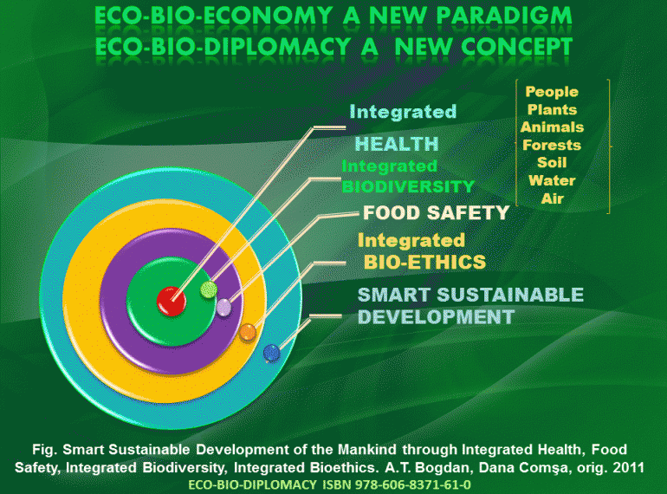

**SECTION III**

**SCINTIFIC PAPERS LIST *AFTER OBTAINED SCIENTIFIC TITLE OF "DOCTOR OF VETERINARY MEDECINE"* (1971) [1]**

**I. Books published and selected by the scientific title of "Doctor of Veterinary Medecine" (1971)**

1. Bogdan A.T. – coordonator; autori: A.T. BOGDAN, Iudith Ipate, G.Fl. Tobă, Simona Ivana, M.Matiuți, D.Diaconescu; *Biodiversity of farm animals and eco-bio-economics significances in the food security context*, Editura Academiei Române, 21.05.2012, București, ISBN 978-973-27-2183-4.
2. Bogdan A.T. – coordonator*,* autori: A.T. Bogdan, Iudith Ipate, G.Fl. Tobă, Simona Ivana, M. Matiuți, D. Diaconescu, Romanian Academy, ”Acad. David Davidescu” Center of Studies and Researches for agroforestry Biodiversity (2012), *Biodiversity of farm animals and eco-bio-economics significances in the food security context*, Second Edition - Vol. I”, Editura Academiei Române, București, 15.11.2012, ISBN 978-973-27-2259-6 şi Vol. I 978-973-27-2260-2.
3. Bogdan A.T. – coordonator*,* Second Edition - Volume II, Edite by: A. Ardelean, G. Predoi, G.Fl. Tobă; autori: Iudith Ipate, G.Fl. Tobă, Maria Duca, G. Predoi, Al. Şonea, N. Cornilă, L. Ioniţă, Simona Ivana, S. Chelmu, Violeta Simion, Delia Costache, Adriana Pertuş; *Biodiversity of farm animals and eco-bio-economics significances in the food security context*, Editura Academiei Române, Vol.II, 29.11.2012, ISBN 978-973-27-2259-6,Vol.II-ISBN978-973-27-2261-9 București.
4. Bogdan A.T. – coordonator; autori: A.T. Bogdan, Iudith Ipate, G.Fl. Tobă, D. Diaconescu, *Agroforesty biodiversity and eco-bio-economic significances in corelation with food securiry*, Editura Academiei Române, 17.05.2012, București, ISBN 978-973-27-2183-4.
5. AT Bogdan, Ipate Iudith, *Ecoeconomy and ecosanogenesis in Romania based of agrifood green power* , Romanian Academy Editor 2012, ISBN 978-973-27-2264-0
6. AT Bogdan, Constantin Oprean, Letiția Oprean, *Managementul integrat și strategic al combaterii inteligente a crizei alimentare globale, bazat pe bioeconomie și ecoeconomie,* Editura Academiei Române,2012, București, ISBN 978-973-27-2266-4.
7. Bogdan A.T., G.Fl. Tobă, Iudith Ipate, D. Diaconescu, Dana Comşa: *Soluţii ecobioeconomice bazate pe biodiversitatea agrosilvică pentru asigurarea independenţei şi suveranităţii agroalimentare durabile a româniei europene şi euroatlantice, (cu semnificaţii economice ale sănătăţii integrate a mediului şi bioeconomice ale protecţiei complexe a consumatorilor)*, Ediţia a II-a, revizuită şi complectată, Editura Libris Danubiu, 22 aprilie 2012, ISBN 978-606-928-29-0-8.
8. **A.T. Bogdan**, **Ipate Iudith,**  Covaci Brânduşa (2013), *Innovation activities in biodiversity and eco-bio-economics doctoral research for safety and food security*, Editura Economica, ISBN 978-973-709-672-2.
9. **A.T. Bogdan**, **Ipate Iudith,**  Covaci Brânduşa (2013), *Innovation activities in juridical science for sustaining environment, safety and food security, biotechnology and eco-economy trough doctoral research*,Editura Economica, ISBN 978-973-709-674-6.
10. **A.T. Bogdan**, **Ipate Iudith,** Covaci Brânduşa (2013), *Innovation activities in dental medicine doctoral research in order to sustain bioeconomy and biodiversity desiderata*,Editura Economica, ISBN 978-973-709-675-3.
11. **A.T. Bogdan**, **Ipate Iudith,**  Covaci Brânduşa (2013), *Solutii inter-multi-disciplinare în contextual strategiilor ecoeconomice şi bioeconomice pentru siguranţa şi securitatea alimentelor şi furajelor din ecosisteme antropice*,Editura Economica, ISBN 978-973-709-681-4.
12. Bavaru A., S. Godeanu, Galia Butnaru, A.T. Bogdan (2007), *Biodiversitatea şi ocrotirea naturii*, Editura Academiei Române, Bucureşti, *Premiul Academiei Române* în 2009.
13. Bogdan A.T., D.L. Diaconescu, Amalia-Gianina Străteanu, S. Chelmu, I. Surdu, M.Th. Paraschivescu (2009), *Soluţii pentru criza zootehniei prin asigurarea independenţei şi suveranităţii agroalimentare durabile a României Europene* (dezbatere naţională „Ce putem învăţa de la actuala criză economică?", Aula Academiei Române,14 aprilie 2009), Editura Academiei Române, ISBN 978-973-27-1802-5.
14. Bogdan A.T., B. Păsărin, S. Chelmu, Amalia-Gianina Străteanu, I. Surdu,M. Th. Paraschivescu (2009), *Poziţionarea ştiinţelor zootehnice la baza conceptului original referitor la dezvoltarea prioritară a României europene ca putere verde groalimentară*, Simpozionul Naţional „Zootehnia modernă – ştiinţă, creativitate şi inovare", Iaşi, 9-10 aprilie 2009) Editura Academiei Române, ISBN 978-973-27-1800-1.
15. **Otiman P.I., D. Grigorescu, M. Enache, A.T. Bogdan *-* coordonatori (2010),** ***Geo- şi biodiversitatea în Ţara Haţegului* - *Retezat*, vol. I, *Partea III -*** *Studiu privind identificarea de metode şi instrumente de monitorizare, conservare şi valorificare a biodiversităţii în arealele Rezervaţia Ştiinţifică Gemenele – Retezat şi Ţara Haţegului*, **Editura Academiei Române, Bucureşti, ISBN 978-973-27-1941-1.**
16. Bogdan A.T., A. Ardelean, C. Opean (2010), *Ghid metodologic, ştiinţific, didactic şi financiar. Şcoala Postdoctorală pentru Biodiversitate Zootehnică şi Biotehnologii Alimentare pe baza Ecoeconmiei şi Bioeconomiei necesare Ecosanogenezei,* Ediţia I, Editura Vision Design.
17. Comșa Dana, A.T. Bogdan (2012), *Eco-Bio-Diplomaţie, un nou concept pentru o dezvoltare durabilă inteligentă, într-o lume globalizată, în context eco-bio-economie*, Editura Academiei Oamenilor de Ştiinţă din România, Bucureşti, ISBN 978-606-8371-61-0.
18. A.T. Bogdan, Gh. Mencinicopschi, Simona Ivana, Gh. Câmpeanu, S. Bărăităreanu (2010), *Biotehnologii alimentare*, Editura Asclepius, Bucureşti, ISBN 978-606-92360-3-1, 978-606-92360-2-4.
19. Chirovici E.O., A.T. Bogdan, G.I. Năstase, B. Dumitrache, Daniela Itu, D.L. Diaconescu (2004), *Cultura antreprenorială din perspectiva programului UNCTAD/ Empretec în România*, Editura Global, Bucureşti.
20. Chirovici E.O., A.T. Bogdan, G.I. Năstase, B. Dumitrache, Daniela Itu, D.L. Diaconescu, R. Iordăchel (2004), *Proprietatea intelectuală în activitatea întreprinderilor mici şi mijlocii*, Editura Global, Bucureşti.
21. Chirovici E.O., A.T. Bogdan, G.I. Năstase, B. Dumitrache, O. Nicolescu, G. Năstase, Ruxandra Anca Popescu, Daniela Itu, D.L. Diaconescu, I. Piţurescu (2004), *Bazele dezvoltării economice a întreprinderilor mici şi mijlocii în România*, Editura Global, Bucureşti.
22. Bogdan A.T., M.Bistriceanu, C. Majina (1981), *Reproducţia animalelor de fermă.* Editura Scrisul Romanesc, Craiova. *Premiul Academiei Române* în1983.
23. Bogdan A.T., I. Târnovean, Dorina Salanţiu (1984), *Fertilitatea, prolificitatea şi  
    natalitatea în zootehnie*, vol. I, Editura Dacia, Cluj-Napoca.
24. Bogdan A.T., I. Târnovean, Dorina Salanţiu (1984), *Fertilitatea, prolificitatea şi  
    natalitatea în zootehnie*, vol. II, Editura Dacia, Cluj-Napoca.
25. Bogdan A.T. (2002) *Performanţe româneşti în zootehnie*; capitolul „*Producţia animală*” din tratatul „Secolul XX performanţe în agricultură”, coordonatori D. DAVIDESCU şi Velicica DAVIDESCU pag. 607–671, Editura Ceres, Bucureşti.
26. Bogdan A.T., Şt. Mantea, Dorina Bogdan (1999), *Tratat de reproducţie şi însămânţări artificiale la suine*, Editura Tehnica Agricolă, Bucureşti.
27. Boitor, I., M. Muntean, A.T. Bogdan, N. Mateş (1969), *Caiet de lucrări practice* *la reproducţte,* Lito. Inst. Agr. Cluj.
28. Boitor. I., A.T. Bogdan, M. Munteanu, N. Mates, R. Gellner (1970), *Îndrumător clinic de obstetrică şi ginecologie veterinară,* Lito. Inst. Agr. Cluj-Napoca.
29. Bogdan Elena, A.T. Bogdan (1971), *Anatomia patologică şi fiziopatologie*, Editura Ceres Bucuresti.
30. Boitor, I., M. Munteanu, N. Mates, A.T. Bogdan (1973), *Caiet de lucrări practice şi clinice la reproducţia şi patologia reproducţiei la animale,* Lito. Inst. Agr. Cluj-Napoca.
31. Mureşan E., M. Gaboreanu, A.T. Bogdan, A.I. Baba (1974), *Tehnici de histologie  
    normală şi patologică*, Editura Ceres Bucureşti.
32. Bogdan A.T., Eugenia Diaconu, Inge­borg Bogdan (1976), *Metode actuale şi de perspective pentru intensificarea reprocducţiei la animale în fermele zootehnice.* Crevedia, Centrul de perfecţionare a cadrelor din agricultură.
33. Bogdan A.T., Gh. Suciu, A.D. Vasilescu (1976), *Intensi­ficarea reproducţiei la ovine şi eficienţa ei economică. Crevedia.* Cen­trul de perfecţionare a cadrelor didactice din agricultură.
34. Bogdan A.T., Gh. Suciu, T. D. Vasilescu (1976), *Intensivizarea reproduţiei la ovine,* Lito M.A.I.A.
35. Bogdan A.T., R. Morar, C. Simionescu, Ingeborg Bogdan, Dorina Salanţiu (1976) *Caiet de lucrări practice la reproducţia animalelor dornestice.* Cluj-Napoca, Inst. Agr.
36. Bogdan A.T., Eugenia Diaconu, Inge Bogdan (1976), *Metode actuale* *şi de perspectivă pentru intensivizarea reproducţiei la animate în fermele zootehnice,* Central de perfecţionarea cadrelor din agricultură, Băneasa.
37. Mureşan E., M. Gaboreanu, A.T. Bogdan, A.I. Baba, (1976) *Tehnici de histochimie normală şi patologică*, Editura Ceres Bucureşti.
38. Dumitrescu I., A.T. Bogdan, M. Năforniţă, O. Turliuc (1976), *Reproducţia animalelor de fermă*, Editura Didactică şi Pedagogică, Bucureşti.
39. Bogdan A.T., R. Morar, Dorina Bogdan Salanţiu (1977), *Actualităţi şi perspective în reproducţia animalelor de fermă*, Editura Tipo Agronomia Cluj-Napoca.
40. Bogdan A.T., Ingeborg Bogdan (1978), *Aspecte noi în creşterea animalelor, din zootehnia R. F. Germania*, Editura Ceres, Bucureşti.
41. Dabija G., A.T. Bogdan, Elena Bogdan, N. Georgescu (1978), *Bolile infecţioase ale animalelor domestice,* Editura Ceres, Bucureşti.
42. Dumitrescu I., G.Magiari, M. Pătraşcu, M. Paraschivescu, T. Feredean, A.T. Bogdan (1979), *Însâmânţările artificiale la animalele de fermă*, Editura Ceres, Bucureşti.
43. Dabija Gh., A.T. Bogdan, Elena Bogdan, N. Georgescu (1979), *Bolile infecţioase ale animalelor domestice,* Editura Ceres Bucureşti.
44. Dumitrescu I., A.T. Bogdan*,* M.Năforniţă, O. Turliuc (1981), *Reproducţia şi patologia reproducţiei*, Editura Didactică şiPedagogică Bucureşti.
45. Bogdan A.T. coordonator, Mihaela Mălău, Amalia-Gianina Străteanu (2000) *Curs universitar de Ecologie şi Ecopatologie,* Editura Bioterra Bucureşti.
46. Bogdan A.T. coordonator, Maria Paraschivescu, Amalia-Gianina Străteanu (2000) *Curs universitar de Ecologie şi Protecţia Mediului,* Editura Bioterra Bucureşti.
47. G.F.Tobă, A.T. Bogdan, N. Ilinca, L. Hârceagă, N. Păcală (2000), *Biotehnologia transferului de embrioni la taurine*, Editura Bioterra Bucureşti.
48. Dumitrache B., A.T. Bogdan, Dorina Bogdan, A. Bârţoiu, S. Chelmu, Maria Vasile, P. Abrudan (2000), *Controlul zooveterinar al indicatorilor de reproducţiei la taurine*, Editura Bioterra Bucureşti.
49. Bogdan A.T. – coordonator; coautori: Dorina Bogdan, Şt. Mantea, A. Şonea, N. Onac, S. Chelmu, MariaVasile, Gh. Neaţă, G.F. Tobă, C. Dascălu, Constanţa Strasser, S. Iepure, (2000), *Ştiinţe zootehnice – volumul I, Biotehnologii de reproducţie*, Colecţia Manuale Universitare, I.S.B.N.973-99398-8, Editura Bioterra Bucureşti.
50. Bogdan Dorina – coordonator; coautori: A.T. Bogdan, Şt. Mantea, A. Şonea, N. Onac, S. Chelmu, MariaVasile, Gh. Neaţă, G.F.Tobă, C. Dascălu, Vasilica Radu, V. Dănacu, B. Dumitrache, Constanţa Strasser, S. Iepure (2000), *Zootehnie generală, volumul I, fertilitatea şi alimentaţia animalelor*, Colecţia Manuale Universitare, I.S.B.N.973-99398-1-3, Editura Bioterra Bucureşti.
51. Mălău Mihaela, A.T. Bogdan, Crina Mladin, Amalia-Gianina Străteanu, Daniela Niţulescu (2001), *Curs universitar de Ecologie şi Protecţia Mediului,* ediţia a II-a, Editura Bioterra Bucureşti.
52. Bogdan A.T. coordonator, Şt. Mantea, V. Puşcă, Vasilica Radu, N. Onac (2001), *Cursul universitar de Ştiinţe zootehnice* ediţia a II-a, Editura Bioterra Bucureşti.
53. Radu Vasilica, A.T. Bogdan, N. Onac, Amalia-Gianina Străteanu (2002) *Curs universitar de Zootehnie specială, tehnologii de creştere şi ameliorare la taurine, ovine suine,* ediţia a II -a, Editura Bioterra Bucureşti.
54. Bogdan A.T., Amalia-Gianina Străteanu coordonatori, Mihaela Mălău, Maria Paraschivescu, I. Constantinescu, Crina Mladin, Daniela Niţulescu - Focşeneanu (2002) *Curs universitar de Inspecţie şi Legislaţie pentru Protecţia Mediului,* Editura Bioterra Bucureşti.
55. Radu Vasilica, A.T. Bogdan, N. Onac, Amalia-Gianina Străteanu (2002) *Curs universitar de Zootehnie generală şi specială,* Editura Bioterra Bucureşti.
56. Constantinescu I., A.T. Bogdan, Maria Parachivescu, C. Dascălu, Amalia-Gianina Străteanu(2002), *Ecologie şi Protecţia Mediului,* Editura Bioterra Bucureşti.
57. Dumitrache B.M., A.T. Bogdan, Dorina Bogdan, A. Bârtoiu, G. Frătilă, S. Chelmu, Maria Vasile, P. Abrudan (2003), *Controlul zooveterinar al indicatorilor de reproducţie la taurine*, Editura Tehnică Agricolă, București.
58. Simona Ivana, A.T. Bogdan, I. Ţogoe, Gh. Câmpeanu., Ipate Iudith, N. Popescu (2010), *Microbiologia alimentelor,* vol. 1, Editura Asclepius, Bucureşti, ISBN: 978-973-88785-8-7, 978-606-92360-00.
59. Simona Ivana, A.T. Bogdan, I. Ţogoe, Gh. Câmpeanu, Ipate Iudith, N. Popescu (2010), *Microbiologia alimentelor,* vol. 2, Editura Asclepius, Bucureşti, ISBN: 978-973-88785-8-7, 978-606-92360-0-0.
60. Simona Ivana, A.T. Bogdan, I. Ţogoe, Gh. Câmpeanu, Ipate Iudith, N. Popescu (2010), *Microbiologia alimentelor,* vol. 3, Editura Asclepius, Bucureşti, ISBN: 978-973-88785-8-7, 978-606-92360-3-1.
61. Simona Ivana, A.T. Bogdan, Iulian Ţogoe, Gh. Câmpeanu, Ipate Iudith, N. Popescu (2011), *Microbiologia alimentelor* - *Patogeni alimentari*, ediţie revizuit, Editura Asclepius, ISBN electronic 978-606-8236-26-1.
62. **Ipate Iudith, Simona Ivana, A.T. Bogdan (2012), *Contaminanţi alimentari de origine microbiană,* ISBN:978-606-8236-30-8, Editura Asclepius.**
63. Simona Ivana, A.T. Bogdan, Cristina Dinu Pârvu, G. Predoi, S. Bărăităreanu, Ipate Iudith, P.Z. Iordache, A.N. Popescu, LetiŢia Purdoiu (2012), *Leptospirosis and Pasteurellosis*, *an occupational health hazard for pet owners and a public health issue for urban communities*, Editura Asclepius, Bucureşti, ISBN 978-606-8236-25-4.
64. **Ivana Simona, Ipate Iudith, A.T. Bogdan (2012), *Managementul riscului microbiologic in toxiinfectiile alimentare produse de bacteriile din familia Enterobacteriaceae*, ISBN: 978-606-8236-32-2, Editura Asclepius.**
65. **Ivana Simona, Ipate Iudith, A.T. Bogdan (2012), *Biotehnologii, securitate si suveranitate alimentara,* ISBN: 978-606-8236-27-8, Editura Asclepius.**
66. **Ivana Simona, Ipate Iudith, A.T. Bogdan (2012), *Indicatori ai calitatii microbiologice si ai sigurantei alimentare,* ISBN: 978-606-8236-28-5, Editura Asclepius.**
67. **Ivana Simona, Ipate Iudith, A.T. Bogdan (2012), *Toxine microbiene implicate in contaminarea produselor alimentare,* ISBN:978-606-8236-30-8, Editura Asclepius.**

**II. Selection of scientific papers**

1. Bogdan A.T., G. Brem, I. Seregi, I. Groza, Iudith Ipate, Monika Gustscher, G. F. Tobă, L. Zoldag, A. Maroti-Agots, Simons Ivana, L.D. Diaconescu, Amalia-Gianina Străteanu (2009), *Management of DNA Information Bank Using TypiFix Method for Microsatellite Analysis and SNP Assays in Order to Ensure Safety Food by Animal Filiations and Traceability for Animal Biodiversity under the New Circumstances of the Eco-Economicy Paradigm*. Bulettin USAMV, Veterinary Medicine 66(1), 424-432.
2. Bogdan A.T., Dorina Bogdan, I. Groza, M. Paraschivescu, G.F. Tobă, S. Chelmu, D.L. Diaconescu, Amalia-Gianina Străteanu, I. Surdu (2009), *More Animal Production in Agrifood Green Power Development, a New Paradigm of Concept Regarding Sustainable Rural Bioeconomics and Eco - Economics*. USAMV Cluj vol. 66, 416-423.
3. Bogdan A.T. (1998), *Concepţia profesorului G.K. Constantinescu despre zootehnizarea agriculturii româneşti şi rolul managerial al inginerilor zootehnişti în realizarea acestui obiectiv strategic naţional*. Lucrări ştiinţifice USAMV Iaşi, 41, 268-278.
4. Bogdan A.T., Dorina Bogdan, Elena Cristea (1991), *Cronobilogical studies  
   about in vitro ATP - metabolism of the oocytes using the videometry and bioluminiscence method*. Proc. 1st Congr. Cell.Mol.Biol, Paris (abst), p.24.
5. Bogdan A.T., Dorina Bogdan, Ecaterina Angi, A. Constantinescu, I. Ladoşi (1991), *Folosirea metodei de biolumiscenţă computerizată pentru evaluarea individuală a ovocitelor, utilizabile în biotehnologia reproducţiei*. Lucr. Ses. Ref. şi Comun. Ştiin. A Fac. Zoot, 5-6 decembrie, Cluj-Napoca,Tipo Agronomia, 306-310.
6. Bogdan A.T. (1968) , *Recherches histochimiques sur l'endomètre de la vache récolté par biopsie dans les phases du cycle sexilel.* In : Lucrările VI Congr. Inst. de Reproducţie Anim. şi Însăm. Artif. iulie, vol. I, Paris, pp.687-691
7. Bogdan A.T., I. Boitor, Ingeborg Bogdan (1968), *Folosirea biopsiei uterine în studiul histopatologic al unor forme de sterilitate la vacă.* În : Lucrările ştiinţifice ale Inst. agr. Seria Med. Vet. şi Zoot. vol. 23-24. Cluj, 1967-1968, pp. 147-153.
8. Bogdan Elena, A.T. Bogdan (1968), *Bolile infecţioase ale animalelor domestice,* Bucureşti, Editura Agro-Silvica p. 339
9. Popescu P., A.T. Bogdan, Ingeborg Bogdan (1968), *Lokale Behandlung der Endometriten beim Rind mit Geimisch Reverin-Zitratblut.* Blauen Hefte Tierarzt, nr. 38, pp. 25-29.
10. Cristea. I., A.T. Bogdan, M. Munteanu (1969), *Beobachtungen uber die akute Ovaritis bei Sauen.* In : I. Internat. Pig. Vet. Soc. Congr., Cambridge, p. 85.
11. Bogdan A.T., Bogdan I. (1970), Luteolytic effect of the uterus domestic animals. Dtsch Tierarztl Wochenschr. Aug 1, 77 (15), 385-388.
12. Bogdan A.T., I. Boitor, Ingeborg Bogdan (1970), *Zur glandularzystischen Hyperplasie des Endometriums beim Rind.* În : Fortpfl. Haust., 6, nr. 6, p. 325.
13. Căpaţână V., I. Ivascu, I. Cristea, I. Boitor, M. Munteanu, A.T. Bogdan, M. I. Darie, A. Cociu, N. Mates (1970), *Cerce­tări privind folosirea romtiazinei in practica medicinei veterinare.* In : Lucr. şt Inst. Agr. Seria Med. Vet., 26, Cluj, p. 109.
14. Căpaţână V., I. Cristea, I. Boitior, I. Ivascu, A. Cociu, M. Munteanu, N. Mates, A.T. Bogdan, I.M. Darie (1970), *Cercetări privind utilizarea oxigenoterapiei ca* *metodă de reanimare în* *urgenţele chirurgicale şi obstetricale.* In: Lucr,-st. ale Inst. Agr. Seria Med. Vet., 26 mai, p. 129.
15. Mureşan E., A.T. Bogdan, Ingeborg Bogdan, Z.Papay (1970), *Histoenzymologische Untersuchungen des endometrialen Zyklus beim* *Rind.* Acta Histochem., vol. 36, p. 238.
16. Mureşan E., A.T. Bogdan, Ingeborg Bogdan, Z. Papay (1970), *Histochemische und enzymhistologische Untersuchungen am Genitale weiblichen Rindes.* Zuchthyg., nr. 5, p. 88.
17. Mureşan E., A.T. Bogdan, Lisovschi C., Bogdan Inge­borg, I. Stana, Papay Z. (1971), *Cercetări anatomohistologice asupra* *aparatului genital mascul şi femel la nurcă (Mustela vizon)*. Lc. st. Inst. agr. Cluj. Seria med. vet., vol. 27.
18. Bogdan A.T., I. Bogdan, I. Lupu (1972), Probleme der Fortpflanzungsbiologie und der Kunstliche Besamung bei industriellbetribener Schweine-produktion, 7-te Internationale Kongress fur Fortpflanzung und Besamung, Munchen, Buch 2, s. 1250.
19. Pop A., A.T. Bogdan, E. Mireşan, L. Kadar, Ingeborg Bogdan (1972), *Cercetări privind natalitatea la ovine în corelaţie cu spermograma şi unii electroliți din sperma de berbec.* Lucr. st. Inst. Agr. Cluj, Seria zoot., vol. 27, pp. 47-54.
20. Bogdan A.T., E. Muresan, Ingeborg Bogdan, A. Petre, Z. Papay (1972), *Enzymhistologische Untersuchungen uber den endometrielen Zyklus beim Rind und ihre genetische Deutung.* In : VII. Congr. Int. Reprod. Anim. si Ins. Artif. vol. 2, Munchen, p. 805.
21. Muresan E., A.T. Bogdan, M. Gaboreanu, Inge­borg Bogdan, Z. Papay (1973), *Folosirea metodelor histoenzimologice în medicina veterinara şi zootehnie.* Rev. de zoot. si med. vet., nr. 9, pp. 75-78
22. Bogdan A.T., Ingeborg Bogdan, V. Buzan, D. Constantinescu (1974), *Aspecte ale biologiei şi patologiei reproducţiei la vacile de lapte din sistemul industrial de creştere.* In : Rev. de zoot. şi med. vet., nr. 2, p. 66
23. Morar R., A.T. Bogdan, T. Feredean, G. Pura, P. Dobrescu, S. Tănăsescu, N. Todor, C. Cristea (1975), *Observaţii asupra folosirii fructozei în reţelele diluanţilor pentru material seminal de vier,* Simp. "Probleme actuale de reproducţie şi glanda mamară", Inst. Agr. Cluj-Napoca,
24. Bogdan A.T., A. Abraham, I. Boitor, Georgeta Buga, E. Morar, D. Manta, Imreh Paraschiva, N. Farkas (1976), *Relation between spermogramme and incorporation dynamics of some radioactive labelled amino-acide in boar sperm.* In :VI. Simp. Int. Soc. Europ. Agr. Nucl. Cadarache. Septembrie. Franţa.
25. Bogdan A.T., R. Morar, A. Pop, Ingeborg Bogdan, N. Arvanitopol (1976), *Diagnosticul gestaţiei la ovine.* In : Rev. crest. anim. 10, p. 9.
26. Bogdan A.T., E. Balomiri, V. Dinu, V. Cozmuta, Gr. Bura, R. Morar, Ingeborg Bogdan, L. Folosea, I. Constantin, N. Todor, C. Cristea (1976), *Folosirea metodei histologice pentru diagnosticul timpuriu al gestaţiei la scroafe.* In Rev. Cresterea anim., nr. 2, p. 19.
27. Bogdan A.T., M. Paraschivescu, R. Morar, M. Rusu, V. Negoiţă (1976), *Histochemistry of the spermatozoon before and after freezing in liquid nytrogen.* Histochemistry and Cyto­chemistry. Bucuresti, p. 53.
28. Gluhovschi N., C. Măjină, Ingeborg Bogdan, A.T. Bogdan, M. Bistriceanu, E. Bedrosian (1976), *Behandlungsergebnisse mit Gestafortin bei Kuhen und Fersen mit ovarieller Hypoplasie und Funktioneller Brunstlosigkeit.* In : Vet. Med. Nach., nr. 1, pp. 55-62.
29. Bogdan A.T., Victoria Zinca, E. Mureşan, Cornelia Duca, Papay Z. (1976), *Histochemistry of the endometrial cycle on ranch animate.* In*:* Histochemistry and Cytochemistry, Bucureşti, p. 53.
30. Băltan Gh., A. Sechel, A.T. Bogdan, I. Oniga, Z. Matei, Minerva Matei, I. Suciu, Dorina Salanţiu, C. Cristea (1977) , *Contribuţii asupra unor particularităţi ale reproducţiei la păsări în creşterea de tip industrial*, Simp. „Probleme actuale în domeniul reproducţiei animalelor domestice”, multigrafiat, Bucureşti, 16-17 decembrie, pp. 33-34.
31. Boitor I., M. Muntean, I. Bogdan, A.T. Bogdan, R. Morar (1977), *The efficiency  
    of some therapeutic processes in controlling reproduction diseases in cattle*, Revista  
    de Creştere a Animalelor, 5-6, 36-39.
32. Popescu V., I. Puia, A.T. Bogdan, Viorica Tarau, H. Popescu, Iolanda Csakanyi (1977), *Acţiunile fitoestrogenilor asupra funcţiei de reproducţie la animalele de fermă.* Simpoz. : Probleme actuale in domeniul reproductiei animalelor domestice. Inst. agr., Bucu­resti, p. 26.
33. Băltan Gh., I. Suciu, A.T. Bogdan, Floarea Avram (1978), *Însămânţările artificiale la palmipede: recoltarea şi controlul producţiei de spermă*, Simp. „Sisteme sol-plantă-animal”, Cluj-Napoca, 5-6 mai.
34. Duca C., S. Duca, Z. Uray, A.T. Bogdan, A. Suciu, R. Lezeu, E. Angi (1978),   
    *Improvement of perfusion flow in the isolated rat liver under the influence of streptase. Autohistoradiographic aspects of 1251-labelled fibrinogen deposition* Arzneimittelforschung 28 (3), 407-409.
35. Bogdan A.T., G. Coltău, Dorina Salanţiu, Maria Roşu, L. Ferședi, D. Constantinescu, Maria Paraschi­vescu, G. Ştef, T.D. Vasi1escu (1978), *Indicele de natalitate şi semnificaţia lui zootehnică, sanitar-veterinară şi economică. In :* Simp. ,,Metode noi de sporire a producţiei la animale". Iaşi, Inst. Agr., p. 8.
36. Salantiu Dorina, A.T. Bogdan, M. Pătraşcu, R. Morar, H. Magdun, Rodica Magdun, C. Rusu, Lu­cia Selegean (1978), *Coeficienţi de corelaţie statistică şi dreptele de regresie între parametri spermogramei uzuale la tauri de reproductie.* Simpozionul : Metode noi de sporire a productiei la animale. Iasi, Inst. agr., p. 21.
37. Ciupercescu D., A.T. Bogdan, I. Boitor, M. Pătraşcu (1978), *Semnificaţia zootehnică, sanitar-veterinară şi economică a profilaxiei genetice.* In: Simp. Nat. Reproductia şi patologia reproductiei în cresterea intensivă a animalelor. Bucureşti, Inst. Agr., p. 20.
38. Popescu V., I. Puia, H. Popescu, Viorica Tarau, A.T. Bogdan (1978), *Fitoestrogenii: relaţii între structura compușilor naturali şi activitatea lor biologică.* Cluj-Napoca, Filiala Academiei R.S.R.
39. Marcu N., C. Velea, A.T. Bogdan, Dorina Salanţiu, G. Nut, St. Buruian, D. Onise, Al. Crişan, F. Lorincz (1978), *Valoarea şi dinamica indicilor de reproducţie la materialul cabalin Furioso Northstar şi Semingreu romînesc de la Herghelia Bonţida.* Simpozionul ,,Sisteme sol-planta-animal", 5-6 mai, Cluj-Napoca.
40. Popescu V., I. Puia, A.T. Bogdan, Viorica Tarau, H. Popescu, Iolanda Csakanyi, I.Siliste (1978), *Fitoestrogenii şi semnificaţia lor practică în creşterea şi reproducerea ovinelor.* Rev. Cresterea animalelor, nr. 2, pp. 51-59.
41. Morar R., A.T. Bogdan, I. Boitor, Georgeta Iftodean (1978), *Prostaglandinele şi biotehnica utilizării lor în intensivizarea reproducţiei la taurine.* Simpoz. : ,,Sisteme sol-planta-animal", 5-6 mai, Cluj-Napoca .
42. Popescu V., I. Puia, Ingeborg Bogdan, H. Popescu, Viorica Tarău, A.T. Bogdan (1979), *The estrogenic activity of some fodder plants, in Romanian varieties of Trifolium pretense L. Notulae Botanicae Horti Agrobotanici*, Cluj-Napoca, 10, 127-132.
43. Temișan V., A.T. Bogdan, R. Morar (1979), *Precocitatea reproducţiei la juninci furnizoare de viţei pentru producţia de carne.* Simpoz. Probleme de ameliorare, tehnologie de creştere şi patologie la taurine şi ovine. 11-3 2 mai, Cluj-Napoca, p. 39.
44. Morar R., Ileana Fodor, A.T. Bogdan, C. Velea, Diana Ghiurițan, T. Breharu, D. Chintoan, E. Oarca (1979), *Cercetari* *privind influenţa vârstei la prima fătare asupra indicilor de producţie din lactaţia I*-*III-a la un nucleu de taurine Balțată austriacă.* Simpoz. : Probleme de ameliorare, tehnologie de crestere si patologie la taurine si ovine. 11-12 mai. Cluj-Napoca, p. 99.
45. Bogdan A.T., Dorina Salanţiu, R. Morar, G.Coltău (1979), *Influenţa indicelui de natalitate asupra producţiei de lapte şi carne la taurine.* În : Simpoz. ,,Probleme de ameliorare, tehnologie de crestere şi patologie la taurine şi ovine". 11—12 mai. Cluj-Napoca, p. 49.
46. Bogdan A.T., Gh. Băltan, Ecaterina Angi, D. Man­ta, Virginia Matescu (1979), *Untesuchungen zur Bestimmung von Ganadotrophen und Schilddrusenhormonen bei Legehennen unhand radioaktiver Isotope.* În : Congr. XXI Mond. Med. Vet. 1-7 iulie. 1, Moscova, p. 67.
47. Bogdan A.T., Salantiu Dorina; A. Pop, T.D. Vasilescu, G. Ştef, Maria Paraschivescu, Ileana Tentis (1979), *Aspecte biotehnice actuale şi de perspectivă pentru intensivizarea reproducţiei la ovine.* În: Simp. ,,Probleme de ameliorare, tennologie de creştere şi patologie la taurine şi ovine". Cluj-Napoca, Inst. Agr., pp. 211-215.
48. Băltan Gh., A.T. Bogdan, Dorina Salanţiu (1980), *Efectul stressului în comportamentul sexual la ovine*, În : Rezumatele referatelor şi comunicărilor simpozionului „Contribuţia ştiinţelor fundamentale la dezvoltarea producţiei animale”, Timişoara, p. 83.
49. Bogdan A.T., Dorina Salanţiu, M. Patascu, T.D. Vasilescu, D. Morar, Gh. Stef  
    (1980), Rapid freez ing technology of sperm obtained frorn Coriedale rams under  
    farm conditions. Proc. 9 th Int. Congr. Anim. Reprod. A.I., Madrid, 3, 391.
50. Bogdan A.T., N. G1uhovschi, P. Solyom, Dorina Salan­ţiu (1980), *Obiectivele, organizarea şi desfăşurarea anchetei andrologice la taurine.* În : Simpozionul ,,Probleme de ameliorare, tehnologie de creştere şi patologie la taurine şi ovine. 16-17 mai. Cluj-Na­poca, p. 87.
51. Bogdan A.T., Gh. Băltan,Cornelia Duca, D. Manta, Ecaterina Angi (1980), *Contribuţii la metodologia de utilizare a izotopilor radioactivi în cercetările din avicultură.* În : Sed. com. st. ,,Probleme privind sporirea producţiei de ouă şi carne la păsări". Cluj-Napoca, Inst, Agr., 28 mai.
52. Bogdan A.T., G. Coltau, I. Boitor, Ecate­rina Angi, Dorina Salanţiu (1980), Sex *cycle control in cows and sows by R.I.A. and C.P.B.A. dosage of Hormones with standard kits for human usage.* In : Int. Congr. Anim. Reprod. Artif. Insemin., 16-20 iunie. Madrid.
53. Bogdan A.T., Dorina Salanţiu, Maria Paraschiveseu, Rodica Stoianov, G. Ciungu (1980), *Veterinarhygienische Standpunkte der kunstlichen Besamung in industriellen Schweinebetrieben.* În : Congresul Intern. Pig. Vet. Soc. 30 iunie-3 iulie, Copenhaga, p. 287.
54. Bogdan A.T., Dorina Salanţiu, T. Barbura, Florentina Ionescu, C. Cristea, A.Vana, (1980), *Contribuţii la elaborarea unui sistem de apreciere a comportamentului sexual la berbeci pe durata sezonului sexual.* În : Simpozionul ,,Probleme de ame­liorare, tehnologie de creştere şi patologie la taurine şi ovine.16-17 mai. Cluj-Napoca, p. 289.
55. Manta A.D., Gh. Băltan, Cornelia Duca, A.T. Bogdan, Ecaterina Angi, Stela Timen (1980), *Caracteristici hormonale ale hibrizilor diferentiați prin calitatea ouălor.* Simpoz.: Contribuţia ştiinţelor fundamentale la dezvoltarea productiei animale. Timişoara, p. 38.
56. Morar R., A.T. Bogdan (1980), *Reflexii retrospective şi prospective asupra* *creşterii şi reproducţiei animalelor rustice, cu producţie şi productivitate scăzute.* Simpoz.: Probleme de ameliorare, tehnologie decrestere şi patologie la taurine şi ovine. 16-17 mai. Cluj-Napoca.
57. Salanțiu Dorina, A.T. Bogdan, A.D. Manta, T. Barbura, R. Morar (1980), *Cercetări histofiziologice asupra ciclului spermatogenetic* *la tăuraşi de reproducţie.* Simpozionul: Contribuţia Ştiintelor fundamentale la dezvoltarea producţiei animale. Timişoara, p. 16.
58. Salanţiu Dorina, A.T. Bogdan, R. Morar, Ecaterina Angi, Ileana Tentis-Costin (1980), *Cercetări asupra profilului metabolic mineral la animale de reproductie. VI. Posibilităţi şi limite de utilizare a compozitiei chimice a părului, ca indicator metabolic la bovine.* Simpozionul : Probleme de ameliorare, tehnologie de creştere şi patologie la taurine şi ovine. Cluj-Napoca, pp. 107-111.
59. Salanţiu Dorina, A.T. Bogdan, O. Popa, C. Babiuc, Solyom P., V. Cojocaru (1980), *Biochemical and histological studies correlated with spermogenesis in joung bulls fad additional microminerals.* Int. Congr. Anim. Reprod. Artif. Insemn. Madrid, 16—20 iunie.
60. Bogdan A.T., Gh. Băltan, Dorina Salanţiu (1980), *Stadiul actual* *al rezultatelor obţinute în cercetarea ştiinţifică integrată în biotehnica însămânţărilor artificiale în zootehnie,* Lito. Inst. Agr. Cluj-Napoca.
61. Puia I., A.T. Bogdan, V. Soran, Teodora Marcu (1981), *Utilizarea izotopilor radioactivi în cercetarea ştiinţifică a diferitelor agroecosisteme în scopul creşterii productivităţii acestora ,*Lito. Inst. Agr. Cluj-Napoca.
62. Salanţiu Dorina, A.T. Bogdan, C. Cristea, Ileana Bartos-Guşatu, M. Pelea, (1981), *Cercetări citomorfologice şi citometrice asupra spermatozoizilor de la animale de fermă.* Nota 3. Valorile la vieri, Inst. Agr. Cluj-Napoca, 10-11 apr.
63. Bogdan Dorina, A.T. Bogdan, Ecaterina Angi, Elena Cristea, I. Ladoşi (1991), *Cercetări videomicrografice şi de planimetrie stereologică asupra ovocitelor foliculare cultivate in vitro,* Lucr. Ses. Ref. şi Comun. Ştiin. A Fac. Zoot., 5-6 decembrie, Cluj-Napoca, Tipo Agronomia, pag. 311-316.
64. Ladoşi I., A.T. Bogdan (1992), *Cercetări de videomicrografie şi micromorfometrie asupra ovocitelor foliculare de scroafă,* Simp. Nat. Fac. Zoot., Cluj-Napoca, vol. XVIII, pag. 409.
65. Bogdan Dorina, A.T. Bogdan (1993), *Bazele ştiintiţice ale transferului de embrioni şi biotehnologiile asociate,* Simp. ''Bazele Ştiintifice ale biotehnologiilor aplicate în agricultură şi industria alimentară", Academia Română Bucureşti, p.8.
66. Ladoşi I., Grant Shona, A.T. Bogdan (1993), *Potenţialul de fertilizare in vitro a ovocitelor foliculare de scroafă.* Simp. Nat. Fac. Zoot., Cluj-Napoca, vol. XIX. pag. 279-283.
67. Ladoşi I., A.T. Bogdan, V. Miclea,, Daniela Ladoşi (1995), *Videotechnics for in vitro quality assessment of the sow follicular oocytes,* Simp. "New Trends in Development of Animal Husbandry", 3-6 octombrie, Belgrade, Yugoslavia, p. 12 .
68. Ladoşi I., A.T. Bogdan, V. Miclea, Daniela Ladoşi (1996), *Posibilităţi privind stabilirea criteriilor de apreciere a calităţii ovocitelor foliculare de scroafă prin analiză videomorfologică,* Simp. Fac. Zoot. Bioteh., Cluj-Napoca, vol. XXII, 2, pag. 322-327.
69. Ladoşi I., A.T. Bogdan, Dorina Bogdan, Mirela Tescula, Daniela Ladoşi, V. Miclea (1997), *Ultramicroscopy studies upon the quality of sow oocytes by computerised videmorphometry,* Macedonean Journal of Reproduction, 3, 1. pag. 43-48.
70. Ladoşi I*,* A.T. Bogdan. (1997), *Analiza videomorfometrică a embrionilor suini cultivaţi in vitro.* Simp. Nat. Fac. -Zoot. Biot., vol. XXIII, Cluj-Napoca, pag. 497-502.
71. Bogdan Dorina, A.T. Bogdan, Ecaterina Angi, Elena Cristea, I. Ladoşi (1991),   
    *Cercetări videomicrografice şi de planimetrie streologică asupra ovocitelor foliculare cultivate in vitro*. Lucr. Ses. Ref. şi Comun. Ştiin. Fac, Zoot, 5-6 decembrie, Cluj-Napoca, Tipo Agronomia, 311-316.
72. Bogdan Dorina, A.T. Bogdan, Paraschivescu M., Cristea Elena (1991),  
    *Methodological aspects by videomicrography and planimetry of morphoparameters in ovine follicular oocytes*. Proc. 7Th Meteeing of. A.E.T.E.,126.
73. Bogdan Dorina, A.T. Bogdan, M. Paraschivescu, Elena Cristea, I. Ladoşi,  
    A. Constantinescu (1991), *Computerised videomicrography for morphometrical researches on ewe follicular oocytes*. Lucr. Simp. Fac. Med. Vet., Cluj-Napoca, 145-146.
74. Bogdan A.T., I. Ladoşi (1992), *Scientific base of Videomicromorphometry in  
    biological study*. Lucr. Simp.Naţ. Fac. Zoot. Vol XVIII, II, 402-413.
75. Bogdan A.T., I. Ladoşi, Dorina Bogdan, A. Constantinescu, N. Onac, Diana Bogdan (1992), *Computer utilization in assissted reproduction technology/andrology for equine*, J. Thymology, 26.
76. Bogdan A., I. Ladoşi, N.Onac, Bogdan A.T. (1992), *Possibilites and limitis of computerized analysis in farm animal reproduction biology*. Biotehnolojia Stocarstvo, 9 (1-2), 75-85.
77. Bogdan A.T., Mirela Teşculă, Viorica Crăciun (1992), *Studiu ultramicroscopic al ovocitelor de scroafă*. Lucr. Simp. Naţ. Fac. de Zoot. Biotehn., Cluj - Napoca, vol. XVII, Tipo. Agronomia, 83-88.
78. Ladoşi I., A.T. Bogdan (1992), *Cercetări de videomicrografie şi micromorfometrie asupra ovocitelor foliculare de scroafă*. Simp. Naţ. al Fac. de Zoot., Cluj-Napoca, vol. XVIII, 409.
79. Bogdan A.T. (1993), *Biotehnologii actuale şi de perspectivă în reproducţia  
    animalelor*. Simp. Acad. Române, "Bazele ştiinţifice ale biotehnologiilor aplicate în agricultură şi industria alimentară" Bucureşti.
80. Bogdan A.T. (1993), *Realizări şi perspective în cercetare ştiinţifică din domeniul  
    biotehnologiilor agricole*, Zilele Academice Clujene, 25-30 octombrie, Cluj-Napoca, p. 14
81. Bogdan A.T., Dorina Bogdan (1993), *Biotehnologii actuale şi de perspectivă în  
    reproducerea animalelor*. Simp. Nat. al Acad. Române, Bucureşti, p.17
82. Bogdan A.T., I. Ladoşi, N. Onac, Daniela Mândrescu (1993), *Caracterizarea prin  
    metoda videomorfografică a ovocitelor foliculare de scroafă, maturate în vitro*. Lucr. Simp. Naţ., Facult. Zoot. Biotehn., Cluj -Napoca, vol. XIX, Tipo Agronomia, 206 - 210.
83. Bogdan A.T., V. Lăluţ, I. Ladoşi, A. Şonea (1993), *Noi posibilităţi tehnice de utilizare a ultrasonografiei în transferul de embrioni*. Simp. Soc. Naţ. Biologie celulară, Iaşi.
84. Bogdan A.T., G. Liciu, L. Runceanu (1993), *Paradigme şi sintagme în biologia şi tehnica reproducţiei animale*, Ses. Şt. Anuală a Fac. Med. Vet. Iaşi, 26-27 noiembrie.
85. Brem G., A.T. Bogdan, I.Seregi, Iudith Ipate, G.F. Tobă, M. Paraschivescu, A. Bota, F. Grigore (2008),  *Identificarea genelor de rezistenta la BVD si Paratuberculoza la taurine si bubaline prin analizele microsatelitare SSR.* Simpozion ştiinţific FMV cu participare internaţională „Contributii ale cercetării stiințifice la progresul medicinii veterinare” Bucuresti, 20 noiembrie.
86. Bogdan A.T., Vioara Mureşan, Viorica Boboc, D.L. Diaconescu, M.Th. Paraschivescu (2010), *Prospects of agrifood green power and forecasting for 2100*. Bulletin USAMV Cluj-Napoca, Animal Science and Biotechnologies, 43 (1), 188-191.
87. Bogdan A.T., Iudith Ipate, I. R. Urs, V. Pau, M. V. Constantinescu, Simona Constantinescu (2010), *Bioethical Meanings in Scientific Creativity Generating the Intellectual Proprety and Ecoeconomic Impact for Eco-Sustainable Development of the Knowledge Society,* UTM-Lucr. Stiintifice, Simp. Educaţie şi creativitate pentru o societate bazata pe cunoastere - ediţia IV, 29-30 oct.
88. Bogdan A.T., Angela Stoica, A. Sonea, P. Tăpăloagă, Monica Marin, Iudith Ipate, G.F. Tobă, D.L. Diaconescu, S. Chelmu, M.Th. Paraschivescu, Dana Popa, Nicoleta Isfan, Amalia Străteanu (2010), *Biotechnological innovation and husbandry diversity in the development animal production bioengeneering using artificial insemination and embryotransfer*, The 39th International Session of Scientific Communications of the Faculty of Animal Science, U.S.A.M.V. Bucuresti. Lucrari Stiintifice, Seria D. Vol.LII pag.164-175.
89. Bogdan Dorina, A.T. Bogdan (1993), *Bazele ştiinţifice ale transferului de  
    embrioni şi biotehnologiilor asociate*. Simp. Acad. Române, "Bazele ştiinţifice ale  
    biotehnologiilor aplicate în agricultură şi industria alimentară" Bucureşti, p. 19
90. Bogdan A.T., R. Rey, M.Th. Paraschivescu, Iudith Ipate (2007*), Contribuţii la elaborarea unei strategii pentru realizarea biodiversităţii zootehnice montane, în contextul schimbărilor climatice şi al dezvoltării durabile a comunităţilor montane*. Seminarul „Schimbările climatice şi munţii", Bucureşti, 10-11.
91. Bogdan A.T., Iudith Ipate, V. Bara, D.L. Diaconescu, Cornelia Purcarea, Amalia-Gianina Străteanu (2010), *Ecoeconomic and Bioeconomic Impact of Food Safety and Security in Perspective Increased Consumption of Food and Feed During* *2030-2100,* Analele Universităţii din Oradea, Fascicula Protecţia Mediului.
92. Bogdan A.T., Brîndușa Covaci, Violeta Simion, D.L. Diaconescu, D. Țepuș, S. Chelmu, D. Gabor, Amalia-Gianina Străteanu (2011), *E-banking products and services for agribusiness based eco-economy, with ways “from the farm to the fork” in forecasting the developed and developing countries on period 2020-2050-2100,* WSEAS, Recent Researches in Business Administration, Finance and Product Management, ISBN: 978-960-474-265-3, pag. 100-105.
93. Ipate Iudith, F. Brucher, A.T. Bogdan, M. Visarion (2007), *Evaluation method of the bull spermatozoa by acrosomial staining and in vitro fertilization,* Revista Romana de Medicina Veterinara, vol 17 nr.2, ISSN 1220-3173, pg.357
94. Ipate Iudith, A.T. Bogdan, L.G. Tobă, G.F Tobă, Simona Ivana (2007), *Cercetari privind biopsia embrionara în vederea sexării şi testării genetice a embrionilor bovini*, Rev. Rom. Med. Vet. 4/2007 serie nouă, vol. 17 ISSN: 1220-3173, cod: 239 B+, pag. 213. ISSN: 1220-3173, cod: 239 B+, 4 ref.CAB International Publishing, Record No. 2008335506
95. Ipate Iudith, A. Bartoiu, A.T. Bogdan, Ivana Simona (2007), *Cercetări privind optimizarea tehnologiilor de intreţinere şi alimentaţie a donatoarelor şi receptoarelor din rasa Montbeliard*, Scientific Works, Veterinary Medicine, LII, ISSN 1222- 5304 Bucarest, pg.88, 5 ref. CAB International Publishing, Record No. 20083036088
96. Ipate Iudith, F. Brucher, A.T. Bogdan, G.F. Toba, D. Erfulescu (2007), *Researchs of evaluation the buffalo spermatozoa fertilization fertility power capacity by propidium iodid staining*, Revista Romana de Medicina Veterinara, vol 17 nr.2, ISSN 1220-3173, pg.364.
97. Ipate Iudith., A.T. Bogdan (2007), *Aplication the biotechnology reproduction in biodiversity conservation*, DAGENE (Danubian Countries Alliance for gene conservation in Animal Species), Irding Austria - 27-29 iunie, ONGENE pg. 325.
98. Ivana Simona, F.I. Ivana, A.T. Bogdan, A.N. Popescu, Iudith Ipate (2007), *Diagnosticul si tratamentul infectiilor bacteriene produse de Salmonella si E.coli la bovine, cabaline si ovine*, Scientific Works, Veterinary Medicine, LI, 2007, ISSN 1222-5304 Bucharest, pg.262- CAB International Publishing, Record No. 20083036006
99. Ivana Simona, F.I. Ivana, A.T. Bogdan, A.N. Popescu, Iudith Ipate, Dana Caplan (2007), *Biodiversitatea stereomicroscopica a principalelor drojdii si mucegaiuri din alimente*, Scientific Works, Veterinary Medicine, LI, 2007, ISSN 1222- 5304 Bucarest, pg.273- CAB International Publishing, Record No. 20083036008
100. Ipate Iudith, A.T. Bogdan, L.G. Tobă, G.F. Tobă, Simona Ivana (2007), *Cercetari privind biopsia embrionară în vederea sexării şi testării genetice a embrionilor bovini*, Al X-lea Congres de Medicină Veterinară, Poiana Braşov, oct., Rev. Rom. Med. Vet. 4/2007 serie nouă, vol. 17 ISSN: 1220-3173, cod: 239 B+, pag. 213. ISSN: 1220-3173, cod: 239 B+, CAB International Publishing, Record No. 20083035506.
101. Simona Ivana, A.T. Bogdan, Nicoleta Andreescu, Dana Magdalena Caplan, C.  
     Savu, Alexandrina Alecu, Iudith Ipate, Dana Pusta, A.N. Popescu, B. Georgescu  
     (2008), *Diagnosis and treatment of leptospirosis in humans and dogs*. Buletin USAMV, Veterinary Medicine 65 (1), 259-265.
102. Simona Ivana, A.T. Bogdan, Nicoleta Andreescu, Dana Magdalena Caplan, C.  
     Savu, Alexandrina Alecu, Iudith Ipate, Dana Pusta, A.N. Popescu, B. Georgescu  
     (2008), *Study regarding antibioresistance of salmonella strains isolated from fish   
     flour*. Bulettin USAMV, Veterinary Medicine 65 (1), 477-478.
103. Ipate Iudith, A.T. Bogdan, Simona Ivana, Magdalena Caplan, Delia Costache (2008), *Biodiversitatea stereomicroscopica a bacteriilor din genurile Leptospira si Pasteurela,* Lucrări ştiinţifice, vol.51 (10), ISSN 1454-7406, Medicina Veterinara, partea II Iaşi, pg.775.
104. Ivana Simona, A.T. Bogdan, L. Ioniţă, Ipate Iudith, A.N Popescu (2008), *Simptome, diagnostic şi tratament în fascioloza de origine alimentară,* Revista Romana de Parazitologie, vol XVIII supliment, ISSN 1221-1796, pg.115.
105. Ivana Simona, A.T. Bogdan, L. Ioniţă, Iudith Ipate, A.N. Popescu (2008), *Incidenţa cazurilor de toxoplasmoză transmise la om prin alimente*, Revista Romana de Parazitologie, vol XVIII supliment, ISSN 1221-1796, pg.118.
106. Ivana Simona, Dana Magdalena Caplan, A.T. Bogdan, Iudith Ipate (2008), *Biodiversitatea genurilor de drojdii si mucegaiuri din alimente*, Lucr. ştiinţifice, vol.51(10), ISSN 1454-7406, Medicină Veterinară, partea II Iaşi, pg.792, CAB International Publishing, Record No. 20083036008.
107. Ivana Simona, A.T. Bogdan, L. Ioniţă, Iudith Ipate, A.N. Popescu (2008), *Cat-Scratch diseas*, Lucrări ştiinţifice, vol.51(10), ISSN 1454-7406, Medicină Veterinară, partea II Iaşi, pg.416, CAB International Publishing, Record No. 20083322004.
108. Ivana Simona, A.T. Bogdan, Iudith Ipate, L. Ioniţă (2008), *Boxer keratitis*, Lucrări ştiinţifice, vol.51(10), ISSN 1454-7406, Medicină Veterinară, partea II Iasi, pg.421, CAB International Publishing, Record No. 20083322005.
109. Ipate Iudith, A.T. Bogdan, Simona Ivana, Marcel Parachivescu (2008), *Use rare breed for genuine foods in romanian rural turism*, DAGENE - Kozard, 13-15 iunie.
110. Ivana Simona, Magdalena Caplan, A.T Bogdan, A. Popescu, Iudith Ipate (2008), *Food poisoning- The main danger in the catering type food industry in Romania*, XII International Congress of Bacteriology and Applied Microbiology, 5-9 august, Istanbul, BP-473.
111. Ivana Simona, Magdalena Caplan, A.T. Bogdan, A. Popescu, Iudith Ipate (2008), *Achievement of an efficacios treatment scheme in pasteurolosis in man and pets*, XII International Congress of Bacteriology and Applied Microbiology, 5-9 august, Istanbul BP-558.
112. Ivana Simona, Dana Magdalena Caplan, A.N. Popescu, A.T. Bogdan, Iudith Ipate (2008), *The food safety in food poisoning caused by Clostridium botulinum*, XII International Congress of Bacteriology and Applied Microbiology, 5-9 august, Istanbul BP-474.
113. Ivana Simona, A.T. Bogdan, Ipate Iudith, A.N. Popescu (2008), *The hog cholera (classical swine fever, peste du porc, cholera porcina, virusschweinepest),* IV National Veterinary Pathology Congress, Antalya, Turcia, 31 oct. 2008, BP 16.
114. Maróti-Agóts Á, L. Zöldág, L. Jávorka, Iudith Ipate, A.T. Bogdan, Simona Ivana, G.F. Tobă (2008), *European Farm Animal Biodiversity Information System  - The Hungarian Country Node and Romanian possibility node extension*, Simpozionul ştiinţific FMV cu participare internaţională „Contributii ale cercetarii stiintifice la progresul medicinii veterinare” Bucuresti, 20 noiembrie.
115. Brem G., A.T. Bogdan, I. Seregi, G.F. Tobă, Iudith Ipate, M.Milea, M.Paraschivescu, L. L. Năstase, M.Dumitru (2008), *Metoda typy-fix ultrarapida de analiza moleculara genetica pentru diagnosticul scrapiei la ovine*, Simpozionul ştiinţific FMV cu participare internaţională „Contributii ale cercetarii stiintifice la progresul medicinii veterinare” Bucuresti, 20 noiembrie.
116. Simona Ivana, A.T. Bogdan, Iudith Ipate, Akos Maroti Agots, A. Popescu, S. Braitareanu (2009), *Achievement of an efficacious human and companion animals theraphi in Pasteurella Multocida infections,* Buletin USAMV Cluj, ISSN 1843-5270, pag. 452-459, vol. 66.
117. Simona Ivana, A.T. Bogdan, Iudith Ipate, L. Ionita, S. Baraitareanu, A.Tanase, A.N. Popescu, Dana Caplan, M. Danes (2009), *Food microbial contamination - the main danger in the catering type food industry in Romania,* Roumanian Biotechnological Letters - ISSN 1224-5984, Vol 14, nr.4.
118. Simona Ivana, A.T. Bogdan, Iudith Ipate, L.Ionita, S. Baraitareanu, A.Tanase, A.N. Popescu, Dana Caplan, M. Danes (2009), *Food safety and botulinum toxin,* Roumanian Biotechnological Letters, ISSN 1224-5984, Vol 14, nr.3.
119. Ipate Iudith, G. Brem, A.T. Bogdan, Monika Gustscher, I. Seregi, G. F. Tobă,  
     L. Zoldag, A. Maroti - Agots, M. Pârvu, N. Popescu (2009), *Genes Assisted selection  
     as instrument of the biodiversity and pooling the genetic diseases*. Lucrări Şt.  
     Zoot. şi Bioteh., Timişoara , Vol. 42 (1), 568-574.
120. Ipate ludith, G. Brem, A.T. Bogdan, Monika Gustscher, I. Seregi, G. F. Tobă, L. Zoldag, A. Maroti-Agots, M. Pârvu, N. Popescu (2009), *Analiza microsateliţilor pentru studiul biodiversităţii şi trasabilităţii la suine*. Lucrări Şt. Zoot. şi Bioteh. Timişoara, Vol. 42 (1), 563-567.
121. Tobă G.F., S. Chelmu, A.T. Bogdan, R. Morar, M. Th. Paraschivescu, Iudith Ipate, M. Mateuţii, Amalia - Gianina Străteanu, L.D. Diaconescu, M. Enache (2009), *Contribution to the Vulnerability Issue in Farm Animal Biodiversity*, Bulettin USAMVVeterinary Medicine 66 (1), 452-459.
122. Ipate Iudith, G. Brem, A.T. Bogdan, Monika Gutscher, I. Seregi, G.F. Tobă, S. Ivana, L. Zoldag, A. Maroti-Agots, M. Pârvu, N. Popescu(2009), *Selectia asistata de gene (gas) ca instrument de selectie a biodiversitatii si prevenirea bolilor genetice*, Lucrari stiintifice zootehnie si biotehnologii – vol 42 (1) USAMV-Timisoara, pg.569.
123. Străteanu Amalia-Gianina, M. Enache, A.T.Bogdan, Iudith Ipate, D. Lasc (2009), *Study of cinegetic biodiversity in “Haţeg country” area*, Lucrări Stiintifice Zootehnie, Seria D. Vol.LII-ISSN 1224 – 4295, pag. 408-411.
124. Ipate Iudith, G. Brem, A.T. Bogdan, Monika Gutscher, I. Seregi, G.F. Tobă, I. Zoldag, A. Maroti-Agots (2009), *Microsatellite analysis – for the study of biodiversity and traceability to animals*, Lucrări Stiintifice Zootehnie, Seria D. Vol.LII 2009-ISSN 1224 – 4295, pag. 408-411.
125. Ipate Iudith, A.T.Bogdan, G. Brem, Amalia Strateanu, I. Seregi, L. Zoldag, Simona Ivana (2009), *Comparative study and research to determine the scrapie resistance of sheeps in Rusetu areea and Hateg county*, Scientific works, Veterinary Medicine, vol.LV(1),2009, Bucharest, CNCSIS-Cod 48B+, pag.281.
126. Ivana Simona, Gh. Câmpeanu, A.T. Bogdan, M. Danes, Iudith Ipate, A.N. Popescu (2009), *The hog cholera epidemiology and diagnostic*, Scientific works, Veterinary Medicine, vol.LV(1), Bucharest, CNCSIS-Cod 48B+, pag.288.
127. Ivana Simona, Gh. Câmpeanu, A.T. Bogdan, M. Danes, Ipate Iudith, A.N. Popescu, S. Bărăităreanu, Mariana Sandu, Delia Costache (2009), *Serological and entomological monitoring of bluetongue in Romania*, Scientific works, Veterinary Medicine, vol.LV(1),2009, Bucharest, CNCSIS-Cod 48B+, pag.294.
128. Matiuţi M., A.T. Bogdan, E. Crăiniceanu (2009), *A case study of Transilvanian Pinzgau in Banat Areal*. Lucrări Şt. Zoot. şi Bioteh., Timişoara , Vol. 42 (1), 169-174.
129. Tobă G.F., S. Chelmu, A.T. Bogdan, R. Morar, M.Th. Paraschivescu, Iudith Ipate, M. Mateuti, Amalia Strateanu, D.L. Diaconescu, M. Enache (2009), *Contribution to the vulnerability Issue in Farm Animal Biodiversity; The Case of Transilvanian Pinzgauer breed in Tara Hategului (Hateg Land),* Buletin USAMV Cluj, ISSN 1843-5270, pag. 452-459, vol 66.
130. Ivana Simona, Iudith Ipate, A.T. Bogdan, N. Popescu (2009), *Surveillance of bluetongue in Romania*, FEMS, 28 iunie, Gothenburg, Suedia.
131. Ipate Iudith, A.T. Bogdan, G. Brem, I. Seregi, G.F. Tobă, M.Th. Paraschivescu, Amalia Străteanu, M. Enache, Mariana Sandu, Simona Ivana (2010), *Research regarding the new biodiversity indicator in genetic diversity of region - country Haţeg*. Timişoara Scientific papers volume 43(1), 170-176.
132. Ivana Simona, Gh. Câmpeanu, A.T. Bogdan, N. Manolescu, L. Ioniţă, Emilia Balint, Carmen Ioniţă, Ipate Iudith, A.N. Popescu (2010), *Characterization of Pasteurella sp. Strains by macrorestriction profiles PFGE bands from oral swab samples*, Romanian Bioiechnological Letters, 15 (1), 5034-5041
133. Matiuţi M., A.T. Bogdan, E. Crăiniceanu, Carmen Matiuţi (2010), *Research regarding the hibryds resulted from domestic pigs and wildboar*. Sciantific Papers. Animal Science and Biotechnologies, 43 (1) 188-191.
134. Ipate Iudith, A.T. Bogdan, M.Th. Paraschivescu, Mariana Sandu, Simona Ivana N. Ipate, Amalia Străteanu, G.F.Tobă, M. Enache (2010), *Use rare breed for genuine food in Romanian rural turism and possibility of traceability traditional products*, Simpozionul „Prospects for the 3rd milenium agriculture" USAMV Cluj, vol. 67 issue 1-2, 225-230.
135. Simona Ivana, F.I. Ivana, C. Chiurciu, Gh. Câmpeanu, A.T. Bogdan, L. Ionita, Iudith Ipate, A.N. Popescu, B. Georgescu, C. Ioniţă (2010), *Achievement of an efficacious human and companion animal’s therapy in Pasteurella multocida infections*, Romanian Biotehnological Letters, vol. 15, no. 2, ISSN: 1224-5984.
136. Paraschivescu M. Th., A.T. Bogdan, M. Paraschivescu, Iudith Ipate, G.F. Tobă (2010), *Degree extinction risk in farm animal production*, Simpozionu „Prospects for the 3rd milenium agriculture” USAMV Cluj vol. 67(2), pag. 87-91.
137. Ioniţă L., A.T. Bogdan, Carmen Ionita, Violeta Simion, Simona Ivana, Iudith Ipate, G.F. Tobă, Amalia–Gianina Străteanu (2010), *Pollution Control through Ecopathological Indicators for Nutritional and Metabolic Disorders by Diary Cows from Farm Animals Ecosystems near Industrially Polluted Areas,* Advances in Biology, Bioengineering and Environment.8th WSEAS International Conference on Environment, Ecosystems and Development (EED '10) International Conference on Bioscience and Bioinformatics (ICBB '10), Athens, Greece December 29- 31,
138. Ioniţă L., A.T. Bogdan, Iudith Ipate, Simona Ivana, Cristina Pârvu Dinu, Carmen Ioniţă, Andrei Tanase, Ionut Garjoaba (2010), *The Soil – Plant – Animal Relationship as an Ecopathological Indicator in Dairy Cows,* Analele Universităţii din Oradea, Fascicula Protecţia Mediului.
139. Ioniţă Carmen, A.T. Bogdan, Iudith Ipate, Simona Ivana, L. Ioniţă, G. Bogdan (2010), *Strategies for Conserving Biodiversity in Bird - Danube Delta,* Analele Universităţii din Oradea, Fascicula Protecţia Mediului.
140. Tobă G.F., A.T. Bogdan, Iudith Ipate, M.Th. Paraschivescu, Mariana Sandu, L.G. Tobă, C.Şonea (2010), *The Role of Biotechnology for Breeding Progress and Development of Livestock Production in View of Food Security,* Analele Universităţii din Oradea, Fascicula Protecţia Mediului.
141. Iudith Ipate, G. Predoi, A.T. Bogdan (2010), *Identification of Genotypes Valuable Resistant in Scrapie by Genotyping Methods*, Scientific Works, Vet. Med. vol LVI (1), ISSN 1222-5304, pg. 85.
142. Ipate Iudith, G. Predoi A.T. Bogdan, G. Brem, Simona Ivana, G.F. Tobă, Valerica Dănacu, Carmen Ioniţă (2010), *Prion Protein Gene Polymorphisms in Scrapie at Turcana Sheep in Romania*, Scientific Works, Vet. Med. vol LVI (1), ISSN 1222-5304, pg.79.

## Tobă G.F., A.T. Bogdan, A. Sonea, L.G. Tobă, A.I. Bârţoiu, M.Th. Paraschivescu, Iudith Ipate (2010), *Research on non-surgical techniques for obtaining embryo donor cows in relation to superovulatory ovarian response*, Simpozionul "Contribuţii ale cercetării ştiinţifice la progresul medicinii veterinare", noiembrie,Facultatea de Medicină Veterinară.

1. Seregi I., L. Zöldág, Á. Maróti-Agóts, A.T. Bogdan, Iudith Ipate, G. Zsarnóczay, Á. Kovács, G. Brem, Z. Kovács (2010), *The domestic animal of the climate change: Buffalo*, DAGENE (Danubian Countries Alliance for gene conservation in Animal Species- Brazi-Romania, 15-17 aprilie).
2. Ivana Simona, A.T. Bogdan, Iudith Ipate, L. Ionita, A.N. Popescu (2010), *Food poisoning – The main danger in the catering type food industry in Romania*, DAGENE (Danubian Countries Alliance for gene conservation in Animal Species-Brazi-Romania 2010, 15-17 aprilie).
3. Ivana Simona, Gh. Câmpeanu, A.T. Bogdan, N. Manolescu, L.Ioniţă, Emilia Balint, Carmen Ioniţă, Iudith Ipate, Al.N. Popescu(2010), *Characterization of Pasteurella sp. strains by macrorestriction profiles of PFGE bands from oral swab samples*, Romanian Biotechnological Letters Vol. 15, No.1.
4. Ivana Simona, Filea I. Ivana, Chiurciu Constantin, Gheorghe Câmpeanu, A.T. Bogdan, Ionita Lucian, Ipate Iudith, Alexandru Nicolae Popescu, Bogdan Georgescu, Carmen Ioniţă (2010)*, Achievement of an efficacious human and companion animal’s therapy in Pasteurella multocida infections*, Romanian Biotehnological Letters, vol. 15, no. 2, ISSN: 1224-5984.
5. Bogdan A.T., M. Matiuti, C. Matiuti,G. Toba, I. Ipate, A. Strateanu (2010),  Progress in biosciences based ecoeconomy and bioeconomy for foodsafety and security with forecasting on the period 2020-2050-2100  plenary presentation Humboldt Kolleg  Knowledge, Culture, Science 23-28 nov. 2010
6. Bogdan Alexandru, M. Matiuti, C. Matiuti,G. Toba, I. Ipate, A. Strateanu (2010),  Utilisation of the new genomic method Typi-Fix for  food transability in European logo „from the farm to the fork/the table” and increase live quality, plenary presentation Humboldt Kolleg  Knowledge, Culture, Science 23-28 nov.
7. Marcel Matiuți, Alexandru T. Bogdan (2011), The role of animal husbandry engineer in the selection of animals for Preservation zoogenetics resources of biodiversity in Banat area, Alexander von Humboldt Knowledge, Culture and Science-Social Foundation for the Quality of Life Timișoara 23-28.11.2010, Ed.  Politehnica Timișoara printed 12.12.2011, ISBN 978-606-554-314-0, pag. 170-177
8. Ioniță L., A.T. Bogdan, Carmen Ioniță, Simona Ivana, C. Belu, Cristina Dinu Pârvu, A. Tănase, A. Tutunaru (2011), *Monitoring Metabolic Profile Parameters During Adapting Diseases in Cattle,* WSEAS, Recent Researches in Sociology, Financing, Environment and Health Sciences, ISBN: 978-960-474-287-5, pag. 61-66.
9. Ilie C., C. Dascalu, A.T. Bogdan, S. Chelmu, C. Sonea, Mihaela Rusu, Simona Stan, I. Constantinescu, St. Nastasie, D. Tapus(2011), *Using bioinformatics and reproduction indicators for understanding the relationships that environmental influence cows' milk production,* WSEAS, Recent Researches in Energy & Environment, ISBN: 978-960-474-274-5, pag. 224-229.
10. Dascalu C., A.T. Bogdan, A. Sonea, P.R. Tăpăloagă, S. Chelmu, C. Sonea, R. Burlacu, I. Constantinescu, C. Ilie, Elisabeta Claudia Dascălu, St. Nastasie, D. Tapus (2011), *The influence of technological factors on cow milk production in zootechnic ecosystems from Vrancea County in Romania,* WSEAS, Recent Researches in Energy & Environment, ISBN: 978-960-474-274-5, pag. 248-254.
11. Ardelean A., A. Pisoschi, A.T. Bogdan, V. Pau, Brîndușa Covaci, M. Covaci (2011), *The ethical dimension of the Romanian scientific research for sustainable development,* WSEAS, Recent Researches in Energy & Environment, ISBN: 978-960-474-274-5, pag. 255-260.
12. Covaci Brîndușa, A.T. Bogdan, D.L. Diaconescu, Violeta Simion, D. Țepuș, S. Chelmu, D. Gabor, Amalia-Gianina Străteanu (2011), *Internet-banking in global rural area and agribusiness based on bioeconomy for sustainable development of agrifood green power in forecasting the periods 2020-2050-2100,* WSEAS, Recent Researches in Business Administration, Finance and Product Management, ISBN: 978-960-474-265-3, pag. 106-111.
13. Bulz N., A.T. Bogdan, S. Chelmu, Amalia Strateanu (2011), *Does the Generosity_Creativity_Solidarity Triad Matter on the Dual Domain: Knowledge Based Bio-Economy and Digital Business Ecosystems?* WSEAS, Recent Researches in Sociology, Financing, Environment and Health Sciences, ISBN: 978-960-474-287-5, pag. 67-72.
14. Pîrvu Cristina Dinu, Mirela Mitu, Alina Ortan, L. Ionita, A.T. Bogdan, Carmen Ionita, Simona Ivana, Gabriel Predoi (2011), *Nanobiotechnology for Improving Transdermal Drug Delivery,* WSEAS, Recent Researches in Sociology, Financing, Environment and Health Sciences, ISBN: 978-960-474-287-5, pag. 250-355.
15. Bulz N., A.T. Bogdan, S. Chelmu, Amalia Strateanu (2011), *Integrated Project for the Exergy and Sustainable Development of the Agro-Biodiversity through an Interactive Modeling Analysis regarding the Synergy between Rural Ecoeconomy and Bioethics based upon Smart Growth, Eco-innovation and Large Scale Systems,* WSEAS, Recent Researches in Energy, Environment, Devices, Systems, Communications and Computers, ISBN: 978-960-474-284-4, pag. 96-102.
16. Pârvu Monica, A.T. Bogdan, Ioana Cristina Andronie, Adriana Amfim (2011), *Aspects of Energy Metabolism in Mangalitsa Pigs Exposed at Thermic Neutral Temperature,* Scientific Papers: Animal Science and Biotechnologies, 44 (2), pag.180-183
17. Costache Delia, C. Costache, A.T. Bogdan (2011), *Elements Of Clinical Pathology and Electrocardiographic Changes in Trichinellosis,* Bulletin of the *Transilvania* University of Brasov, Series VI: Medical Sciences • Vol. 4 (53) No. 1, pag. 61-66.
18. Iudith Ipate, F. Banateanu, C. Şonea, A.T. Bogdan, Cornelia Purcarea, Adriana Petrus, Monica Pârvu, Simona Ivana, G.F. Toba (2011), *Biotechnology Reproduction and Biodiversity Indicators in Buffalo Breeding,* Scientific Papers: Animal Science and Biotechnologies, 44 (1), Timisoara.

## Ipate Iudith, A.T. Bogdan, G. Predoi, Florica Barbuceanu, Claudia Mihaila(2011), *Food security and adaptation to climate change with investigation of the molecular genetic basis of traceability,* Revista de Medicina Veterinara, IDSA.

1. Mihailă Claudia, I. Surdu, A.T. Bogdan, Iudith Ipate (2011), *Impact of the dietary copper level on pig performance and on copper accumulation in the blood and organs*, Revista de Medicina Veterinara, IDSA.

## Ipate Iudith, A.T. Bogdan, Amalia-Gianina Strateanu, M. Enache (2011), *Farm to Fork Traceability Through DNA Technology* Scientific Works, Vet. Med. vol LVII.

1. Costache Delia, A.T. Bogdan, Iudith Ipate, C. Costache (2011), *Zoonosis Impaired Nervous System In Human Trichinellosis*, Scientific Works, Vet. Med. vol LVII
2. Costache Delia, A.T.Bogdan, Iudith Ipate, C. Costache (2011), *The Zoonosis Dangers-Renal Disorders in Trichinellosis,* Scientific Works, Vet. Med. vol LVII.
3. Iudith Ipate, A.T. Bogdan, J. Seregi, L. Zoldag, A. Maroti-Agots, Monica Gutscherγ (2011), *Gene Bank Valuable Genotypes of Animals in Romania and Hungary with Biotechnology Reproduction*, Cambridge, UK, February 23-25, version: ISSN:1792-8230 ISBN: 978-960-474-274-5,214 6th WSEAS International Conference on EE Special Session: Agrifood-Biodiversity Related with Eco-Economy and Bio-Economy Print.
4. Iudith Ipate, A.T. Bogdan, G. Brem, Simona Ivana, Adriana Petrus, Carmen Ionita (2011), *Using Typifix Method for Microsatellite Analysis and SNP Assays with using the Genetic Biodiversity Indicator for Identification in Evves of Romania Genotypes Valuable Resistant in Scrapie,* 6th WSEAS International Conference on CELLULAR and MOLECULAR BIOLOGY, BIOPHYSICS and Advances in Biology, Bioengineering and Environment. Print version ISSN: ISSN:1792-7412;ISSN:1792-7374;ISSN:1792-7439 Electronic version: ISSN: 1792-7420; ISSN:1792-7382;ISSN:1792-7447, ISBN: 978-960-474-261-5.
5. Simion Violeta-Elena, A.T. Bogdan, V. Andronie, Iudith Ipate, Monica Parvu, Brindusa Covaci, Elena Mitranescu, Cristina Andronie (2011), *Macro and Microclimate – from Beneficial to Noxious Action on the Animals,* 6th WSEAS International Conference on EE Special Session: Agrifood-Biodiversity Related with Eco-Economy and Bio-Economy Print version: ISSN:1792-8230, ISBN: 978-960-474-274-5.
6. Popescu P., C. Anghel, L. Boitor, A.T. Bogdan (1965), *Antibiohemoterapia locală în infecţiile uterine şi cervico-vaginale la vacă şi scroafă,* Lucr. Şt. Inst. Agr. Cluj, Seria med. vet. zoot., 21, 119.
7. Popescu P., I. Boitor, A.T. Bogdan (1966), *Instrument pentru biopsie uterină la vacă,* Lucr. st. Inst. agr. Cluj, Seria med. vet. zoot., 22, Cluj, pp. 129-136.
8. Popescu P., A.T. Bogdan (1967), *Hyperplasia glandulo-chystique de l'endometre chez la vache.* Congr. VIII. Mond. Med. Vet, 2,2 Paris, p. 821.
9. Popescu P., Seiciu Fl., Boitor I., A.T. Bogdan (1967), *Studiul clinic si histologic al involuției uterine la vaci.* Lucr. st. Inst. agr., Seria C, Bucuresti, vol. 10, p. 417.
10. Popescu P., A.T. Bogdan, I. Dumitrescu, I. Boitor, Bogdan Ingeborg, M. Gaboreanu, M.Munteanu (1967-1968), *Cercetări clinice şi anatomo-histopatologice asupra mortalităţii embrionare la vacă.* Lucr. şt. Inst. Agr. Gluj, Seria med. vet., vol. 23-24, p. 129-134.
11. Ladoşi I., Grant Shona, A.T. Bogdan (1993), *Potenţialul de fertilizare in vitro a  
    ovocitelor foliculare de scroafă*. Simp. Naţ. al Fac. de Zoot., Cluj -Napoca, vol XIX, 279-283.
12. Rădulescu E., A.T. Bogdan, M. Gaboreanu, I. Ladoşi (1993), *Preliminary  
    cythochemical study on farm animals oocytes*. Note I: Methodological contributions. Biotech. Stocarvtu, 9 (1-2), 7-13.
13. Ladoşi I., A.T. Bogdan, Daniela Ladoşi (1994), *Assement of in vitro viability of follicular swine oocytes matured in culture media supplemented with some biostimulators*. Simp. „125 de ani de învăţământ superior agronomic clujean", Clul-Napoca, 123.
14. Ladoşi I., A.T. Bogdan, V. Miclea, Daniela Ladoşi (1995), *Videotechnics for in  
    vitro quallity assment of the sow sollicular oocytes*. Simp. "New trends in Development of animal Husbandry", 3-6 Oct., Belgrade, Yugoslavia.
15. Ladoşi I., A.T.Bogdan, V. Miclea, Daniela Ladoşi (1996), *Posibilităţi privind  
    stabilirea criteriilor de apreciere a calităţiii ovociteior foliculare de scroafă prin analiză videomorfologică*. Simp. Fac. Zoot. Biotehn. Cluj- Napoca. Vol XXII, 2, 322-327.
16. Ladoşi I., A.T. Bogdan, Dorina Bogdan, Mirela Teşculă, Daniela Ladoşi, V. Miclea (1997), *Ultramicroscopy studies upon the quality, of sow oocytes by computerised videomorphometry*, Macedonean Journal of Reproduction, 3 (1), 43-46.
17. Ladoşi I., A.T.Bogdan (1997), *Analiza videomorfometrică a embrionilor suini  
    cultivaţi in vitro*. Simp. Naţ. Fac. Zoot. Biotehn. Vol XXIII, Cluj- Napoca, 497-502.
18. Bogdan A., N. Istudor, R. Gruia, G.F. Tobă, N. Bulz, I. Gâf-Deac, S. Chelmu, C. Găvan, I. Prică, C. Paşalău, *New Holistic Approach of Bioeconomics and Ecoeconomics Theories, Practical Bridging from the Green Economy to Blue Economy, trough New Integrated and Innovative Paradigm about “Bio-eco-geo-economy”*, Procedia Economics and Finance 8 (2014) iii–vi, pag. 83 – 90.
19. Bogdan A., N. Istudor, R. Gruia, G.F. Toba, S. Chelmu, N. Craciun, I. Stegaroiu, C. Gavan, R. Serea, C. Pasalau, *Developing Georgescu-roegen’s bioeconomics concept with a New Smart Approach, from “Fiat Panis” to “Habemuspanis”, based on a New Economic Theory for Globalised Biopower through More Agrifood and Seafood,* Procedia Economics and Finance 8 (2014) iii–vi, pag. 91 – 99.
20. Iudith I., A. Bogdan, S. János, A. Strateanu, M.L. Enache, M. Sandu, H. Strasser, G.F. Toba, *Genetic Fingerprint-innovative Method for Animal Products Traceability in the Context of Bio-economy*, Procedia Economics and Finance 8 (2014) iii–vi, pag. 414 – 419.
21. Tobă G.F., M.T. Paraschivescu, A. Bogdan, M. Sandu, *The Bio-economic Impact of the MOET Program for the Development of Vulnerable Genetic Resources through Eco-innovative Reproduction Biotechnologies*, Procedia Economics and Finance 8 (2014) iii–vi, pag. 697 – 703.

**III. Patents :**

1. Bogdan A.T. şi col. (1979) - *Pahar izoterm pentru recoltarea şi diluarea  
materialului seminal*. Certificat de inventator nr. 71894, OSIM;

2. Bogdan A.T. şi col. (1979) - *Speculum luminos pentru vaginoscopie la animale.* Certificat de inventator nr. 71895, OSIM;

3. Bogdan A.T. şi col. (1979) - *Pahar izoterm pentru recoltarea şi diluarea  
materialului seminal la tauri*. Certificat de inventator nr. 71898, OSIM;

4. Bogdan A.T. şi col. (1979) - *Pahar izoterm pentru recoltarea şi diluarea  
materialului seminal la vieri*. Certificat de inventator nr. 71899, OSIM;

5. Bogdan A.T. şi col. (1981) - *Procedeu biotehnic de însămânţare artificială a animalelor, în special a scroafelor*. Certificat de inventator nr. 78811, OSIM;

6. Bogdan A.T. şi col. (1981) - *Vagin artificial pentru recoltarea biotehnică a  
materialului seminal de la armăsar*. Certificat de inventator nr. 78812, OSIM;

7. Bogdan A.T. și col. (1981) - *Vagin artificial pentru recoltarea  
biotehnică a materialului seminal de la vier*. Brevet de invenţie nr. 78813, OSIM.

8. Bogdan A.T. şi col. (1981) - *Aparat pentru recoltarea biotehnică a zigoţilor în special la animale*. Certificat de inventator nr. 78827, OSIM;

9. Bogdan A.T. şi col. (1981) - *Recipient izoterm pentru identificarea zigoţilor*  
Certificat de inventator nr. 79303, OSIM;

**IV. INNOVATIVE CERTIFICATES**

1. Bogdan A.T. şi col. (1978) - *Metodă tactilo-cervicaiă pentru inocularea  
materialului seminal la oi*. Certificat de inovator nr. 73, Ministerul Educaţiei şi învăţământului;

2. Bogdan A.T. şi col. (1978) - *Baie izotermă pentru efectuarea însămânţărilor artificiale la ovine în zone colinare şi submontane*. Certificat de inovator nr. 74, Ministerul Educaţiei şi învăţământului;

3. Bogdan A.T. şi col. (1979) - *Bare şi băi universale de includere a biopsiilor*.  
Certificat de inovator nr. 84, Ministerul Educaţiei şi învăţământului.

Prof. BOGDAN T. Alexandru, DVM, PhD., D. h.c. (m)

Senior research

Member of Romanian Academy

Member of the Academy of Agricultural and Forestry Science

Member of Romanian Academy of Scientists

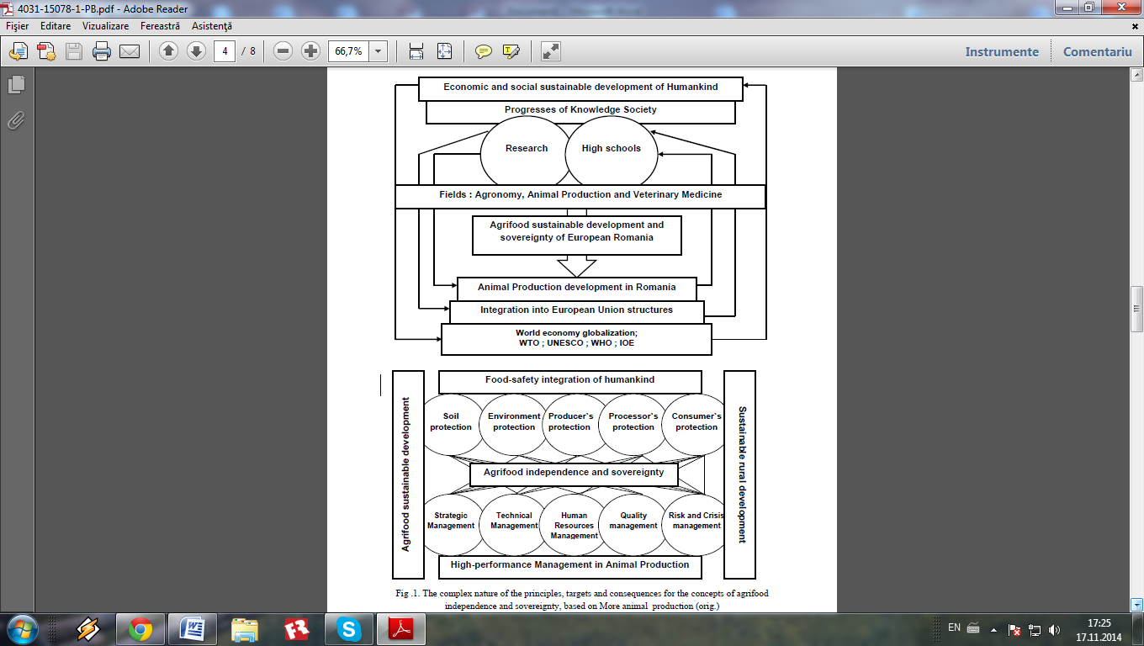

Fig. … The complex nature of the principles, targets and consequences for the concepts of agrifood independence and sovereignty, based on more animal production

(orig. Alexandru T. Bogdan, Dorina Bogdan and Amalia Străteanu - 2007)

1. Title of PhD thesis: "Research on the relations between the uterus and corpus luteum function in the cow" (1971); doctoral PHD Univ. Emeritus, Dr. Doc Nicolae GLUHOVSCHI; supported in Timisoara Agronomic Institute (since 1990 = USAMV of Banat Timişoara)